INSTALLATION QUALIFICATION REPORT
For the PDA / eLambda Linearity Tester (TE82969-2)

PREPARED BY

Name | Role | Signature | Date
Emma Pierce | Test Validation Engineer

REVIEWED BY

Name | Role | Signature | Date
Jaaffar Ismail | Test Engineering Senior Manager

APPROVED BY

Name | Role | Signature | Date
Andre Kopoyan | Senior Operations Quality Engineer

The “Prepared By” signature denotes that this document accurately describes the qualification activities.

The “Reviewed By” signature[s] denotes agreement with the description of the qualification activities.

The “Approved By” signature denotes that this document has been reviewed and approved for overall quality and completeness.

REVISION HISTORY

Version | Author | Summary of change
00 | Emma Pierce | First document for approval

Purpose

The PDA / eLambda Linearity Tester (TE82969-2) is located in the Warranty and Repair Area in Milford, MA. This station is used to verify that linearity of PDA Detectors of the following part numbers is within specification: 186015026, 186002998, 186015032, 186015033, 186015030, 700002787, 700004035, 700005424, 700005427, 186299800, N2971013, N2971035, 186020003, 186017003, 279002655, and 186017013 as well as the equivalent refurbished part numbers: 800000202, 800000244, 800000245, 800000304, 800000305, 800000397, 800000453, and 800000476. Note that not all part numbers have a refurbished equivalent. After the UUT has completed the firmware download at the PDA Detector Download Station (TE83057) and has passed the linearity test, it is moved to the 2998 Final Test System (TE82882) to test noise, drift, and optics.

This Installation Qualification is being performed as required by the Validation Assessment Form TE82969-28SEP17-VAF which can be found in the TE0082969QX directory of SAP.

Scope of Report

This Installation Qualification Report details the qualification activities undertaken for the PDA / eLambda Linearity Tester (TE82969-2) based on the requirements of the Installation Qualification Procedure 730004135, Ver. 00 and TE82969-28SEP17-VAF.

This Installation Qualification Report defines the documents used to qualify the PDA / eLambda Linearity Tester (TE82969-2).

Summary of Results - Statement of Fitness for Intended Use

The PDA / eLambda Linearity Tester was tested in accordance with the Installation Qualification Procedure 730004135, Ver. 00 and TE82969-28SEP17-VAF. All required Test Scripts were performed and all objective evidence requirements have been met.

Waters now has the necessary documentation in place to ensure that the PDA / eLambda Linearity Tester complies with Waters’ requirements, the latest relevant quality system regulations, and cGMP practices.

Following the approval of this Qualification Report, the PDA / eLambda Linearity Tester (TE82969-2) can be considered fully qualified and fit for intended use.

Glossary

The following definitions are used in this document:
Term | Explanation
BOM | Bill of Materials
CAL/PM | Calibration/Preventive Maintenance
cGMP | Current Good Manufacturing Practice
IQ(R) | Installation Qualification (Report)
N/A | Not Applicable
P/N | Part Number
PC | Personal Computer
PDA | Photo Diode Array
SAP | Enterprise Resource Planning Software
S/N | Serial Number
TSP | Test Specification and Procedure
UUT | Unit Under Test
VAF | Validation Assessment Form

Training

The operator of the PDA / eLambda Linearity Tester (TE82969-2) was trained according to the PDA Final Test Procedure 735001613, Ver. 19. The executor of this qualification was trained according to the Installation Qualification Procedure 730004135, Ver. 00. Both training records are provided as Attachments 7.1 and 7.2, respectively.

Qualification Results

Test Script IQ-01: Associated Documentation Verification was performed according to Installation Qualification Procedure 730004135, Ver. 00. The completed Test Script Data Sheet is provided as Attachment 7.3.

The PDA Final Test Procedure 735001613, Ver. 19 was confirmed to be in SAP with a status of Ready, as evidenced below:

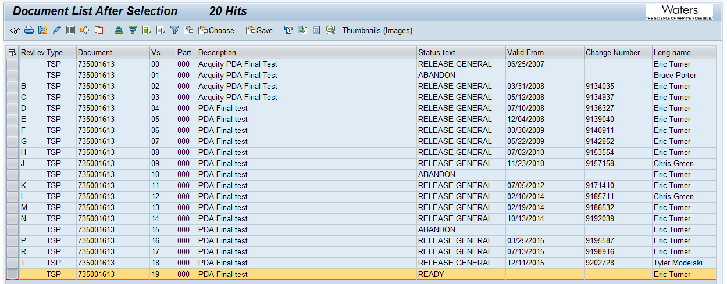

The PDA Linearity Test System Preventative Maintenance Procedure 735003437, Ver. 00 was confirmed to be in SAP with a status of Release General, as evidenced below:

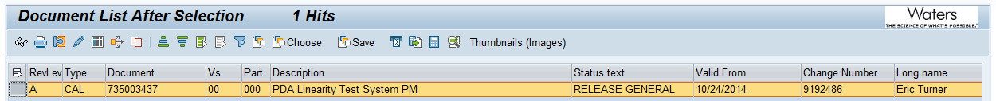

Test Script IQ-02: Site Verification and Test Script IQ-03: Instrumentation Calibration Verification were not performed according to TE82969-28SEP17-VAF.

Test Script IQ-04: Software and Instrument Firmware Version was performed according to Installation Qualification Procedure 730004135, Ver. 00. The completed Test Script Data Sheet is provided as Attachment 7.4.

The TE82969 Test Equipment Software version listed in PDA Final Test Procedure 735001613, Ver. 19 is Test Software 2.0 and was verified to match the version listed on the Test Record. The Test Record is provided as Attachment 7.6.

The firmware version listed in the BOM for P/N: 186017013 is 1.65.6205 and was verified to match the version listed on the Test Record. A screen capture of the BOM in SAP is provided as Attachment 7.5. Refer to Attachment 7.6 for the Test Record.

Test Script IQ-05: General Safety and Alarms was not performed according to TE82969-28SEP17-VAF.

Test Script IQ-06: Functional Verification was performed according to Installation Qualification Procedure 730004135, Ver. 00. The completed Test Script Data Sheet is provided as Attachment 7.7.

The Acquity Arc Bio PDA 2998 (P/N: 186017013) was chosen as the UUT for this Installation Qualification because it is the part number being added to the test system as specified in TE82969-28SEP17-VAF.

One (1) UUT (P/N: 186017013, S/N: J17BPD002A) was tested using the PDA / eLambda Linearity Tester (TE82969-2) with all tests passing. Refer to Attachment 7.6 for the passing Test Record.

This table provides a summary of each test script as performed according to 730004135, Ver. 00 along with the attachment location of all objective evidence. The table also indicates any deviation taken from the scripts during qualification.
Script or Section | Pass/Fail | Objective Evidence | Deviations
IQ-01 | Pass | Attachment 7.3 | None
IQ-04 | Pass | Attachments 7.4, 7.5, and 7.6 | None
IQ-06 | Pass | Attachments 7.6 and 7.7 | None

Attachments

Completed Operator Training Record 735001613, Ver. 19

Completed Executor Training Record 730004135, Ver. 00

Completed Test Script IQ-01: Associated Document Verification

Completed Test Script IQ-04: Test Software and Instrument Firmware Version

Objective Evidence IQ-04: Screen Capture of the BOM for P/N: 186017013

Objective Evidence IQ-04: Passing Test Record for UUT Part #186017013 (J17BPD002A)

Completed Test Script IQ-06: Functional Verification of UUT Part #186017013 (J17BPD002A)

Deviation from Test Equipment Qualification

There were no deviations generated during the execution of the Installation Qualification Procedure 730004135, Ver. 00.

References

The current approved versions of the following documents are referenced within this report:
Document Number | Document Title
730004135, Ver. 00 | Installation Qualification Procedure
735001613, Ver. 19 | PDA Final Test Procedure
735003437, Ver. 00 | PDA Linearity Test System PM Procedure
721007611, Ver. 01 | 2998 PDA Detector Functional Specification
TE0082969QX | Validation Assessment Form TE82969-28SEP17-VAF

