INSTALLATION QUALIFICATION REPORT
For the Acquity SDS Automated Test System (TE82943-13)

PREPARED BY

Name | Role | Signature | Date
Chan Yee Hwa | Manufacturing Engineer

REVIEWED BY

Name | Role | Signature | Date
Emma Pierce | Test Validation Engineer
Ed Jackson | Principal Test Engineer

APPROVED BY

Name | Role | Signature | Date
Andre Kopoyan | Senior Operations Quality Engineer

The “Prepared By” signature denotes that this document accurately describes the qualification activities.

The “Reviewed By” signature[s] denotes agreement with the description of the qualification activities.

The “Approved By” signature denotes that this document has been reviewed and approved for overall quality and completeness.

REVISION HISTORY

Iteration | Author | Summary of Change
00 | Siew Yee Yeap | First document for approval
01 | Chan Yee Hwa | Part number add, firmware and software updates

Purpose

The Acquity SDS Automated Test System (TE82943-13) is located at the WPPL Flextronics Contract Manufacturer Site in Singapore. The test station is used to perform the final functional test of the following part numbers: 186015000, 186015001, 186015018, 186015041, 186015080, 186015081, 186015082, 186015083, 18615084, and N2971030. This system has two software versions installed to test QSM and BSM products. In the final test, the UUT is connected to the test station and the electrical, mechanical, and fluidic performance of the unit are tested.

This Installation Qualification is being performed as required by TE82943-28MAR2018-VAF, which can be found in the TE0082943QX directory of SAP.

Scope of Report

This Installation Qualification Report details the qualification activities undertaken for the Acquity SDS Automated Test System (TE82943-13) based on the requirements of the Installation Qualification Procedure 730004135, Ver. 00.

This Installation Qualification Report defines the documents used to qualify the Acquity SDS Automated Test System (TE82943-13).

Summary of Results - Statement of Fitness for Intended Use

The Acquity SDS Automated Test System was tested in accordance with the Installation Qualification Procedure 730004135, Ver. 00. All required Test Scripts were performed and all objective evidence requirements have been met.

Waters now has the necessary documentation in place to ensure that the Acquity SDS Automated Test System complies with Waters’ requirements, the latest relevant quality system regulations, and cGMP practices.

Following the approval of this Qualification Report, the Acquity SDS Automated Test System (TE82943-13) can be considered fully qualified and fit for intended use.

Glossary

The following definitions are used in this document:
Term | Explanation
% | Percent
§ | Section
BOM | Bill of Materials
BSM | Binary Solvent Manager
CAL | Calibration
cGMP | Current Good Manufacturing Practice
CTQ | Critical to Quality
ECR | Engineering Change Request
EDV | Equipment Design Verification
F/W | Firmware
ID | Identification
IPA | Isopropanol
IQ(R) | Installation Qualification (Report)
LED | Light Emitting Diode
LSL | Lower Specification Limit
MeOH | Methanol
mL/min | Mililiters per Minute
N/A | Not Applicable
nL/min | Nanoliters per Minute
P/N | Part Number
PSI(G/min) | Pounds per Square Inch (Gauge per Minute)
QSM | Quaternary Solvent Manager
SAP | Enterprise Resource Planning Software
SDS | Solvent Delivery System
TMD | Temporary Manufacturing Deviation
TSP | Test Specification and Procedure
uL (µL) | Microliters
UPLC | Ultra Performance Liquid Chromatography
USL | Upper Specification Limit
UUT | Unit Under Test
VAF | Validation Assessment Form
VDC | Volts Direct Current
WPPL | Waters Pacific Private Limited

Training

The operator of the Acquity SDS Automated Test System (TE82943-13) was trained according to the Acquity BSM Pump Automated Test Procedure 735002010, Rev. L, Ver. 10, the Acquity QSM Final Instrument Test Procedure 735002155, Rev. H, Ver. 07. The executor of this qualification was trained according to the Installation Qualification Procedure 730004135, Ver. 00. Operator and executor training records are provided as Attachment 7.1 and 7.2, respectively.

Qualification Results

Test Script IQ-01: Associated Documentation Verification was performed according to Installation Qualification Procedure 730004135, Ver. 00. The completed Test Script Data Sheet is provided as Attachment 7.3.

The Acquity BSM Pump Automated Final Test Procedure 735002010, Rev. L, Ver. 10 was confirmed to be in SAP with a status of Ready, as evidenced below:

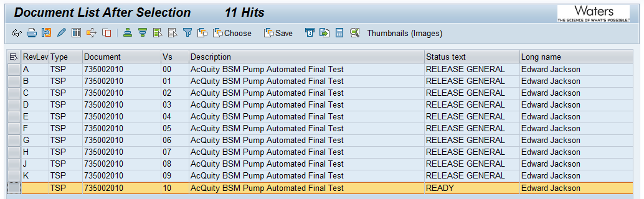

The Acquity QSM Final Instrument Test Procedure 735002155, Rev. H, Ver. 07 was confirmed to be in SAP with a status of Ready, as evidenced below:

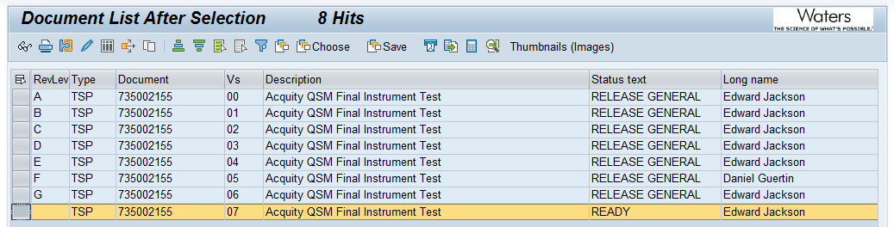

The Calibration / Maintenance for TE82943 Procedure 735001828, Rev. E, Ver. 04 was confirmed to be in SAP with a status of Release General, as evidenced below:

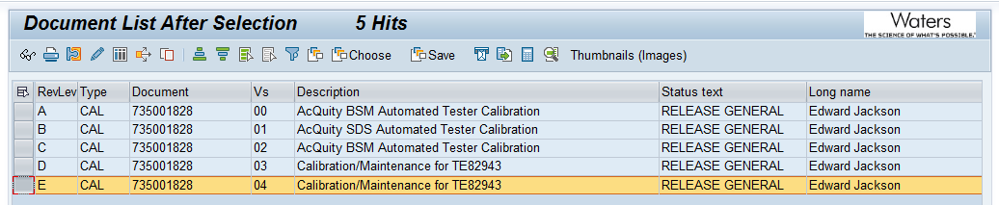

Test Script IQ-02: Site Verification and Test Script IQ-03: Instrumentation Calibration Verification were not performed as part of this Qualification according to TE82943-28MAR2018-VAF.

All results can be found in the previously executed TE82943-13-IQR_Iteration 00, which can be found in the TE0082943QX directory of SAP. This remains a valid qualification for the TE82943-13 system.

Test Script IQ-04: Software and Instrument Firmware Version was performed according to Installation Qualification Procedure 730004135, Ver. 00. The completed Test Script Data Sheet is provided as Attachment 7.4.

The BSM Test Equipment Software version listed in the Acquity BSM Pump Automated Final Test Procedure 735002010, Rev. L, Ver. 10 is Test Software 2.2 and was verified to match the version listed on the passing test record. Refer to Attachment 7.8.

The QSM Test Equipment Software version listed in the Acquity QSM Final Instrument Test Procedure 735002155, Rev. H, Ver. 07 is Test Software 1.7 and was verified to match the version listed on the passing test record. Refer to Attachment 7.5 or Attachment 7.7.

The firmware version for P/N: 186015080 listed in ECR #9221562 is version 1.71.381 and was verified to match the version listed on the test record. Refer to Attachment 7.7.

The firmware version for P/N: 186015001 listed in ECR #9221631 is version 1.71.387 and was verified to match the version listed on the test record. Refer to Attachment 7.8.

The firmware version for P/N: 186015018 listed in ECR #9221630 is version 1.71.381 and was verified to match the version listed on the test record. The passing test record is provided as Attachment 7.5.

Test Script IQ-05: General Safety and Alarms was not performed as part of this qualification according to TE82943-28MAR2018-VAF.

All results can be found in the previously executed TE82943-13-IQR_Iteration 00, which can be found in the TE0082943QX directory of SAP. This remains a valid qualification for the TE82943-13 system.

Test Script IQ-06: Functional Verification was performed according to Installation Qualification Procedure 730004135, Ver. 00. The completed Test Script Data Sheet is provided as Attachment 7.6.

One (1) Acquity UPLC H-Class QSM Plus (P/N: 186015080, S/N: D18QSP002A) was tested using the Acquity SDS Automated Test System (TE82943-13) with all tests passing. The passing test record is provided as Attachment 7.7.

One (1) Acquity UPLC BSM (P/N: 186015001, S/N: D18UPB453A) was tested using the Acquity SDS Automated Test System (TE82943-13) with all tests passing. The passing test record is provided as Attachment 7.8.

This table provides a summary of each test script as performed according to 730004135, Ver. 00 along with the attachment location of all objective evidence. The table also indicates any deviation taken from the scripts during qualification.
Script or Section | Pass/Fail | Objective Evidence | Deviations
IQ-01 | Pass | Attachment 7.3 | None
IQ-04 | Pass | Attachment 7.4, 7.5, 7.7, and 7.8 | None
IQ-06 | Pass | Attachments 7.6, 7.7, and 7.8 | One: see §8.1

Attachments

Completed Operator Training Record

Completed Executor Training Record

Completed Test Script IQ-01: Associated Document Verification

Completed Test Script IQ-04: Test Software and Instrument Firmware Version

Objective Evidence IQ-04: Passing Test Record for UUT Part #186015018 (S/N: D18QSM152A)

Completed Test Script IQ-06: Functional Verification

Objective Evidence IQ-06: Passing Test Record for UUT Part #186015080 (S/N: D18QSP002A)

Objective Evidence IQ-06: Passing Test Record for UUT Part #186015001 (S/N: D18UPB453A)

Deviation from Test Equipment Qualification

There was a deviation generated during the execution of the Installation Qualification Procedure 730004135, Ver. 00.

Description: P/N: 186015082 was not tested as part of this qualification as specified in TE82943-28MAR2018-VAF.
Proposed Corrective Action: There is no need to test P/N: 186015082 because the part is not built or tested at this site.
Resolution: No resolution necessary. Functional tests of P/N: 186015080, P/N: 186015001, and P/N: 186015018 are sufficient to prove the functionality of this test system.

References

The current approved versions of the following documents are referenced within this report:
Document Number | Document Title
730004135, Ver. 00 | Installation Qualification Procedure
735002010, Rev. L, Ver. 10 | Acquity BSM Pump Automated Test Procedure
735002155, Rev. H, Ver. 07 | Acquity QSM Final Instrument Test Procedure
735001828, Rev. E, Ver. 04 | Calibration / Maintenance for TE82943 Procedure
ECR #9221562 | Engineering Change Request Releasing Emerald Firmware for New Parts
ECR #9221630 | Engineering Change Request Releasing Emerald Firmware for Existing Parts
ECR #9221631 | Engineering Change Request Releasing Emerald Firmware for Existing Parts
TMD010478 Ver. 01 | Temporary Manufacturing Deviation for Bifrost Validation
TE82943-28MAR2018-VAF | Validation Assessment Form for Bifrost Part Number Add
TE82943-13-IQR_Iteration 00 | Installation Qualification Report for TE82943-13

