DOCUMENT TITLE: ALLIANCE HEATER COOLER TEST CAL/PM PROCEDURE
DOCUMENT TYPE: Calibration Preventive Maintenance
EQUIPMENT NAME: 269x alliance heater cooler test system
EQUIPMENT NUMBER: te0084018

AUTHOR(S): tyler modelski | DATE: August 28, 2018
REVISED BY: N/A | DATE: N/A

Equipment Required
Quantity | Part Number | Description
N/A | N/A | N/A

Disposables Required
Quantity | Part Number | Description
N/A | N/A | N/A

reference documentation
Document Number | Description
730001799 | Operating Procedure, Calibration and PM
730000295MP | Quality System Document Control
735004582 | Alliance Heater Cooler Test Procedure
TE0084018EQ | Alliance Heater Cooler Test System Design Documents

DEFINITIONS AND ABBREVIATIONS
Term | Definition/Abbreviation
Calibration | A process to ensure that equipment is capable of producing accurate results. This includes verifying measurements and/or making adjustment(s) to ensure measurement accuracy.
PM | Preventive Maintenance: The servicing, for the purpose of maintaining equipment in satisfactory working order, by performing systematic inspection, detection, and correction of potential failures. PM activities may include tests, measurements, and parts replacement.
NI | National Instruments

Procedure
- NI-9217 Calibration
  - Remove the side panel of the tester. Send the NI-9217 Temperature Input Module out for calibration by an accredited calibration house.
NOTE: Unscrew the black wired connector and remove the entire module from the cDAQ-9174 chassis. The NI-9217 module is removable by squeezing the clips on the top and bottom (see picture below).

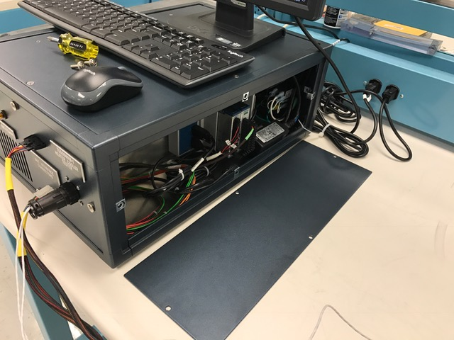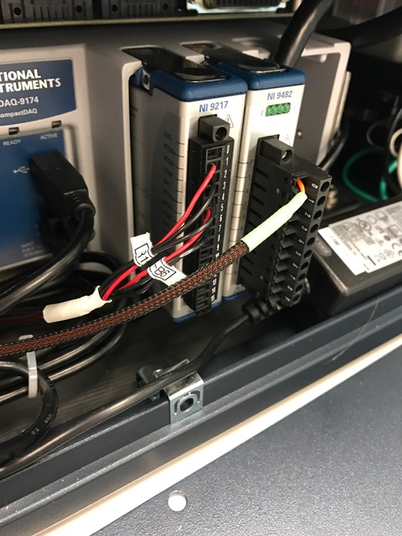

- Computer Maintenance
- Maintain Test Computer per 735003678, Generic PC Maintenance Procedure. | PERFORMED SEE NOTE

- Vacuum and Cleaning
- General Cleaning, inside and out. | PERFORMED SEE NOTE

- Electrical
- Inspect cables for wear or physical damage. Replace as needed. | PERFORMED SEE NOTE
- Inspect connectors for wear or physical damage. Replace as needed. | PERFORMED SEE NOTE

- Mechanical
- Inspect packaging physical damage/deformation. | PERFORMED SEE NOTE
- Inspect packaging or sharp edges. | PERFORMED SEE NOTE
- Check inside and around tester enclosure for loose hardware. | PERFORMED SEE NOTE

- Functional Check
- Run the test using a known good UUT. Verify a passing result is achieved. | PASS FAIL SEE NOTE
WATERS CORPORATION
269X Alliance Heater Cooler Test System
CALIBRATION and PREVENTIVE MAINTENANCE RECORD
Date: | Performed By:
Equipment I.D. | Location:
Due Date: | Interval (Months): | Next Due Date:

Test Equipment Used | Serial Number/Identification Number | Calibration/PM Date

SECTION 1: NI-9217 Calibration | RESULT | RESULT
Step 1.1: Calibration NI-2917 | Calibration Status Valid | PASS FAIL SEE NOTE

SECTION 2: Computer Maintenance | RESULT
Step 2.1: Maintain Test Computer per 735003678, Generic PC Maintenance Procedure. | PERFORMED SEE NOTE

SECTION 3: Vacuum and Cleaning | RESULT
Step 3.1: General Cleaning, inside and out. | PERFORMED SEE NOTE

SECTION 4: Electrical | RESULT
Step 4.1: Inspect cables for wear or physical damage. Replace as needed. | PERFORMED SEE NOTE
Step 4.2 Inspect connectors for wear or physical damage. Replace as needed. | PERFORMED SEE NOTE

SECTION 5: Mechanical | RESULT
Step 5.1: Inspect packaging physical damage/deformation. | PERFORMED SEE NOTE
Step 5.2: Inspect packaging or sharp edges | PERFORMED SEE NOTE
Step 5.3: Check inside and around tester enclosure for loose hardware. | PERFORMED SEE NOTE

SECTION 6: Functional Check | RESULT
Step 6.1: Run the test using a known good UUT. Verify a passing result is achieved. | PASS FAIL SEE NOTE

NOTES

