DOCUMENT TITLE: tEST sPECIFICATION AND pROCEDURE, alliance heater cooler test
SYSTEM/ASSEMBLY NAME: assy, heater/cooler, 2690/2790
PART NUMBER AFFECTED 289000560
TEST EQUIPMENT NAME: 2690/2790 Alliance heater cooler test system
TEST EQUIPMENT NUMBER: te0084018
TEST SOFTWARE: *0.0*

AUTHOR(S): tyler modelski | DATE: October 23, 2018
REVISED BY: N/A | DATE: N/A

Equipment Required
Quantity | Part Number | Description
1 | TE0084018 | Alliance Heater Cooler Test System
1 | 210000411 | Assy, PCB, eAlliance CPU ROHS
1 | WAT270471 | Power Supply, 600W Tested
1 | WAT270616 | Cable Assy, H/C DC Power
1 | WAT270354 | Cable Assy, Option Control (serial communication PCB to UUT)
1 | WAT270089 | Cable Assy, Pump/CPU, DC Power
1 | 441000294 | Cable, 9-Pin to MMJ, 25 FT (cut and modified to 1 foot)
1 | NI cDAQ-9174 | 4-Slot, USB Compact DAQ Chassis
1 | NI 9217 | C Series Temperature Input Module
1 | NI 9482 | C Series Relay Output Module
1 | RTD-805 | Omega Air Temperature RTD Sensor
1 | RTD-860 | Omega Precision RTD Probe for Lab Applications
1 | 99945210 | Polyethylene Foam Box – TE0084018

Disposables Required
Quantity | Part Number | Description
N/A | N/A | N/A

reference documentation
Document # | Description
735004597 | Alliance Heater Cooler Cal/PM Procedure
TE0084018EQ | 269X Alliance Heater Cooler Test System Design Documents
TE0084018SF | 269X Alliance Heater Cooler Test System Software Documentation
WAT270801 | Performance Specification, Heater/Cooler, 2690
810000150 | Performance Specification, Alliance Sample Heater Cooler PCB

Definitions and Abbreviations
Term | Definition
H/C | Heater / Cooler
NI | National Instruments
PCB | Printed Circuit Board
EFF | External Fan Failure
IFF | Internal Fan Failure
WD | Watchdog
ID | Identification
UUT | Unit Under Test
OT | Over Temperature
CAL | Calibration
PM | Preventative Maintenance

Test SPecifications and Traceability Matrix
Test # | Test Specification & Condition | Acceptance criteria | Reference
1 | UUT ID | ID Bit Set | 810000150 Section 4.2
2 | External Fans | External Fan Failure (EFF)  Bit Not Set | 810000150 Section 4.2
3 | Internal Fans | Internal Fan Failure (IFF)  Bit Not Set | 810000150 Section 4.2
4 | Over Temperature Bit | Over Temperature (OT)  Bit Not Set | 810000150 Section 4.2
5 | Watchdog Timer | Watchdog Timer (WD)  Bit Not Set | 810000150 Section 4.2
6 | Temperature Accuracy | +/- 3.0°C | WAT270801 Section 3.3.1
7 | Cooling Test* | Cooling Rate <=  -1.25°C/min | WAT270801 Section 3.3.1
8 | Heating Test* | Heating Rate >=  1.43°C/min | WAT270801 Section 3.3.1
*Refer to the Test Method Description document in TE0084018EQ for a description of the acceptance criteria for the Heating and Cooling Tests.

Test Procedure
- tester setup (perform once)
  - Refer to Appendix A for a cabling connection diagram.
  - Connect the serial cable from the test system connector to the serial port on the Test Computer (COM1).
  - Connect the USB cable from the test system (NI cDAQ-9174) to a USB port on the Test Computer.
  - Connect the UUT serial cable (WAT270354), UUT power cord (WAT270616), and Temperature Probes connector to the front of the tester.
  - Attach the Heater Cooler Temperature Probe and the Ambient Temperature probe to the labeled location on the thermal load (see Appendix B).
  - Power on the Test Computer. Verify that there is a file named “test_parameters.txt” in the following location: C:/Input Files/. If not present, contact test engineering.
    - NOTE: Test Engineer: This file is located on finserv2 in the Test Equipment - Test Code folder. Refer to TE0084018SF in SAP for software documentation.
- TEST SETUP
  - Power on the Test Computer. Launch the Alliance Heater Cooler Test Software. Follow on screen prompts to begin the test.
  - Connect cable WAT270616 from the test system to PCB location J3 on the UUT.
  - Connect cable WAT270354 from the test system to PCB location J8 on the UUT.
  - Install the thermal load on top of the heater cooler sub-assembly. It is recommended this be the LAST step you perform before starting the test. This allows for the maximum amount of time for the thermal load to get back to ambient temperature conditions. Slide the thermal load as far forward as possible.

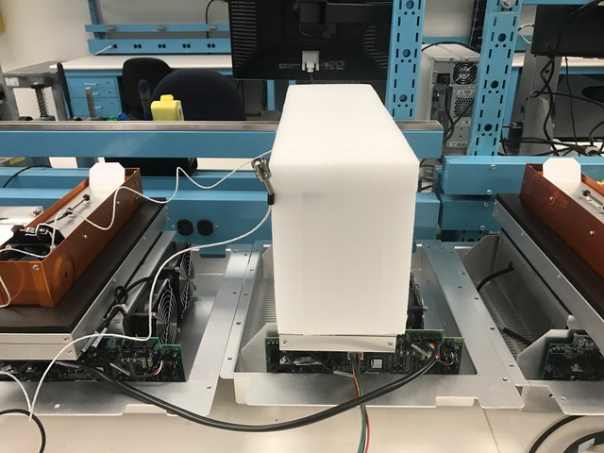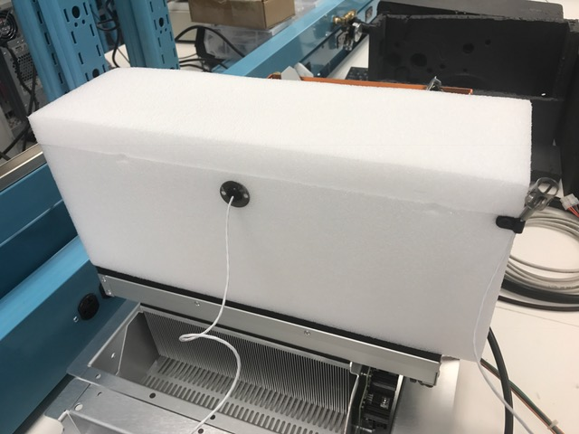
SLIDE TO FRONT

  - Start the Test. See the following notes regarding the test:
    - Each time a test is started, the tester and UUT run an initialization sequence. This is necessary to initialize the Alliance CPU within the tester with the Heater Cooler board connected. You may see some line items during initialization come up as “FAILURE”. This is NORMAL. Ignore them.
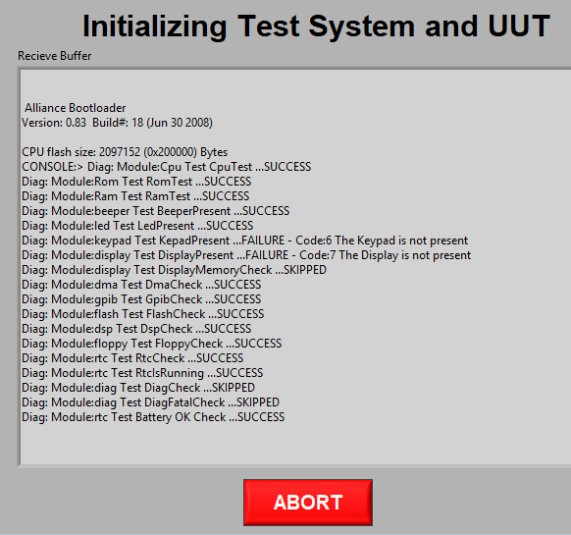
    - Cooling and Heating Test: Prior to running this test, the software will check to ensure the Heater Cooler Temperature Probe is +/- 1°C of the Ambient Temperature Probe. It will wait for a set period of time for the probes to naturally move to +/- 1°C.
Heater Cooler Temperature Probe
Heater Cooler Temperature Probe

If the probes do not get to +/- 1°C of each other in the given time period, the temperature inside the load may need to be adjusted by removing the load to expose it to the ambient temperature conditions. The operator will be prompted if this occurs (see below). Remove the load then monitor the “Heater/Cooler Temp” and “Ambient Temp” until they are +/- 1. Install the load back onto the Heater/Cooler and click “Try Again”.

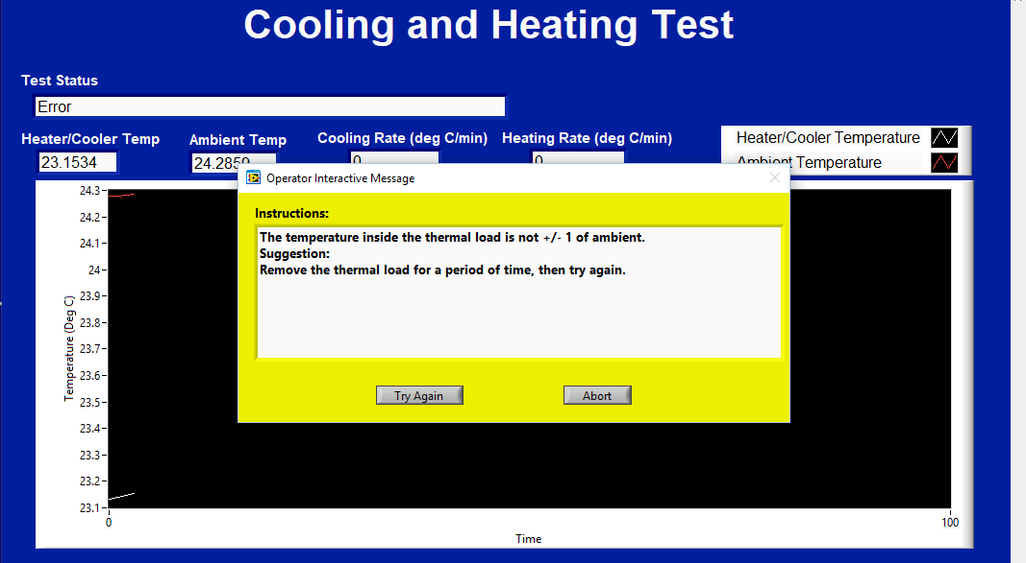

  - Allow the test to run to completion.
    - NOTE: If the UUT fails the cooling or heating test, the operator must allow time for the unit heating/cooling element to get back to ambient temperature conditions. It is recommended the unit be put to the aside and retested after additional UUT testing has been completed. If this is not performed you will have the issue outlined in Step 2.5.2.
  - Remove the thermal load from the top of the heater cooler sub-assembly. Place the thermal load UPSIDE DOWN, to allow the inside of the load to move back to ambient temperature conditions for the next test.

APPENDIX A – CABLING DIAGRAM

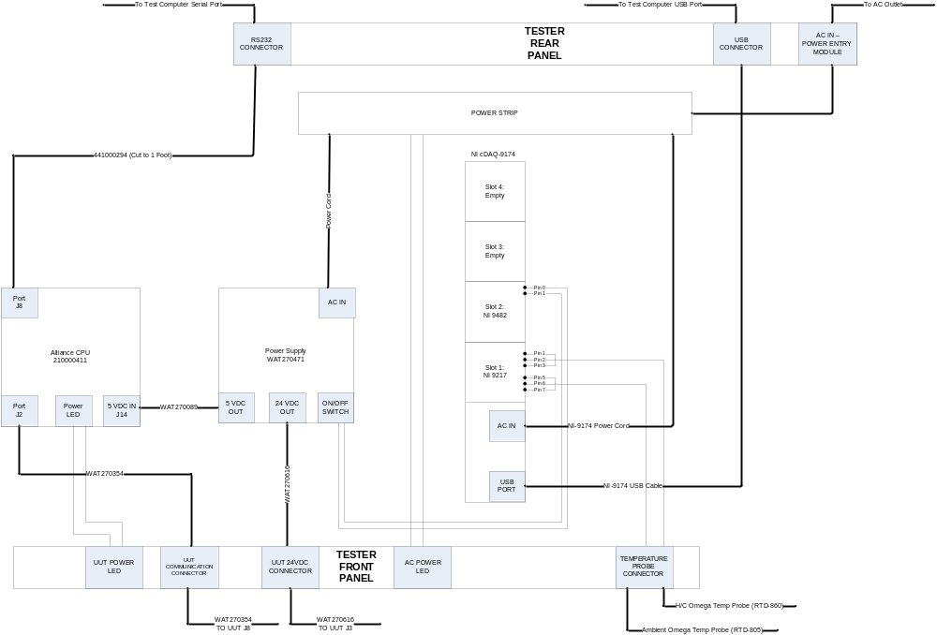

APPENDIX B – THERMAL LOAD

- Push the heater cooling temperature probe through the foam thermal load until the circular plate is pressed against its surface.

Ambient Temperature Probe
Heater Cooler Temperature Probe

- Use a screw to connect the ambient temperature clip to the thermal load.

