Installation qualification REPORT
For the 2998 Final Test System (TE82882-15)

PREPARED BY
Name | Role | Signature | Date
James J. Stors | Senior Test Validation Engineer

REVIEWED BY
Name | Role | Signature | Date
Eric Turner | Principal Test Engineer

APPROVED BY
Name | Role | Signature | Date
Andre Kopoyan | Senior Operations Quality Engineer

The “Prepared By” signature denotes that this document accurately describes the qualification activities.

The “Reviewed By” signature[s] denotes agreement with the description of the qualification activities.

The “Approved By” signature denotes that this document has been reviewed and approved for overall quality and completeness.

REVISION HISTORY
Version | Author | Summary of change
00 | Emma Pierce | First document for approval.
01 | James J. Stors | New software version to print serial number in the Report footer.
02 | James J. Stors | New software version to add Optics Bench part numbers

Purpose
The 2998 Final Test System, TE82882-15, is located in Warranty and Repair in Milford, MA. The 2998 Final Test System is used to perform functionality testing of Waters Corporation’s 2998 Photo Diode Arrays (PDA’s) as defined in TSP 735001613, to ensure compliance to the defined Manufacturing Test Specifications.
The system uses serial ports to communicate to up to four (4) UUT’s in order to test Noise, Drift, and Optics. Upon completion a Final Test Record is automatically generated and a hard copy is printed. In addition, the Final Test Record is sent to the SigmaProd Server.

Scope of Report
This Installation Qualification Report details the qualification activities undertaken for the 2998 Final Test System
(TE82882-15) based on the requirements of the performed Installation Qualification, 730004135, Version 02, as outlined by the Test Software Version 4.1 risk assessment, per TE82882-10JUN19-VAF.
All Test Scripts were executed and are summarized within this report.

Summary of Results - Statement of Fitness for Intended Use
The 2998 Final Test System (TE82882-15) was tested in accordance with Installation Qualification Protocol, 730004135, Version 02. All required Test Scripts were performed and all objective evidence requirements have been met.
Waters now has the necessary documentation in place to ensure that the 2998 Final Test System (TE82882-15) remains compliant with Waters’ requirements, the latest relevant quality system regulations, and cGMP practices.
Following the approval of this Qualification Report, the 2998 Final Test System (TE82882-15) remains fully qualified and fit for intended use.

Glossary
The following definitions are used in this document:
Term | Explanation
ºC | Degrees Celsius
BOM | Bill of Material
cGMP | Current Good Manufacturing Practice
Hz | Hertz
IQ | Installation Qualification
IQR | Installation Qualification Report
N/A | Not Applicable
SAP | Enterprise Resource Planning (ERP) software
TSP | Test Specification and Procedure
UUT | Unit Under Test
VAC | Volts Alternating Current

Training
The executor of the 730004135, Installation Qualification Procedure, is the author and is therefore trained to the procedure. The operator who performed the testing per IQ-06, Functional Verification, per the PDA Final Test - Test and Specification Procedure, 735001613 and the UPC² PDA Detector and Veyron PDA Detector Final Test - Test and Specification Procedure, 735002531, is the author and is therefore trained to the procedures.

Qualification Results

Test Script IQ-01, Associated Documentation Verification, was performed in accordance with Installation Qualification Protocol, 730004135, Version 02.

IQ-01, Associated Documentation Verification Data Sheet, is provided as Attachment 7.1.

The PDA Final Test - Test and Specification Procedure, 735001613, Version 22, was confirmed to be in SAP with a status of Ready. A screen capture is provided below:
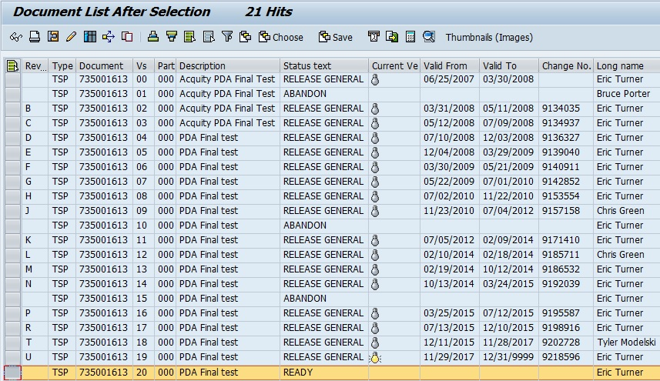

The UPC² PDA Detector and Veyron PDA Detector Final Test - Test and Specification Procedure, 735002531, Version 11, was confirmed to be in SAP with a status of Ready. A screen capture is provided below:
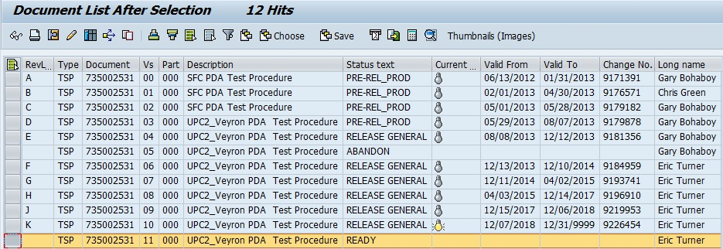

The PDA Linearity Test System Preventive Maintenance Procedure, 735003030, Version 00/Revision A, was confirmed to be in SAP with a status of Release General. A screen capture is provided below:
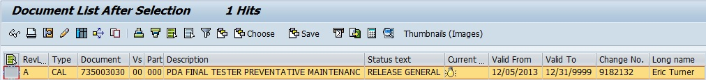

Test Script IQ-02, Site Verification, was performed in accordance with Installation Qualification Procedure, 730004135, Version 02.

IQ-02, Site Verification Test Script Data Sheet, is provided as Attachment 7.2.

The site verification acceptance criteria for temperature and humidity are specified within the Velox 2998 PDA Detector Functional Specification Document, 721007611 within Section 5.5, Environmental.

The ambient temperature and Relative Humidity were measured using a Fluke Model 971 Temperature/Humidity Meter, Control Number: 99157. The ambient temperature and relative humidity were in specification.

The calibration data sheet for the Temperature/Humidity Meter is provided as Attachment 7.3.

The system space and the test bench used for the TE82882-15, 2998 Final Test System, were inspected and confirmed to have sufficient room for the system, testing and service, and be large and strong enough to support the station.

A photo of the TE82882-15, 2998 Final Test System is shown below:
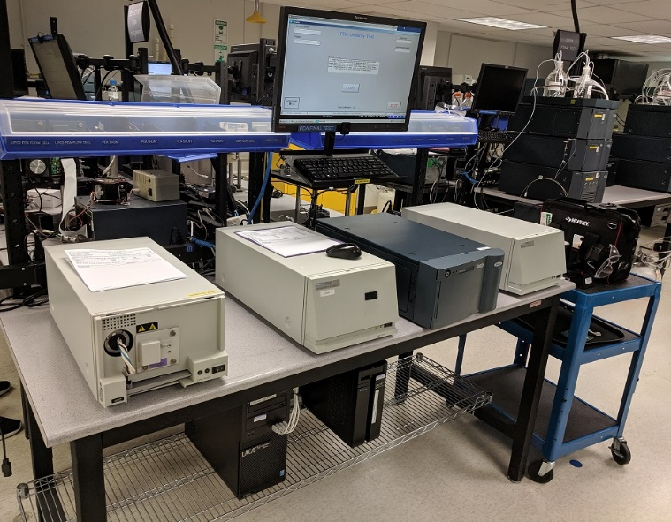

The site verification acceptance criterion for electrical supply is specified within the Velox 2998 PDA Detector Functional Specification Document, 721007611 within Section 5.2.2, Electrical.

The Electrical Supply was measured using a Fluke 289 Digital Multimeter, Control Number: 99155. The voltage and frequency were in specification.

The calibration data sheet for the Multimeter is provided as Attachment 7.4.

The station was confirmed to meet the requirement of having a minimum of six (6) electrical outlets dedicated.

The station was confirmed to meet the requirement of having a minimum of one (1) network dedicated.

Test Script IQ-03, Instrumentation Calibration Verification, was performed in accordance with Installation Qualification Procedure, 730004135, Version 02.

IQ-03, Instrumentation Calibration Verification Test Script Data Sheet, is provided as Attachment 7.5.

The TE82882-15, 2998 Final Test System, was confirmed to have had a preventive maintenance performed and to be in the Calibration Manager Database with a twelve (12) month maintenance cycle.

A copy of the Preventive Maintenance Certificate is provided as Attachment 7.6.

A screen capture of the Calibration Manager Database entry for the TE82882-15, 2998 Final Test System, with a twelve (12) month preventive maintenance cycle, is shown below:
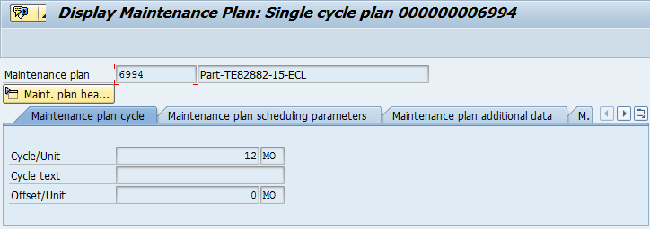

Test Script IQ-04, Test Software and Instrument Firmware Version, was performed in accordance with Installation Qualification Protocol, 730004135, Version 02.

IQ-04, Test Software and Instrument Firmware Version Data Sheet, is provided as Attachment 7.7.

The Test Equipment Software version listed in 735001613, PDA Final Test - Test and Specification Procedure (Version 22), is 4.2 and was verified to match the version displayed on the TE82882-15, 2998 Final Test System program display, as shown in the screen capture below:
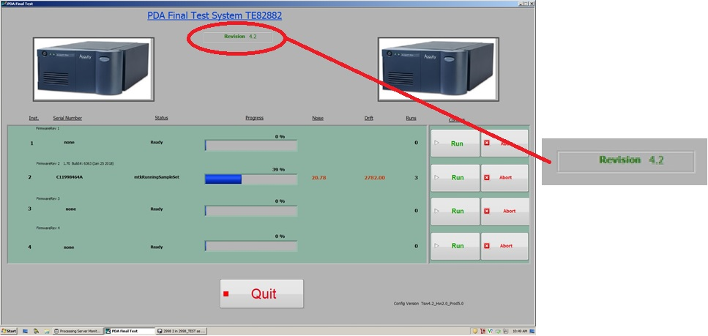

Test Script IQ-05, General Safety and Alarms, was performed in accordance with Installation Qualification Procedure, 730004135, Version 02

IQ-05, General Safety and Alarms Test Script Data Sheet, is provided as Attachment 7.8.

It was confirmed that there were no mechanical safety, pinch points, or sharp edges.

Test Script IQ-06, Functional Verification, was performed in accordance with Installation Qualification Protocol, 730004135, Version 02.

IQ-06, Functional Verification Test Script Data Sheet, is provided as Attachment 7.9.

To cover all system functionality one of each type of Detector that the TE82882-15, 2998 Final Test System tests was run. The 700012243 was selected for the 2998 Detector type, the 700012245 was selected for the eLamda type, and 186015032 was selected for the PDA type.

The Firmware Version specified within the BOM in SAP for each part number that the TE82882-15, 2998 Final Test System tests was verified to be Version 1.70.6367, as shown in the representative screen capture for part number 186015032 provided below:
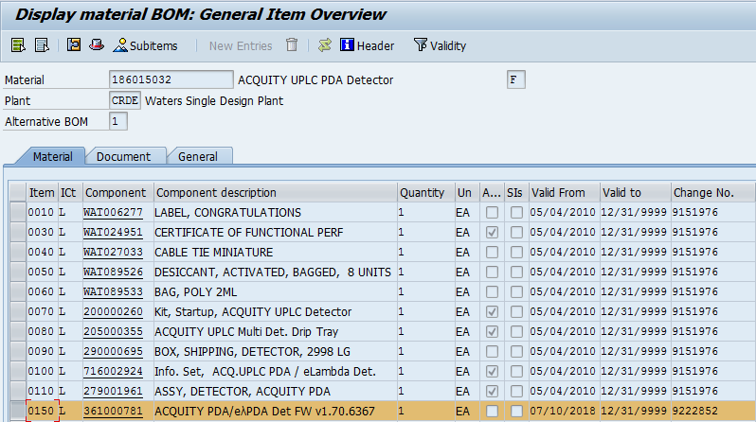

One (1) UUT, Part Number 700012243, was tested using TE82882-15, 2998 Final Test System, and met the requirement of all required CTQ Specification measurements result in a Pass and Firmware Version 1.70.6367 being loaded on the unit.

The Instrument Test Record is provided as Attachment 7.10.

One (1) UUT, Part Number 700012245, was tested using the TE82882-15, 2998 Final Test System, and met the requirement of all required CTQ Specification measurements result in a Pass and Firmware Version 1.70.6367 being loaded on the unit.

The Instrument Test Record is provided as Attachment 7.11.

One (1) UUT, Part Number 186015032, was tested using the TE82882-15, 2998 Final Test System, and met the requirement of all required CTQ Specification measurements result in a Pass and Firmware Version 1.70.6367 being loaded on the unit.

The Instrument Test Record is provided as Attachment 7.12.

A summary of the attached objective evidence that applies to each Test Script is provided in the Table below:
Script or Section | Pass/Fail | Objective Evidence | Deviations
IQ-01 | Pass | Attachment 7.1 | None
IQ-02 | Pass | Attachments 7.2, 7.3, and 7.4 | None
IQ-03 | Pass | Attachment s7.5 and 7.6 | None
IQ-04 | Pass | Attachment 7.7 | None
IQ-05 | Pass | Attachments 7.8 | None
IQ-06 | Pass | Attachment 7.9 through 7.12 | None

Attachments

IQ-01, Associated Documentation Verification Test Script Data Sheet

IQ-02, Site Verification Test Script Data Sheet

Fluke Model 971 Temperature/Humidity Meter, Control Number: 99157, Calibration Data Sheets

Fluke 289 Multimeter, Control Number: 99155, Calibration Data Sheets

IQ-03 – Instrumentation Calibration Verification Test Script Data Sheet

TE82969-2 Preventive Maintenance Certificate

IQ-04, Test Software and Instrument Firmware Version Test Script Data Sheet

IQ-05 – General Safety and Alarms Test Script Data Sheet

IQ-06, Functional Verification Test Script Data Sheet

Instrument Final Test Record, Part Number: 700012243

Instrument Final Test Record, Part Number: 700012245

Instrument Final Test Record, Part Number: 186015033

Deviation from Test Equipment Qualification
There were no deviations generated during the execution of the Installation Qualification, 730004135, Version 02, for the TE82882-15, 2998 Final Test System.

References
The current approved versions of the following documents are referenced within this Report:
Document Number | Document title
721007611 | Velox 2998 PDA Detector Functional Specification Document
730004135 | Installation Qualification Protocol
735001613 | PDA Final Test System Test and Specification Procedure
735002531 | UPC2 PDA Detector and Veyron PDA Detector Final Test Procedure
735003030 | PDA Linearity Test System Preventive Maintenance Procedure
TE82882-10JUN19-VAF | Test Software Version 4.2 risk assessment

