Installation qualification REPORT
For the PDA/eLambda Linearity Tester

PREPARED BY
Name | Role | Signature | Date
James J. Stors | Senior Test Validation Engineer

REVIEWED BY
Name | Role | Signature | Date
Eric Turner | Principal Test Engineer

APPROVED BY
Name | Role | Signature | Date
Megan Marshall | Senior Quality System Engineer

The “Prepared By” signature denotes that this document accurately describes the qualification activities.

The “Reviewed By” signature[s] denotes agreement with the description of the qualification activities.

The “Approved By” signature denotes that this document has been reviewed and approved for overall quality and completeness.

REVISION HISTORY
Version | Author | Summary of change
00 | Emma Pierce | First document for approval.
01 | James J. Stors | New software version to add the 30mg concentration test.
02 | Emma Pierce | Firmware update
03 | James J. Stors | New software version to add Optics Bench part numbers

Purpose
The PDA/ eLambda Linearity Test System (TE82969-2) is located in the Warranty and Repair Area in Milford, MA. The system shares a bench and a monitor with the 2998 Final Test System, TE82882. This station is used to verify that linearity of PDA Detectors of the following part numbers is within specification: 186002998, 186015026, 186015030, 186015032, 186015033, 186015034, 186015053, 186017003, 186017013, 186299800, 279002655, N2971013, and N2971035; as well as the spares and refurbished equivalent parts as listed in the PDA Final Test TSP, 735001613, or the UPC2 PDA Detector and Veyron PDA Detector Final Test Procedure, 735002531. Note that not all part numbers have a refurbished equivalent or spare. After the UUT has completed the firmware download according to the corresponding procedure and has passed the linearity test at TE82969, it is moved to the 2998 Final Test System (TE82882) to test noise, drift, and optics.

Scope of Report
This Installation Qualification Report details the qualification activities undertaken for the PDA/eLambda Linearity Test System (TE82969-2) based on the requirements of the performed Installation Qualification, 730004135, Version 02, as outlined by the Test Software Version 2.2 risk assessment, per TE82969-10JUN19-VAF.
All Test Scripts were executed and are summarized within this report.

Summary of Results - Statement of Fitness for Intended Use
The PDA/eLambda Linearity Test System (TE82969-2) was tested in accordance with Installation Qualification Protocol, 730004135, Version 02. All required Test Scripts were performed and all objective evidence requirements have been met.
Waters now has the necessary documentation in place to ensure that the PDA/eLambda Linearity Test Ststem (TE82969-2) remains compliant with Waters’ requirements, the latest relevant quality system regulations, and cGMP practices.
Following the approval of this Qualification Report, the PDA/eLambda Linearity Test System (TE82969-2) remains fully qualified and fit for intended use.

Glossary
The following definitions are used in this document:
Term | Explanation
cGMP | Current Good Manufacturing Practice
IQ | Installation Qualification
IQR | Installation Qualification Report
mg | Milligram
PDA | Photo Diode Array
SAP | Enterprise Resource Planning (ERP) software
TSP | Test Specification and Procedure
UPC | UltraPerformance Convergence Chromatography
UUT | Unit Under Test
VAF | Validation Assessment Form

Training
The executor of the 730004135, Installation Qualification Procedure, is the author and is therefore trained to the procedure. The operator who performed the testing per IQ-06, Functional Verification, per the PDA Final Test - Test and Specification Procedure, 735001613 and the UPC² PDA Detector and Veyron PDA Detector Final Test - Test and Specification Procedure, 735002531, is the author and is therefore trained to the procedures.

Qualification Results

Test Script IQ-01, Associated Documentation Verification, was performed in accordance with Installation Qualification Protocol, 730004135, Version 02.

IQ-01, Associated Documentation Verification Data Sheet, is provided as Attachment 7.1.

The PDA Final Test - Test and Specification Procedure, 735001613, Version 22, was confirmed to be in SAP with a status of Ready. A screen capture is provided below:
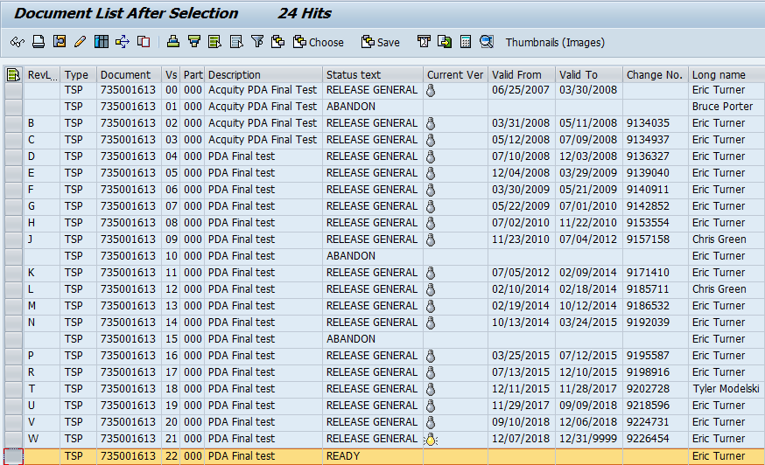

The UPC² PDA Detector and Veyron PDA Detector Final Test - Test and Specification Procedure, 735002531, Version 11, was confirmed to be in SAP with a status of Ready. A screen capture is provided below:
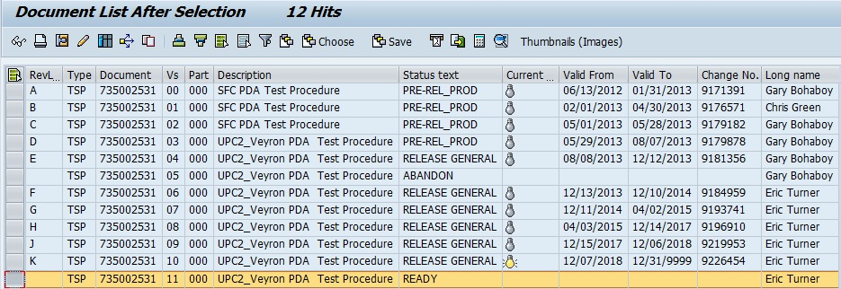

The PDA Linearity Test System Preventive Maintenance Procedure, 735003437, Version 00, was confirmed to be in SAP with a status of Release General. A screen capture is provided below:
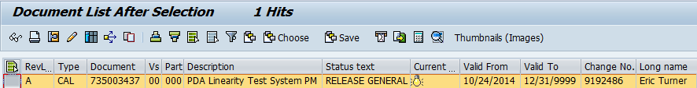

Test Script IQ-02, Site Verification, was performed in accordance with Installation Qualification Procedure, 730004135, Version 02.

IQ-02, Site Verification Test Script Data Sheet, is provided as Attachment 7.2.

The site verification acceptance criteria for temperature and humidity are specified within the Velox 2998 PDA Detector Functional Specification Document, 721007611 within Section 5.5, Environmental.

The ambient temperature and Relative Humidity were measured using a Fluke Model 971 Temperature/Humidity Meter, Control Number: 99157. The ambient temperature and relative humidity were in specification.

The calibration data sheet for the Temperature/Humidity Meter is provided as Attachment 7.3.

The system space and the test bench used for the TE82969-2, PDA/eLambda Linearity Test System, were inspected and confirmed to have sufficient room for the system, testing and service, and be large and strong enough to support the station.

A photo of the TE82969-2, PDA/eLambda Linearity Test System is shown below:
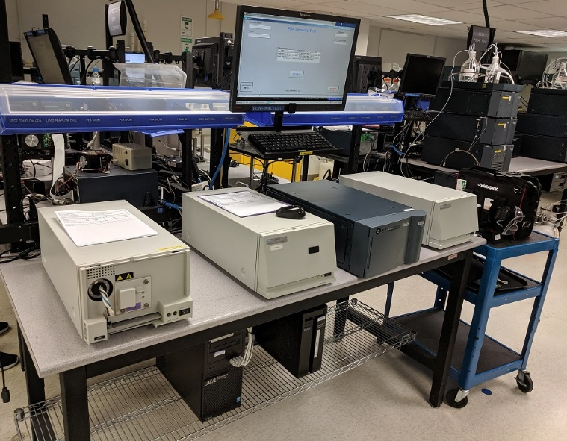

The site verification acceptance criterion for electrical supply is specified within the Velox 2998 PDA Detector Functional Specification Document, 721007611 within Section 5.2.2, Electrical.

The Electrical Supply was measured using a Fluke 289 Digital Multimeter, Control Number: 99155. The voltage and frequency were in specification.

The calibration data sheet for the Multimeter is provided as Attachment 7.4.

The station was confirmed to meet the requirement of having a minimum of three (3) electrical outlets dedicated.

The station was confirmed to meet the requirement of having a minimum of one (1) network dedicated.

Test Script IQ-03, Instrumentation Calibration Verification, was performed in accordance with Installation Qualification Procedure, 730004135, Version 02.

IQ-03, Instrumentation Calibration Verification Test Script Data Sheet, is provided as Attachment 7.5.

The TE82969-2, PDA/eLambda Linearity Test System, was confirmed to have had a preventive maintenance performed and to be in the Calibration Manager Database with a twelve (12) month maintenance cycle.

A copy of the Preventive Maintenance Certificate is provided as Attachment 7.6.

A screen capture of the Calibration Manager Database entry for the TE82969-2, PDA/eLambda Linearity Test System, with a twelve (12) month preventive maintenance cycle, is shown below:
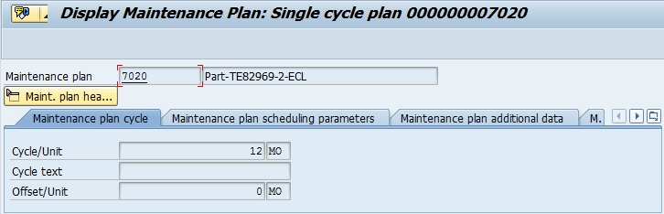

Test Script IQ-04, Test Software and Instrument Firmware Version, was performed in accordance with Installation Qualification Protocol, 730004135, Version 02.

IQ-04, Test Software and Instrument Firmware Version Data Sheet, is provided as Attachment 7.7.

The Test Equipment Software version listed in 735001613, PDA Final Test - Test and Specification Procedure (Version 22), is 2.2 and was verified to match the version displayed on the PDA/eLambda Linearity Tester TE82969 program display, as shown in the screen capture below:
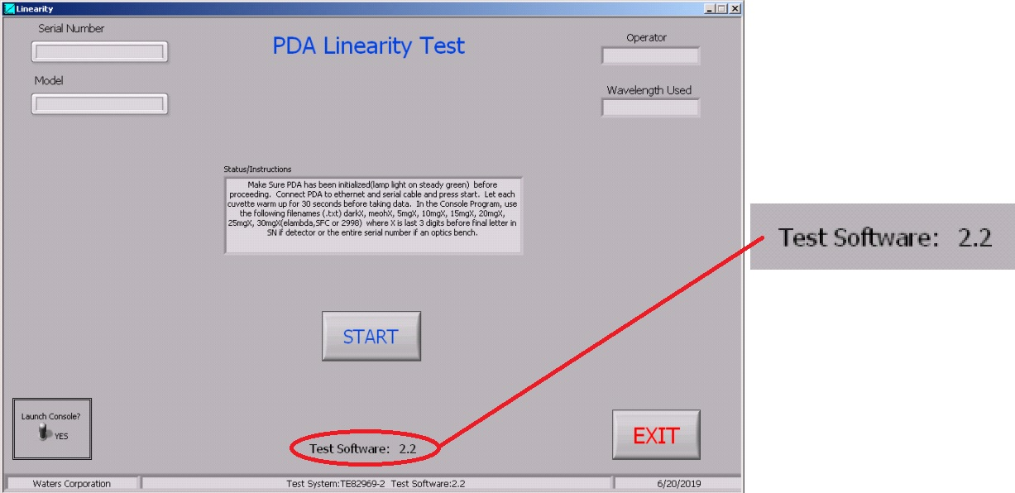

Test Script IQ-05, General Safety and Alarms, was performed in accordance with Installation Qualification Procedure, 730004135, Version 02

IQ-05, General Safety and Alarms Test Script Data Sheet, is provided as Attachment 7.8.

It was confirmed that there were no mechanical safety, pinch points, or sharp edges.

Test Script IQ-06, Functional Verification, was performed in accordance with Installation Qualification Protocol, 730004135, Version 02.

IQ-06, Functional Verification Test Script Data Sheet, is provided as Attachment 7.9.

One (1) UUT, Part Number 700012243, was tested using the TE82969-2, PDA/eLambda Linearity Test System, and met the requirement of all required CTQ Specification measurements result in a Pass.

The Instrument Test Record is provided as Attachment 7.10.

One (1) UUT, Part Number 700012245, was tested using the TE82969-2, PDA/eLambda Linearity Test System, and met the requirement of all required CTQ Specification measurements result in a Pass.

The Instrument Test Record is provided as Attachment 7.11.

One (1) UUT, Part Number 186015032, was tested using the TE82969-2, PDA/eLambda Linearity Test System, and met the requirement of all required CTQ Specification measurements result in a Pass.

The Instrument Test Record is provided as Attachment 7.12.

The above part numbers were selected for testing to cover all three Detector types that the TE82969-2, PDA/eLambda Linearity Test System tests. The 700012243 was selected for the 2998 Detector type, the 700012245 was selected for the eLamda type, and 186015032 was selected for the PDA type.

A summary of the attached objective evidence that applies to each Test Script is provided in the Table below:
Script or Section | Pass/Fail | Objective Evidence | Deviations
IQ-01 | Pass | Attachment 7.1 | None
IQ-02 | Pass | Attachments 7.2, 7.3, and 7.4 | None
IQ-03 | Pass | Attachment 7.5 and 7.6 | None
IQ-04 | Pass | Attachment 7.7 | None
IQ-05 | Pass | Attachments 7.8 | None
IQ-06 | Pass | Attachment 7.9 through 7.12 | None

Attachments

IQ-01, Associated Documentation Verification Test Script Data Sheet

IQ-02, Site Verification Test Script Data Sheet

Fluke Model 971 Temperature/Humidity Meter, Control Number: 99157, Calibration Data Sheets

Fluke 289 Multimeter, Control Number: 99155, Calibration Data Sheets

IQ-03 – Instrumentation Calibration Verification Test Script Data Sheet

TE82969-2 Preventive Maintenance Certificate

IQ-04, Test Software and Instrument Firmware Version Test Script Data Sheet

IQ-05 – General Safety and Alarms Test Script Data Sheet

IQ-06, Functional Verification Test Script Data Sheet

Instrument Final Test Record, Part Number: 700012243

Instrument Final Test Record, Part Number: 700012245

Instrument Final Test Record, Part Number: 186015033

Deviation from Test Equipment Qualification
There were no deviations generated during the execution of the Installation Qualification Protocol, 730004135, Version 02, for the TE82969-2, PDA/eLambda Linearity Test System.

References
The current approved versions of the following documents are referenced within this Report:
Document Number | Document title
721007611 | Velox 2998 PDA Detector Functional Specification Document
730004135 | Installation Qualification Protocol
735001613 | PDA Final Test System Test and Specification Procedure
735002531 | UPC2 PDA Detector and Veyron PDA Detector Final Test Procedure
735003437 | PDA Linearity Test System Preventive Maintenance Procedure
TE82969-10JUN19-VAF | Test Software Version 2.2 risk assessment

