Installation qualification REPORT
For the 2998 Final Test System (TE82882-10)

PREPARED BY
Name | Role | Signature | Date
Luo HuaZhen | Senior Test Engineer

REVIEWED BY
Name | Role | Signature | Date
Eric Turner | Principal Test Engineer

APPROVED BY
Name | Role | Signature | Date
Kah Chin Tan | Senior Quality Assurance Manager

The “Prepared By” signature denotes that this document accurately describes the qualification activities.

The “Reviewed By” signature denotes agreement with the description of the qualification activities.

The “Approved By” signature denotes that this document has been reviewed and approved for overall quality and completeness.

REVISION HISTORY
Version | Author | Summary of change
00 | Emma Pierce | First document for approval.
01 | James J. Stors | New software version to print serial number in the Report footer.
02 | Luo HuaZhen | New software version to add Optics Bench part numbers

Purpose
The 2998 Final Test System, TE82882-10, is located in Singapore at contract manufacturer Flextronics. The 2998 Final Test System is used to perform functionality testing of Waters Corporation’s 2998 Photo Diode Arrays (PDA’s) as defined in TSP 735001613, to ensure compliance to the defined Manufacturing Test Specifications.
The system uses serial ports to communicate to up to four (4) UUT’s in order to test Noise, Drift, and Optics. Upon completion a Final Test Record is automatically generated and a hard copy is printed. In addition, the Final Test Record is sent to the SigmaProd Server.

Scope of Report
This Test Equipment Report details the IQ activities undertaken for the 2998 Final Test System (TE82882-10) based on the requirements of the performed Installation Qualification, 730004135, Version 02 as outlined by the Test Software Version 4.2 risk assessment, per TE82882-10JUN19-VAF.
The risk assessment, based on this change, resulted in the requirement of performing the following test scripts:
- IQ-01 Associated Documentation Verification: To verify that the PDA Final Test System Test and Specification Procedure, 735001613, that references the new software version, 4.2, is in the appropriate state in SAP.
- IQ-04 Test Software Version: To verify the version specified within the PDA Final Test, Test and Specification Procedure, 735001613, matches the version of the program.
- IQ-06 Functional Verification: To verify that the entered UUT Serial Number is correctly listed at the bottom of the Test Record.
All other testing performed, as detailed in TE82882-10-IQR, Iteration 00, remains valid and applicable as there is no change to the installation site, calibration and PM schedule, or the safety and alarms.

Summary of Results - Statement of Fitness for Intended Use
The 2998 Final Test System (TE82882-10) was tested in accordance with the applicable sections of the Installation Qualification Protocol, 730004135, Version 02, as outlined in the Test Software Version 4.2 risk assessment, per TE82882-10JUN19-VAF. All required Test Scripts were performed and all objective evidence requirements have been met.
Waters now has the necessary documentation in place to ensure that the 2998 Final Test System (TE82882-10) remains compliant with Waters’ requirements, the latest relevant quality system regulations, and cGMP practices.
Following the approval of this Qualification Report, the 2998 Final Test System (TE82882-10) remains fully qualified and fit for intended use post the change, as outlined in TE82882-10JUN19-VAF.

Glossary
The following definitions are used in this document:
Term | Explanation
cGMP | Current Good Manufacturing Practice
IQ | Installation Qualification
IQR | Installation Qualification Report
UUT | Unit Under Test
PDA | Photo Diode Array
SAP | Enterprise Resource Planning (ERP) software
TSP | Test Specification and Procedure
PM | Preventive Maintenance
VAC | Volts Alternating Current
Hz | Hertz
ºC | Degrees Celsius
N/A | Not Applicable

Training
The Executor who performed the 2998 Final Test System (TE82882-10) Installation Qualification was trained according to the Installation Qualification Procedure, 730004135, Version 02. The training record is proved as Attachment 7.1.
The Operator who performed the testing of the UUT using the 2998 Final Test System (TE82882-10) per Installation Qualification Procedure, 730004135, Version 02, IQ-06, Functional Verification Test Script, has been trained to the updated PDA Final Test System Test and Specification Procedure, 735001613, Version 22. The Training Record is provided as Attachment 7.2.

Qualification Results

Test Script IQ-01, Associated Documentation Verification, was performed in accordance with Installation Qualification Protocol, 730004135, Version 02, for the PDA Final Test System Test and Specification Procedure, 735001613, as outlined in TE82882-10JUN19-VAF.

IQ-01, Associated Documentation Verification Data Sheet, is provided as Attachment 7.3.

The updated PDA Final Test System Test and Specification Procedure, 735001613, Version 22, was confirmed to have been updated with software version 4.2 and to be in SAP with a status of Ready. A screen capture is provided below:
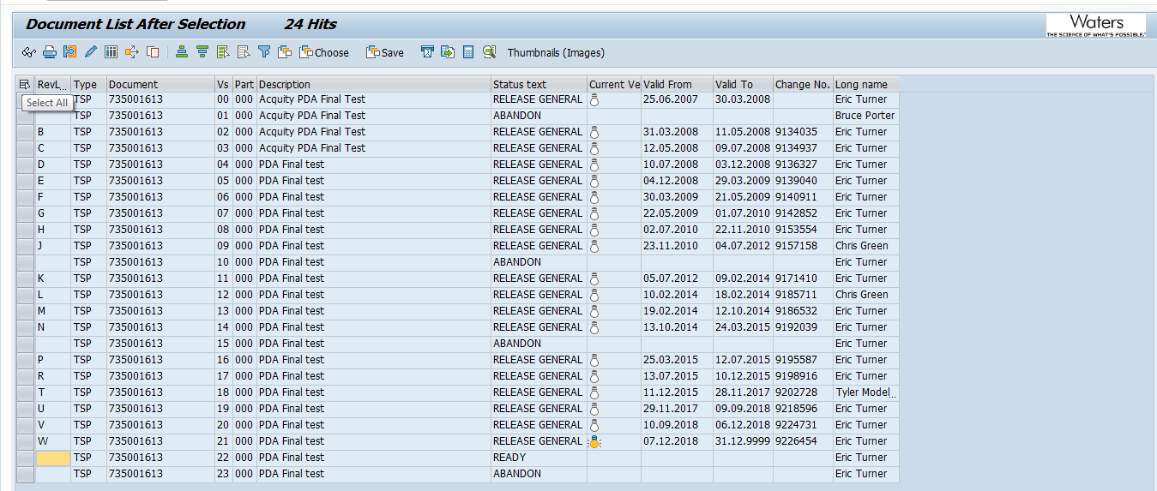

The PDA Linearity Test System Preventive Maintenance Procedure, 735003030, Version 00/Revision A, was confirmed to be in SAP with a status of Release General. A screen capture is provided below:
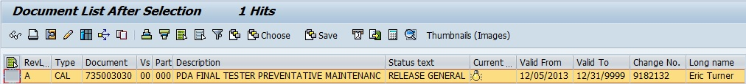

Test Script IQ-04, Test Software and Instrument Firmware Version, was performed in accordance with Installation Qualification Protocol, 730004135, Version 02, for the updated software version 4.2, as outlined in TE82882-10JUN19-VAF.

IQ-04, Test Software and Instrument Firmware Version Data Sheet, is provided as Attachment 7.4.

The Test Equipment Software version listed in 735001613, PDA Final Test System Test and Specification Procedure (Version 22), is 4.2 and was verified to match the revision (listed as Revision on the Operator Interface) displayed on the Test Equipment PDA Final Test System TE82882 program display, as shown in the screen capture below:
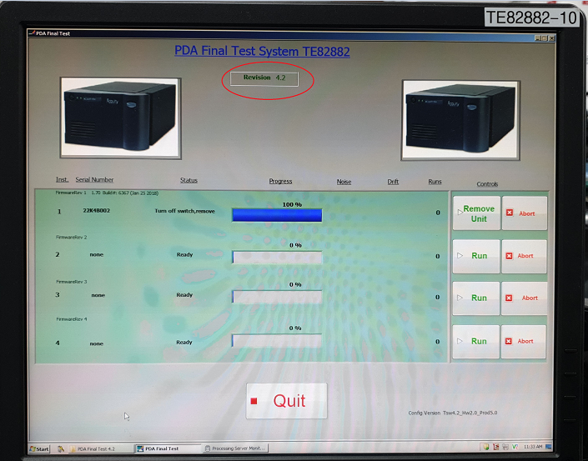

Test Script IQ-06, Functional Verification, was performed in accordance with Installation Qualification Protocol, 730004135, Version 02, for the updated software version 4.2, as outlined in TE82882-10JUN19-VAF.

IQ-06, Functional Verification Data Sheet is provided as Attachment 7.5.

One (1) UUT, Part Number 700012243, was tested using the TE82882-10, 2998 Final Test System, and met the requirement of obtaining a Final Test Record with the UUT Serial Number correctly listed at the bottom of the Test Record.

The Instrument Final Test Record is provided as Attachment 7.6.

One (1) UUT, Part Number 700012245, was tested using the TE82882-10, 2998 Final Test System, and met the requirement of obtaining a Final Test Record with the UUT Serial Number correctly listed at the bottom of the Test Record.

The Instrument Final Test Record is provided as Attachment 7.7.

A summary of the attached objective evidence that applies to each Test Script is provided in the Table below:
Script or Section | Pass/Fail | Objective Evidence | Deviations
IQ-01 | Pass | Attachment 7.3 | None
IQ-04 | Pass | Attachment 7.4 | None
IQ-06 | Pass | Attachment 7.5, 7.6 and 7.7 | None

Attachments

Completed Executor Training Record 730004135, Ver.02

Completed Operator Training Record 735001613, Ver.22

IQ-01, Associated Documentation Verification Test Script Data Sheet

IQ-04, Test Software and Instrument Firmware Version Test Script Data Sheet

IQ-06, Functional Verification Test Script Data Sheet

Instrument Final Test Record for IQ-06, Part Number: 700012243, Serial Number: 22K6P003

Instrument Final Test Record for IQ-06, Part Number: 700012245, Serial Number: 22K4B002

Deviation from Test Equipment Qualification
There were no deviations generated during the execution of the Installation Qualification, 730004135, Version 02, for the 2998 Final Test System (TE82882-10), as outlined in the Test Software Version 4.2 risk assessment, per TE82882-10JUN19-VAF.

References
The current approved versions of the following documents are referenced within this Report:
Document Number | Document title
730004135 | Installation Qualification Protocol
735001613 | PDA Final Test System Test and Specification Procedure
735003437 | PDA Linearity Test System Preventive Maintenance Procedure
TE82882-10JUN19-VAF | Test Software Version 4.2 risk assessment

