Installation qualification REPORT
For the PDA/eLambda Linearity Tester (TE82969-1)

PREPARED BY
Name | Role | Signature | Date
Luo HuaZhen | Senior Test Engineer

REVIEWED BY
Name | Role | Signature | Date
Eric Turner | Principle Test Engineer

APPROVED BY
Name | Role | Signature | Date
Kah Chin Tan | Senior Quality Assurance Manager

The “Prepared By” signature denotes that this document accurately describes the qualification activities.

The “Reviewed By” signature denotes agreement with the description of the qualification activities.

The “Approved By” signature denotes that this document has been reviewed and approved for overall quality and completeness.

REVISION HISTORY
Version | Author | Summary of change
00 | Emma Pierce | First document for approval.
01 | Luo HuaZhen | Firmware Update.
02 | Luo HuaZhen | New software version to add the 30mg concentration test.
03 | Luo HuaZhen | New software version to add Optics Bench part numbers

Purpose
The PDA/eLambda Linearity Tester, TE82969-1, is located in Flextronics Contract Manufacturing Site of WPPL in Singapore. The PDA/eLambda Linearity Tester is is used to verify that linearity of PDA Detectors of the following part numbers is within specification: 186015026, 186002998, 186015032, 186015033, 186015030, 186299800, 186017003, 186017013, 186015034, and 186015053 as well as the spares and refurbished equivalent parts as listed in the PDA Final Test TSP 735001613. Note that not all part numbers have a refurbished equivalent or spare. After the UUT has completed the firmware download at the PDA Detector Download Station (TE83057) and has passed the linearity test, it is moved to the 2998 Final Test System (TE82882) to test noise, drift, and optics.

Scope of Report
This Installation Qualification Report details the qualification activities undertaken for the PDA/eLambda Linearity Tester (TE82969-1) based on the requirements of the performed Installation Qualification, 730004135, Version 02 as outlined by the Test Software Version 2.2 risk assessment, per TE82969-10JUN2019-VAF.
The risk assessment, based on this change, resulted in the requirement of performing the following test scripts:
- IQ-01 Associated Documentation Verification: To verify that the PDA Final Test, Test and Specification Procedure, 735001613, that references the new software version, 2.2, is in the appropriate state in SAP.
- IQ-04 Test Software Version: To verify the version specified within the PDA Final Test, Test and Specification Procedure, 735001613, matches the version of the program.
- IQ-06 Functional Verification: To verify that the functionality of the system when running the new part numbers.
All other testing performed, as detailed in TE82969-1-IQR, Iteration 00, remains valid and applicable.

Summary of Results - Statement of Fitness for Intended Use
The PDA/eLambda Linearity Tester (TE82969-1) was tested in accordance with the applicable sections of the Installation Qualification Protocol, 730004135, Version 02, as outlined in the Test Software Version 2.2 risk assessment, per TE82969-10JUN2019-VAF. All required Test Scripts were performed and all objective evidence requirements have been met.
Waters now has the necessary documentation in place to ensure that the PDA/eLambda Linearity Tester (TE82969-1) remains compliant with Waters’ requirements, the latest relevant quality system regulations, and cGMP practices.
Following the approval of this Qualification Report, the PDA/eLambda Linearity Tester (TE82969-1) remains fully qualified and fit for intended use post the change, as outlined in TE82969-10JUN2019-VAF.

Glossary
The following definitions are used in this document:
Term | Explanation
cGMP | Current Good Manufacturing Practice
IQ | Installation Qualification
IQR | Installation Qualification Report
mg | Milligram
PDA | Photo Diode Array
SAP | Enterprise Resource Planning (ERP) software
TSP | Test Specification and Procedure
UUT | Unit Under Test
VAF | Validation Assessment Form

Training
The Executor who performed the PDA/eLambda Linearity Tester (TE82969-1) Installation Qualification was trained according to the Installation Qualification Procedure, 730004135, Version 02. The training record is proved as Attachment 7.1.
The Operator who performed the testing of the UUT using the PDA/eLambda Linearity Tester (TE82969-1) per Installation Qualification Procedure, 730004135, Version 02, IQ-06, Functional Verification Test Script, was trained according to the PDA Final Test System Test and Specification Procedure, 735001613, Version 22. The training record is proved as Attachment 7.2.

Qualification Results

Test Script IQ-01, Associated Documentation Verification, was performed in accordance with Installation Qualification Protocol, 730004135, Version 02, for the PDA Final Test System Test and Specification Procedure, 735001613, as outlined in TE82969-10JUN2019-VAF.

IQ-01, Associated Documentation Verification Data Sheet, is provided as Attachment 7.3

The updated PDA Final Test System Test and Specification Procedure, 735001613, Version 22, was confirmed to have been updated with software version 2.2 and to be in SAP with a status of Ready. A screen capture is provided below:
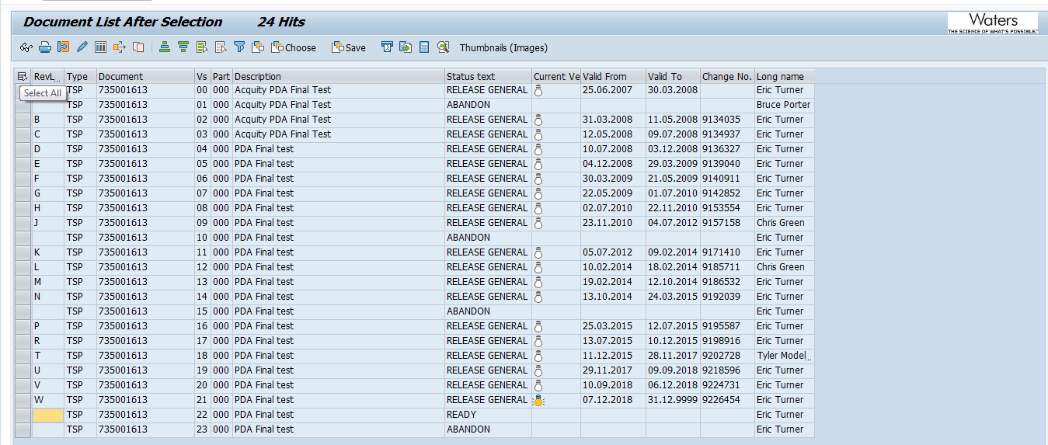

The PDA Linearity Test System Preventive Maintenance Procedure, 735003437, Version 00, was confirmed to be in SAP with a status of Release General. A screen capture is provided below:
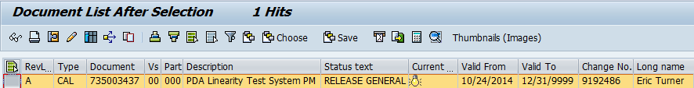

Test Script IQ-04, Test Software and Instrument Firmware Version, was performed in accordance with Installation Qualification Protocol, 730004135, Version 02, for the updated software version 2.2, as outlined in TE82969-10JUN2019-VAF.

IQ-04, Test Software and Instrument Firmware Version Data Sheet, is provided as Attachment 7.4.

The Test Equipment Software version listed in 735001613, PDA Final Test System Test and Specification Procedure (Version 22), is 2.2 and was verified to match the version displayed on the PDA/eLambda Linearity Tester TE82969 program display, as shown in the screen capture below:
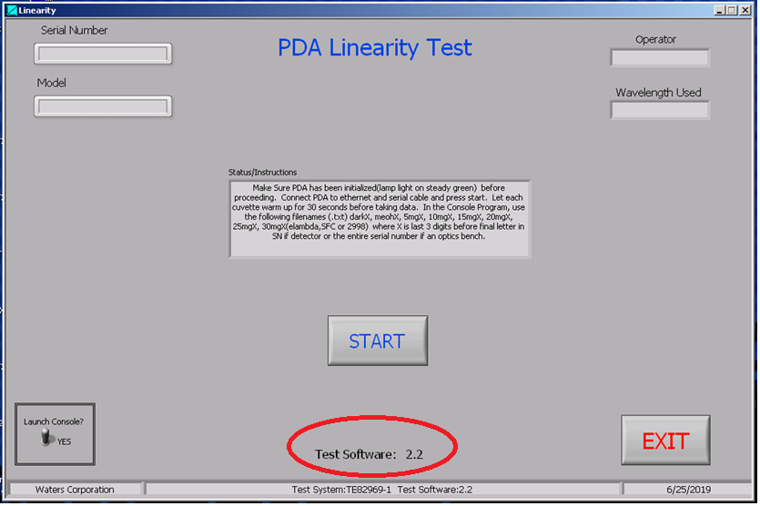

Test Script IQ-06, Functional Verification, was performed in accordance with Installation Qualification Protocol, 730004135, Version 02, for the updated software version 2.2, as outlined in TE82969-10JUN2019-VAF.

IQ-06, Functional Verification Data Sheet is provided as Attachment 7.5.

One (1) UUT, Part Number 700012245, as required by TE82969-10JUN2019-VAF, was tested using the TE82969-1, PDA/eLambda Linearity Tester, and met the requirement of functionality test and reporting it properly on the Test Record.

The Instrument Test Record is provided as Attachment 7.6.

One (1) UUT, Part Number 700012243, as required by TE82969-10JUN2019-VAF, was tested using the TE82969-1, PDA/eLambda Linearity Tester, and met the requirement of functionality test and reporting it properly on the Test Record.

The Test Record is provided as Attachment 7.7.

A summary of the attached objective evidence that applies to each Test Script is provided in the Table below:
Script or Section | Pass/Fail | Objective Evidence | Deviations
IQ-01 | Pass | Attachment 7.3 | None
IQ-04 | Pass | Attachment 7.4 | None
IQ-06 | Pass | Attachment 7.5,7.6 and 7.7 | None

Attachments

Completed Executor Training Record 730004135, Ver.02

Completed Operator Training Record 735001613, Ver.22

IQ-01, Associated Documentation Verification Test Script Data Sheet

IQ-04, Test Software and Instrument Firmware Version Test Script Data Sheet

IQ-06, Functional Verification Test Script Data Sheet

Final Test Record for IQ-06, Part Number: 700012243, Serial Number: 22K6P003

Final Test Record for IQ-06, Part Number: 700012245, Serial Number: 22K4B002

Deviation from Test Equipment Qualification
There were no deviations generated during the execution of the Installation Qualification, 730004135, Version 02, for the PDA/eLambda Linearity Tester (TE82969-1), as outlined in the Test Software Version 2.2 risk assessment, per TE82969-10JUN2019-VAF.

References
The current approved versions of the following documents are referenced within this Report:
Document Number | Document title
730004135 | Installation Qualification Protocol
735001613 | PDA Final Test System Test and Specification Procedure
735003437 | PDA Linearity Test System Preventive Maintenance Procedure
TE82969-10JUN2019-VAF | Test Software Version 2.2 risk assessment

