DOCUMENT TITLE: ACQUITY CMA Test Procedure
SYSTEM/ASSEMBLY NAME: ACQUITY CMA
PART NUMBER AFFECTED 186015043, 186015038, N2971034, 800000311, 800000434
TEST EQUIPMENT NAME: ACQUITY CMA Test System
TEST EQUIPMENT NUMBER: TE83026
TEST SOFTWARE: *1.3*

AUTHOR(S): Ramki Tirur | DATE: July 19, 2010
REVISED BY: Matt Brule | DATE: May 19, 2017

Equipment Required
Quantity | Part Number | Description
1 | TE83026 | AcQuity CMA Test system
2 | N/A | Valve pods Any type will do for torque load
1 | N/A | eCord (cut from discarded column)
2 | 279003049 | APH assemblies (must be electrically functional, no tubing required), 27003049 is an example, any APH will work.

Disposables Required
Quantity | Part Number | Description
N/A | N/A | N/A

reference documentation
Document # | Description
WAT046538 | Electrical Safety Procedure
GP #226 | Functional Specification for Column Manager (CM-A/CHC-A) GP#226, Project Documentation Archives

Definitions and Abbreviations
Term | Definition
CMA, CM-A | Column Manager - Active
nL | Nano Liters
LSL | Lower Specification Limit
USL | Upper Specification Limit
PSC | Production Support Check
CM | Column Manager
CHC-A | Column Heater Cooler – Active
UPLC | Ultra Performance Liquid Chromatography
IVD | In Vitro Diagnostic
UUT | Unit Under Test
LED | Light Emitting Diode
BOM | Bill of Materials
DOS | Disk Operating System (PC operating system)
RS232 | Recommend Standard number 232 (serial communication standard)
Aux | Auxiliary
USB | Universal Serial Bus (Serial communication standard)
PC | Personal Computer
AC | Alternating Current
COM | Communications (port)
APH | Active Pre-Heater
NVRAM | Non-Volatile Random Access memery

Test SPecifications and Traceability Matrix
Test # | Test Specification & Condition | Acceptance  Criteria | Reference
1 | Electrical safety tests | Pass | WAT046538
2 | Fan Check  Operator verifies that the fan is drawing air into the right side of the UUT | Pass | Functional Specification for Column Manager (CM-A/CHC-A) GP#226 Sec. 5.1.20
3 | Firmware Load | Firmware Loaded | UUT firmware is installed per BOM in SAP. See affected P/N(s) on cover sheet.
4 | Ethernet Port  The Ethernet Port is verified using the DOS ping command | Pass | Functional Specification for Column Manager (CM-A/CHC-A) GP#226 Sec. 5.1.15
5 | Front Panel LED  The operator is asked to verify that the Power LED is illuminated green, and that the Run LED blinks red and green. | Pass | Functional Specification for Column Manager (CM-A/CHC-A) GP#226 Sec.5.1.14, 5.2.3.2
6 | Column LED Test  The operator is asked to verify that each of the column LEDs write both red and green | Pass | Functional Specification for Column Manager (CM-A/CHC-A) GP#226 Sec.5.1.14, 5.2.3.5
7 | Door Switch Test  The tester verifies via RS232 that the door switch detects both open and closed condition | Pass | Functional Specification for Column Manager (CM-A/CHC-A) GP#226 Sec.5.1.13
8 | E-cord 3  The system reads that an installed eCord is able to be read | Pass | Functional Specification for Column Manager (CM-A/CHC-A) GP#226 Sec.5.1.14
9 | E-cord 4  The system reads that an installed eCord is able to be read | Pass | Functional Specification for Column Manager (CM-A/CHC-A) GP#226 Sec.5.1.14
10 | E-cord 5  The system reads that an installed eCord is able to be read | Pass | Functional Specification for Column Manager (CM-A/CHC-A) GP#226 Sec.5.1.14
11 | E-cord 6  The system reads that an installed eCord is able to be read | Pass | Functional Specification for Column Manager (CM-A/CHC-A) GP#226 Sec.5.1.14
12 | Serial Number  The UUT serial number Is written to NVRAM. | Pass | PSC - preparation for customer use
13 | Fuses  The status of the DC fuses in the UUT is verified. | Pass | PSC  Early detection of an issue before further testing
14 | Leak Detector Test  The tester simulates a leak detector present and leak / no leak | Pass | Functional Specification for Column Manager (CM-A/CHC-A) GP#226 Sec.5.1.10
15 | Pre-Heater 1  The pre-heater interface on the UUT is verified by connecting a test pre-heater to the interface, and verifying the ID, reading the temperature and exercising the heater, fully testing the interface. | Pass | Functional Specification for Column Manager (CM-A/CHC-A) GP#226 Sec.5.1.3
16 | Pre-Heater 2  The pre-heater interface on the UUT is verified by connecting a test pre-heater to the interface, and verifying the ID, reading the temperature and exercising the heater, fully testing the interface. | Pass | Functional Specification for Column Manager (CM-A/CHC-A) GP#226 Sec.5.1.3
17 | Pre-Heater 3  The pre-heater interface on the UUT is verified by connecting a test pre-heater to the interface, and verifying the ID, reading the temperature and exercising the heater, fully testing the interface. | Pass | Functional Specification for Column Manager (CM-A/CHC-A) GP#226 Sec.5.1.3
18 | Pre-Heater 4  The pre-heater interface on the UUT is verified by connecting a test pre-heater to the interface, and verifying the ID, reading the temperature and exercising the heater, fully testing the interface. | Pass | Functional Specification for Column Manager (CM-A/CHC-A) GP#226 Sec.5.1.3
19 | Upper AUX  A CM-AUX is connected to the interface. The Temperature is read and two connected E-Cords are verified present, full testing the Aux interface. | Pass | Functional Specification for Column Manager (CM-A/CHC-A) GP#226 Sec.5.1.16
20 | Lower Aux  A CM-AUX is connected to the interface. The Temperature is read and two connected E-Cords are verified present, full testing the Aux interface. | Pass | Functional Specification for Column Manager (CM-A/CHC-A) GP#226 Sec.5.1.16
21 | Heater Cooler 1  The heater cooler is driven from ambient to 90°C, then to 4°C, then back to ambient | Pass | Functional Specification for Column Manager (CM-A/CHC-A) GP#226 Sec.5.1.1
22 | Heater Cooler 2  The heater cooler is driven from ambient to 90°C, then to 4°C, then back to ambient | Pass | Functional Specification for Column Manager (CM-A/CHC-A) GP#226 Sec.5.1.1
23 | Left Valve Actuation  A valve cartridge is installed to provide appropriate load and the valve is homed | Pass | Functional Specification for Column Manager (CM-A/CHC-A) GP#226 Sec.5.1.12
24 | Right Valve Actuation  A valve cartridge is installed to provide appropriate load and the valve is homed | Pass | Functional Specification for Column Manager (CM-A/CHC-A) GP#226 Sec.5.1.12
Refer to Functional Specification for Column Manager (CM-A/CHC-A) GP#226 archive document that is stored in Project Documentation Archives by Instrument Design Group, provided upon request.

This procedure assumes that the operator has a basic knowledge of personal computer operation in a Microsoft Windows environment.
All figures in this procedure are for reference only and may differ from actual screens etc.

To shut down a test workstation:
Close all programs.
Click on Start.
Shut Down.
Select Shut Down the Computer?
Select Yes.

Failure to follow these instructions may result in workstation damage.

Test System Setup
Setup TE83026 PC with monitor / keyboard / mouse / barcode scanner (all USB).
Connect relay controller to a USB port.
Connect the power pack to the relay module
Connect the AC power controller to COM2 of the PC.
Connect The AC power controller to appropriate power source.
Connect the PC to the network.
Power up the PC
Login to Windows
Launch the TE83026 test program from the desktop or Start menu.

Test System Controls
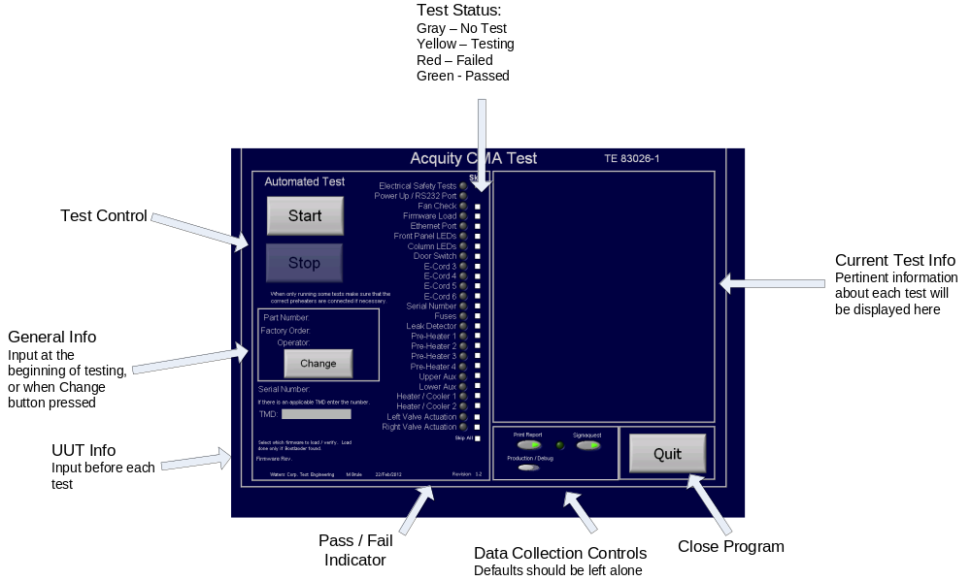
Figure 1 (Reference Only)

UUT connections:
COM1, Instrument LAN, line cord from controller, leak detector cable.
- Electrical Safety Test
  - Perform per procedure WAT046538.
- UUT Test Setup
  - Connect the power cord from the AC power controller to the UUT.
  - Connect the 9 pin serial cable from COM 1 to COM B on the UUT.
  - Connect the Ethernet cable from the Instrument LAN to the UUT.
  - Connect the 3 pin leak detector cable from the test system to the UUT.
  - Install 2 valve pods in the UUT.
  - Connect position 8 of the jumper header in the personality card inside the UUT.
- Test
  - Press the Start Button under Automated test with the mouse.
  - Follow the on-screen instructions and supply the requested data, by scanning with the barcode scanner or typing. If something is entered that the tester does not support or recognize, the system will prompt for the input to be repeated.
The test will proceed sequentially through each of the tests listed in the “Test Status” list. Pertinent test information will be displayed. Follow all instructions to complete testing. When the test is complete a Test Record will be generated, data will be written to the Sigmaquest data collection system. Either pass or fail will be displayed (see Figure 1 for test screen layout).
  - Push the QUIT button on the test screen.
  - Disconnect the following things:
    - Auxiliary cable from the UUT.
    - Remove pre-heaters.
    - Remove I-Buttons
    - Remove serial jumper.
    - Remove 2 Valve pods.
  - When the test is complete:
    - Push the UUT power button to power it off.
    - Disconnect all cables.
    - Remove the shorting plug.
  - Verify that the UUT passed, mark the test record accordingly, and sign.

Hardware Locations for reference.
