DOCUMENT TITLE: Test Proc., Assy, Veyron CMS
SYSTEM/ASSEMBLY NAME: ACQUITY Single Zone Column Manager
PART NUMBER AFFECTED 186015054, 800000447
TEST EQUIPMENT NAME: Column Manager Test System
TEST EQUIPMENT NUMBER: TE0083026
TEST SOFTWARE: *1.0*

AUTHOR(S): B. Abcunas | DATE: June 20, 2013
REVISED BY: Matt Brule | DATE: June 12, 2017

Equipment Required
Quantity | Part Number | Description
1 | TE0083026 | Column Manager Test System
1 | 279001874 | Active Pre-Heater (APH)
1 | N/A | eCord ID button

reference documentation
Document # | Description
721004439 | FSD Veyron CM-S Column Manager
WAT046538 | GENERIC Electrical SafetyTest PROC.
810000478 | PERF SPEC, PCB, CM-A PERSONALITY BOARD

Definitions and Abbreviations
Term | Definition
FSD | Functional Specifications Document
APH | Active Pre-Heater
ID | Identification
CM-S or CMS | Column Manager Single Zone
PSC | Production Support Check
UUT | Unit Under Test
AUX | Auxiliary
SAP | Enterprise Resource Planning (ERP) software
NPI | New Product Introduction
CM | Column Manager
AC | Alternating Current
LED | Light Emitting Diode
RS232 | Serial Communication Transmission Protocol
e-Cord | I-Button contained in a column tag, used to record column data
USB | Universal Serial Bus
PC | Personal Computer
COM | RS232 serial communications port
LAN | Local Area Network
ID | Identification
RTD | Resistance Temperature Detector
R&D | Research and Development
DHCP | Dynamic Host Configuration Protocol
PCB | Printed Circuit Board
TE | Test Engineering

Test SPecifications and Traceability Matrix
Test # | Test Specification & Condition | Acceptance criteria | Reference
1 | Electrical Safety Test | Pass / Fail | 721004439, 5.2.2.1  WAT046538
2 | Power Up / RS232 Port | Pass / Fail | PSC / Pretest Condition  721004439 5.1.19
3 | Fan Check | Air entering right side of UUT and exiting rear | 721004439, 5.1.22
4 | Firmware Load | Pass / Fail | PSC / Pretest Condition  SAP (CS03)
5 | Ethernet Port | Pass / Fail | 721004439 5.1.17
6 | Front Panel LEDs | Power LED Green  Status LED Blinking Red and Green | 721004439 5.2.3.2
7 | Column LEDs | All Column LEDs observed illuminated both reed and green | 721004439, 5.2.3.4
8 | Door Switch | Door open and door closed bit set  Pass / Fail | 721004439, 5.1.8, 5.1.14
9 | E-Cord 3 | Ecord can be initialized and read  Pass / Fail | 721004439, , 5.1.15, 5.2.3.3
10 | E-Cord 4 | Ecord can be initialized and read  Pass / Fail | 721004439, , 5.1.15, 5.2.3.3
11 | E-Cord 5 | Ecord can be initialized and read  Pass / Fail | 721004439, , 5.1.15, 5.2.3.3
12 | E-Cord 6 | Ecord can be initialized and read  Pass / Fail | 721004439, 5.1.15, 5.2.3.3
13 | Serial Number | Serial number programmed and read back  Pass / Fail | PSC, pretest condition  Internal function of instrument firmware
14 | Fuses | All fuse status registers report OK  Pass / Fail | PSC  810000478, 2.4.9.2
15 | Leak Detector | Verify leak detector inputs: present, leak, no leak  Pass / Fail | PSC  721004439, 5.1.10
16 | Pre-Heater 1 | Pre-Heater is detected and heats  Pass / Fail | PSC  721004439, 5.1.4
17 | Upper Aux | Communicate with CM-AUX instrument and read AUX Ecords  Pass / Fail | PSC  721004439, 5.1.18
18 | Lower Aux | Communicate with CM-AUX instrument and read AUX Ecords  Pass / Fail | PSC  721004439, 5.1.18
19 | Heater / Cooler | Heat to 90°C Pass / Fail  Stable within +/- 0.3°C  Cool to 4°C Pass / Fail  Stable with +/- 0.3°C | 721004439, 5.3.4  721004439, 5.3.8  721004439, 5.3.4  721004439, 5.3.8

- ELECTRICAL SAFETY TEST
Perform the Electrical Safety Test per High Pot and Ground Continuity Test Procedure, WAT046538.
Note whether the test passed or failed to log during automated test.
- Automated TEST setup
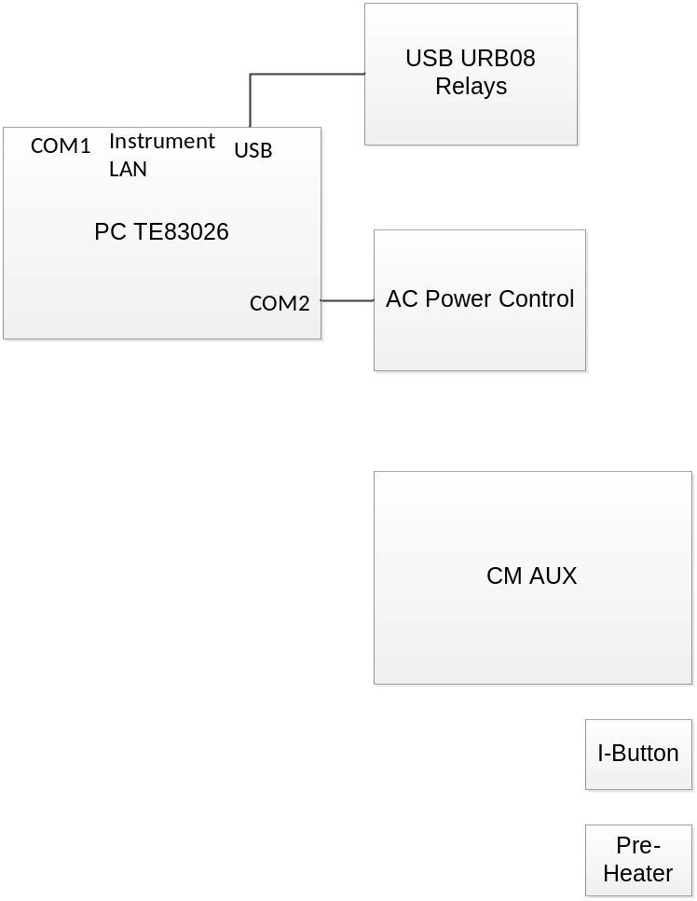
Figure 1 Test System Block Diagram
If not already connected, connect the system as shown in Figure 1 Test System Block Diagram. Note AC power connections are not shown; connect the PC, monitor, CM AUX, and AC power control to appropriate AC power source.
Power up TE 83026 and log in, if not already done.
If the test program is not already running, click the CMS icon from the start menu or the desktop.

- UUt connection
Begin here for repeat testing, where test system is already set up with test program running.
See Figure 2 Test Setup Block Diagram for connections.
Plug in the RS232 cable.
Plug in the Ethernet at Port 1.
Connect the UUT power inlet to the cord from the tester power control Module. The power must come from the tester as it is controlled by the power control module, this control is necessary for successful test.
Connect the 4 pin leak detector simulator cable to the connector on the lower right front of the UUT.

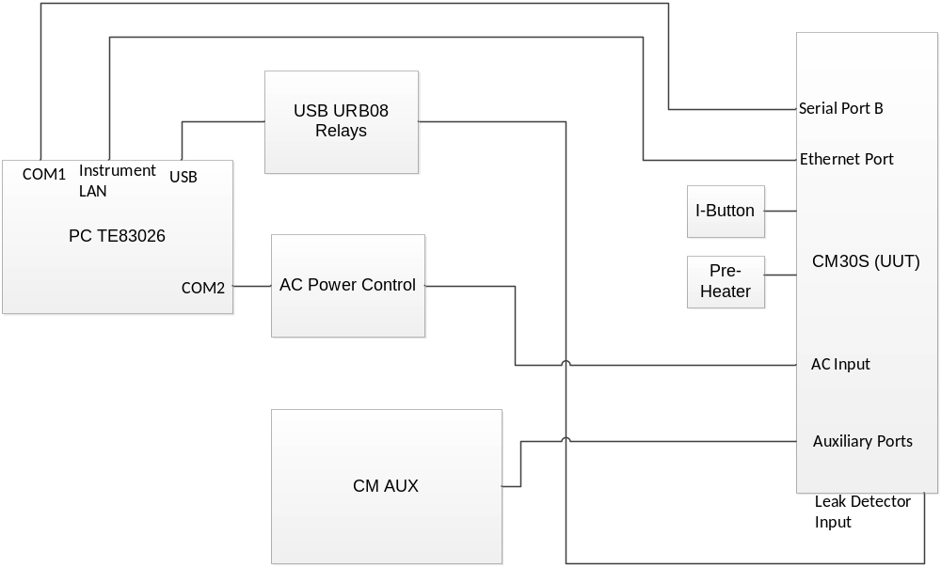
Figure 2 Test Setup Block Diagram

- Test
Press the Start Button under Automated test with the mouse.
Follow the on-screen instructions and supply the requested data, by scanning with the barcode scanner or typing. If something is entered that the tester does not support or recognize, the system will prompt for the input to be repeated.
The test will proceed sequentially through each of the tests listed in the “Test Status” list (see Figure 3). Pertinent test information will be displayed. Follow all instructions to complete testing.
When the test is complete Pass or Fail will be displayed (see Figure 3), a Test Record will be generated and printed, and data will be written to the Sigmasure data base.
When the test is complete, push the UUT power button to power it off as instructed.
Disconnect all cables, remove E-Cords and the pre-heater, as instructed, and remove from the test station.
Verify that all tests are complete and marked passed on printed test record, if so, mark the Instrument Result as Pass, sign and date test record, if not mark the instrument result as Failed, sign and date the Test Record. If any tests were skipped, the test record will not indicate Pass or Fail, but instead Incomplete.
Note: See Appendix 2 at the end of this procedure for detailed test descriptions.

- Appendix 1 Tester controls and operation
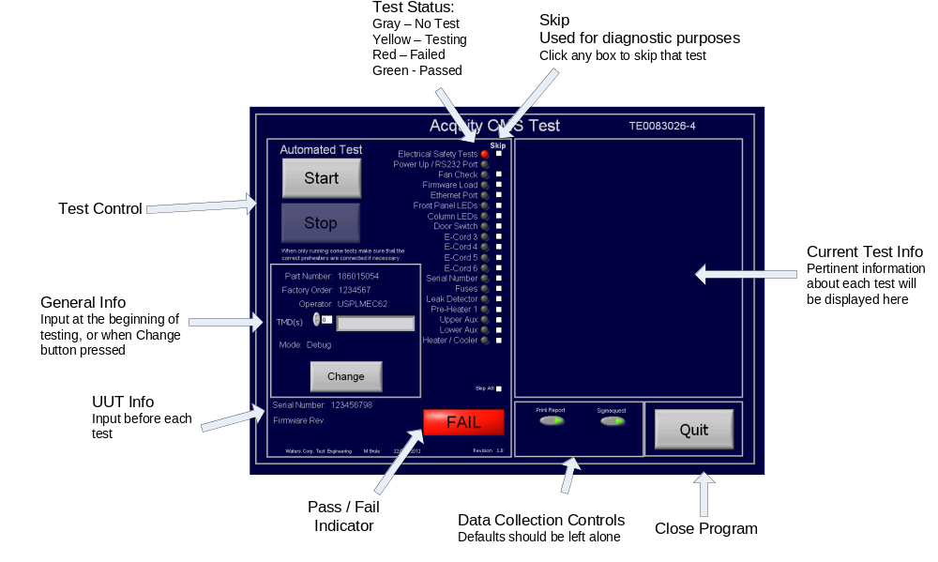
Figure 3

- Appendix 2 test descriptions
Test descriptions for the automated test performed using TE0083026.
If it is the first test since the test program has started, the tester prompts for the user the part number to be tested. The part number must be valid and included in the list expected by the system.
If it is the first test since the test program has started, the tester prompts the user for their user identification. The ID must be the users SAP ID or equivalent. Users must be added to the system by an administrator. Contact Milford Test Engineering or local engineering support to add users when necessary.
If it is the first test since the test program has started, the tester prompts the user for the Factory order of the current UUT. The factory order can be any combination alpha-numeric characters, but cannot be blank.
If it is the first test since the test program has started, the tester prompts the user for the Mode to log test data in. This assures that the test data is sent to the correct repository in SIgmasure / Camstar. A mode must be selected, the most common selection is Production, unless the operator is in Repair / Refurb or NPI, possible choices are:
Production | Manufacturing operations either within Waters or at a CM
Debug | Used by TE for test system repairs / updates / troubleshooting
Refurb | Used by Repair technicians when refurbishing an instrument for resale
Repair | Used by Repair technicians when repairing an instrument for resale
R&D Lab | Used by R&D personal for evaluation testing
New Product Introduction | Used by NPI personal
The tester then prompts for any applicable TMDs. TMDs are entered one at a time pressing the green check mark after each TMD number. Done is pressed after entering all TMDs or if there are no TMDs. TMDs must be in the form TMDxxxxxx, where xxxxx is the six-digit number in SAP.
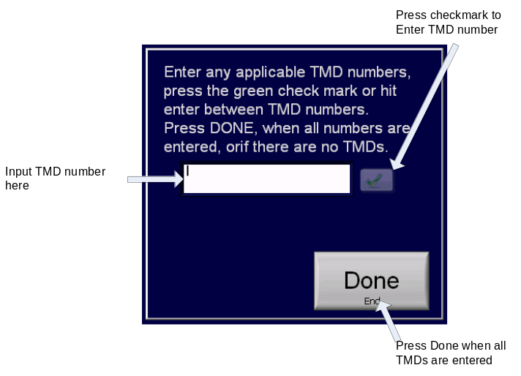
Figure 4
The user is prompted for the serial number of the UUT. The serial number must not be blank. The serial number is programmed into the UUT later in the test, written to the test record and to the database.
Electrical Safety Test. The tester asks the operator for the results of the electrical safety test (Document # WAT046538). This test is primarily for data collection, a “Yes” answer and the test progresses, a “No” answer and the test will fail and stop. All Waters’ instruments must pass electrical safety testing prior to initial power up.
Power up / RS232 Port. UUT power is applied and the tester attempts to gain control of the UUT via COM1 to the RS232 port. The operator is asked to putt UUT power switch in the on position if it is not already there. The power switch on the UUT does not provide visual or tactile indication of whether it is in the on or off position, one most note that the Power LED on the front panel is lit to confirm that the UUT is powered on.
Fan test. The tester asks the operator to verify that air is being drawn it to the right side of the UUT and blown out the rear.
Firmware Load. The tester checks the revision of the firmware in the instrument, if the unit contains only “bootloader”; it is programmed with the current revision application code. If the unit is already programmed with the current revision, the programming is skipped. If the unit is programmed and the revision is not recognized the UUT is programmed with the correct revision. The tester uses the “loader” application to program the firmware through the Ethernet port using a fixed default IP address. The fixed IP address is then reset back to the default (DHCP) after completion of the Ethernet port test.
Ethernet Port, the tester communicates to the UUT via its Ethernet port. If the communication is successful the test passes. Communication is verified using the second Instrument LAN in the test system to “ping” the UUT’s Ethernet address, using windows command line. Prior to doing this the Ethernet options of the UUT are set and the IP address is set.
Commands: Setipflags N F, this disables DHCP and sets the UUT to its default IP address. The “setnetdefaults” command is used to return the UUT to its default DHCP enabled state.
Front Panel LEDs. The tester will prompt the operator to look at the “POWER” LED on the front panel and verify that it is lit green. The tester will then prompt the operator to verify that the “RUN” LED on the front panel is alternating between red and green. The tester uses the “poke” command to write to memory location 0x5000B3, and 0x5000BC are written repeatedly to alternate the RUN LED between red and green.
Column LEDs. The tester will prompt the operator to verify that the column LEDs inside the door all display both red and green. The tester uses the “poke” command to write to memory location 0x5000B2, 170 and 85 are written repeatedly to alternate the RUN LED between red and green.
Door Switch. The system verifies that the door latch actuates the door closed switch when closed and that it does not when open. The operator is instructed when to open and close the door, and the test system read the status of memory location 0x500051 to verify the status.
Ecord Tests (3-6). The operator will be prompted to install an Ecord provided with the test system on each of the 4 ports in succession. It is important that the Ecords are installed at this time, not earlier in the test, or test failures will result. The system will then read each Ecord to verify the interface. The test system uses the ECordPresent command to verify that each ECord is installed.
Serial Number. The UUT serial number is written to its non-volatile memory via the RS232 port, using the “setserial” commend. The serial number is then verified with the “showserial” command.
Fuses. The system verifies that all fuses on the personality card are functioning, using the “fuses” command via the RS232 port.
Leak Detector. The leak detector interface is verified using the “leakdetector” command via the RS232 port to check the leak detector status, and relays driven by the USB bus to toggle the leak detector present and leak bits.
Upper Aux. The test system asks the operator to connect the system CM AUX to the upper port. Communication with the unit and it’s attached Ecords is verified, fully testing the interface.
Lower Aux. The test system asks the operator to connect the system CM AUX to the lower port. Communication with the unit and it’s attached Ecords is verified, fully testing the interface.
Heater / Cooler. The Test system commands the UUT via the RS232 port to heat to 90 degrees C, then cool to 4 degrees C, then returns to ambient.
The test verifies that both heaters are running and that both RTDs are connected, by comparing temperatures. Stability within 0.3 degrees C is verified at both 90 and 4 degrees. If the test does not complete due to failure, the pass / fail indicators on the right side of the test screen indicate what part of the test failed to aid in troubleshooting.
If a test fails, resulting invalid data is recorded on the Instrument Final Test Record and in the Sigmasure / Camstar database as -9999.
Figure 5 below illustrates and describes the heater cooler test screen controls and indicators.
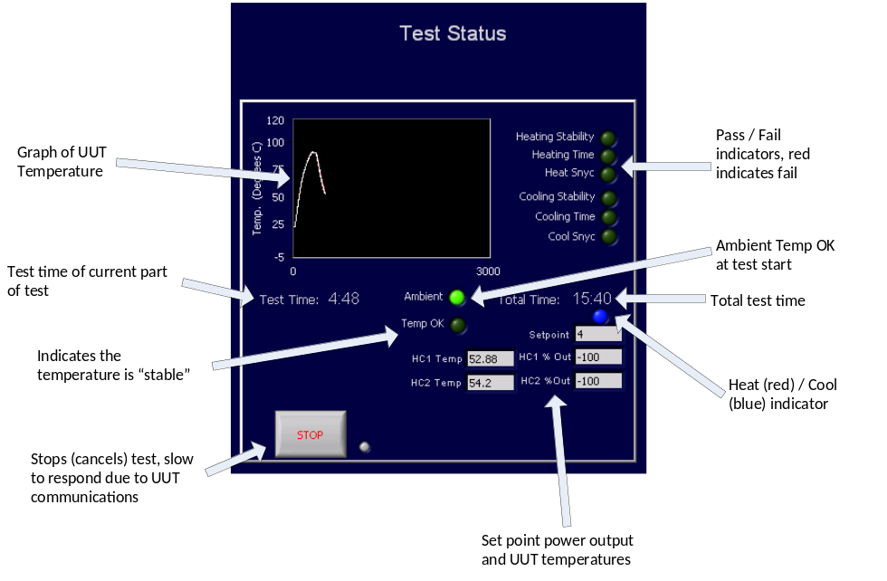
Figure 5

