Equipment design verification REPORT
For the Column Manager Test System (CM-S Program)

PREPARED BY
Name | Role | Signature | Date
James J. Stors | Senior Test Validation Engineer

REVIEWED BY
Name | Role | Signature | Date
Matt Brule | Senior Test Engineering

APPROVED BY
Name | Role | Signature | Date
Andre Kopoyan | Senior Operations Quality Engineer

The “Prepared By” signature denotes that this document accurately describes the verification activities.
The “Reviewed By” signature[s] denotes agreement with the description of the verification activities.
The “Approved By” signature denotes that this document has been reviewed and approved for overall quality and completeness.

REVISION HISTORY
Version | Author | Summary of change
00 | James J. Stors | First document for approval

Purpose
The TE0083026 Column Manager Test System (CM-S Program) is used to perform a final test of the Veyron CM-S product line by performing the following functions:
- Operator verification of the performance of an Electrical Safety Test per WAT046538, Electrical Safety Test Procedure, fan intake/exhaust, and Front Panel/Column LEDs.
- RS232 and Ethernet communication
- Firmware verification/download
- Door switch functionality and Fuse status
- E-Cord 3 though 6 functionality
- Serial number programming
- Verification of leak detector inputs and Heater/Cooler operation
The UUT is connected to a computer running Veyron CM-S custom test software, through an RS-232 cable, an Ethernet cable, a Relay Module, and a Power Module. The Relay Module is used to test the leak detector interface and the Power Module is used to provide UUT supply power, while being controlled by the software. An optional Barcode Scanner can be connected to the computer to enable the Operator to scan in the UUT information.

Scope of Report
This Equipment Design Verification Report details the Verification activities undertaken for the TE0083026 Column Manager Test System (CM-S Program) based on the requirements of the executed protocol, TE0083026-EDV, Iteration 00.
This Equipment Design Verification Report defines the documents used to verify the TE0083026 Column Manager Test System (CM-S Program), including 735002932 – Veyron CM-S Final Test Test and Specification Procedure (TSP).

Summary of Results - Statement of Fitness for Intended Use
The TE0083026 Column Manager Test System (CM-S Program) was tested in accordance with TE0083026-EDV, Iteration 00. All Test Scripts were performed and all objective evidence requirements have been met.
Waters now has the necessary documentation in place to ensure that the TE0083026 Column Manager Test System (CM-S Program) design complies with Waters’ requirements, the latest relevant quality system regulations, and cGMP practices.
Following the approval of this verification Report, the TE0083026 Column Manager Test System (CM-S Program) design can be considered fully verified and fit for intended use.

Glossary
The following definitions are used in this document:
Term | Explanation
cGMP | Current Good Manufacturing Practice
EDV | Equipment Design Verification
EDVR | Equipment Design Verification Report
TSP | Test Specification and Procedure
CM-S | Column Manager Single Zone
UUT | Unit Under Test
LED | Light-Emitting Diode
USB | Universal Serial Bus
BOM | Bill of Material
SAP | Enterprise Resource Planning (ERP) software
E-Cord (I-Button) | One wire memory device used on Waters’ columns

Training
The Executor of the TE0083026-EDV, Column Manager Test System (CM-S Program) Equipment Design Verification, is the Author and is trained to the protocol. The Executor was trained to 735002932, Veyron CM-S Final Test - Test and Specification Procedure (TSP), and a Training Record is provided as Attachment 7.1.

Verification Results

Test Script EDV-01, Specification and Functional Verification, was performed in accordance with Equipment Design Verification Protocol, TE0083026-EDV, Iteration 00.

EDV-01, Specification and Functional Verification Test Script Data Sheet, is provided as Attachment 7.2.

The Bar Code Reader test met the acceptance requirement of the correct serial number being input into the program post scanning using the optional Bar Code Reader.
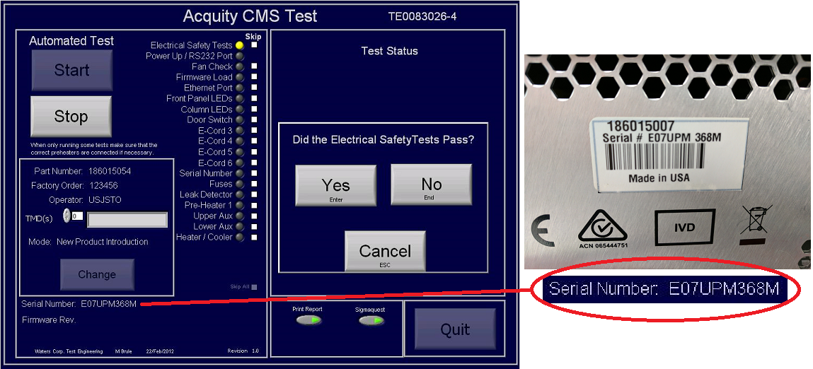

All tests passed and met the acceptance requirement of displaying a green “Pass” indicator on the Operator Interface display and a Pass result on the Final Test Report.

A screen capture of the Operator Interface display indicating all tests with a green “Pass” indicator is provided below:

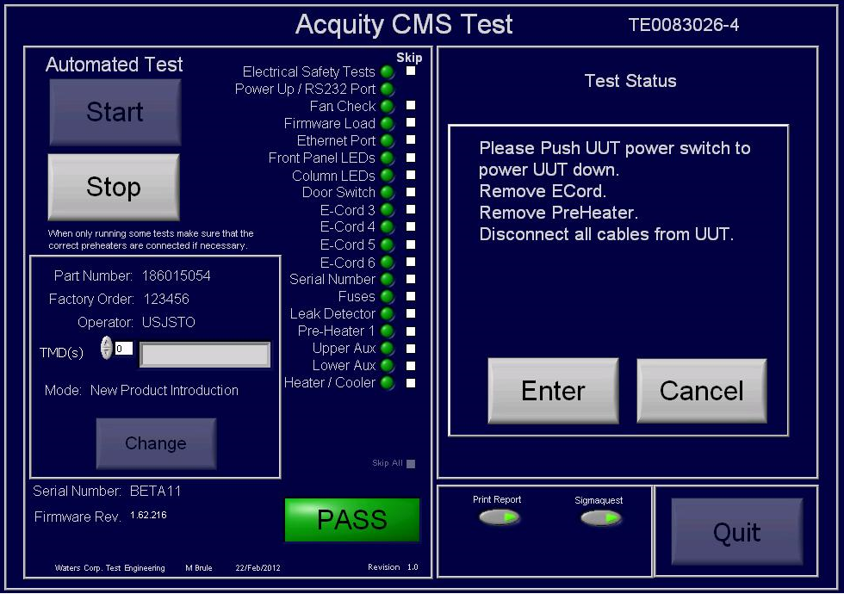

A screen capture of the Firmware Version verification, which met the requirement of loading Firmware Version 1.62.216 onto the UUT, as specified in the 186015054, ACQUITY Single Zone Column Manager Bill of Material, is provided below:
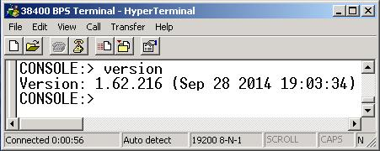

A screen capture of the UUT serial number verification, which met the requirement of writing the specified serial number “BETA-11” to the UUT, is provided below:
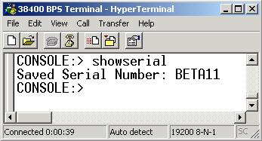

A copy of the Final Test Record for Test Script EDV-01 is provided as Attachment 7.3.

Test Script EDV-02, Fault Insertion Test, was performed in accordance with Equipment Design Verification Protocol, TE0083026-EDV, Iteration 00.

EDV-02, Fault Insertion Test, Test Script Data Sheet, is provided as Attachment 7.4.

The Electrical Safety Fault Insertion Test met the acceptance requirement of displaying a red “Fail” indicator on the Operator Interface display and a Fail result on the Final Test Report.

A screen capture of the Operator Interface display indicating a red “Fail” indicator for the Electrical Safety Fault Insertion Test is provided below:
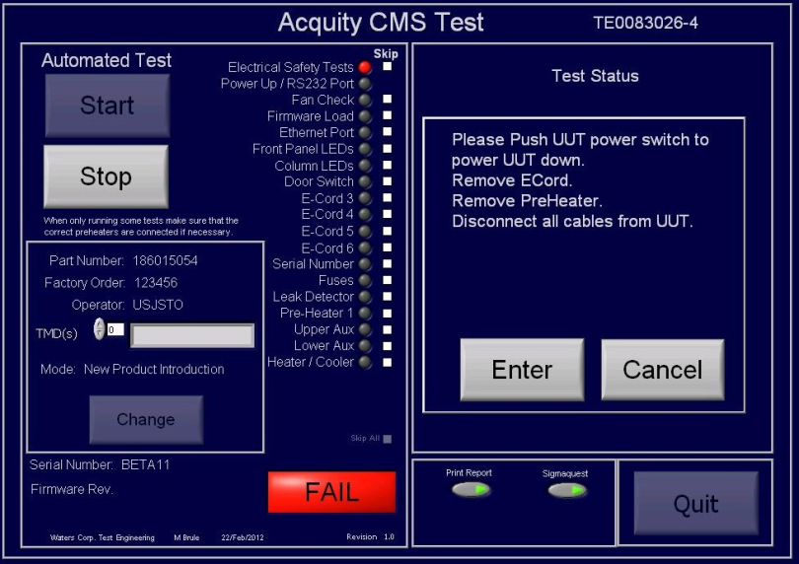

A copy of the Final Test Record for the Electrical Safety Fault Insertion Test is provided as Attachment 7.5.

The Power Up/RS232 Port Fault Insertion Test met the acceptance requirement of displaying a red “Fail” indicator on the Operator Interface display and a Fail result on the Final Test Report.

A screen capture of the Operator Interface display indicating a red “Fail” indicator for the Power Up/RS232 Port Fault Insertion Test is provided below:
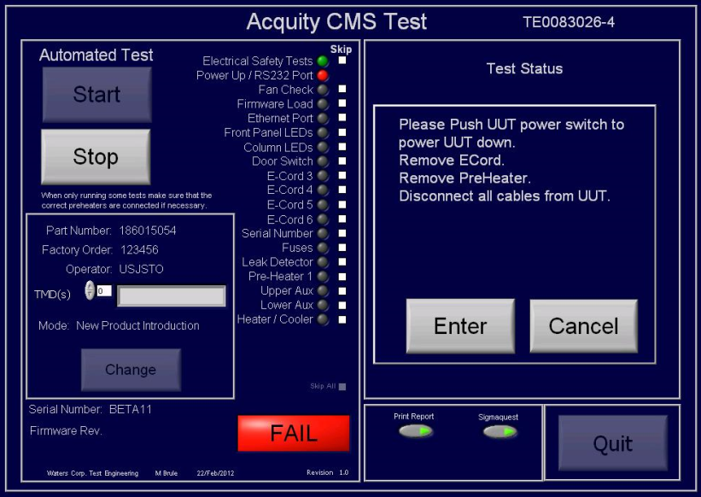

A copy of the Final Test Record for the Power Up/Serial Port Fault Test is provided as Attachment 7.6.

The Fan Check Fault Insertion Test met the acceptance requirement of displaying a red “Fail” indicator on the Operator Interface display and a Fail result on the Final Test Report.

A screen capture of the Operator Interface display indicating a red “Fail” indicator for the Fan Check Fault Insertion Test is provided below:
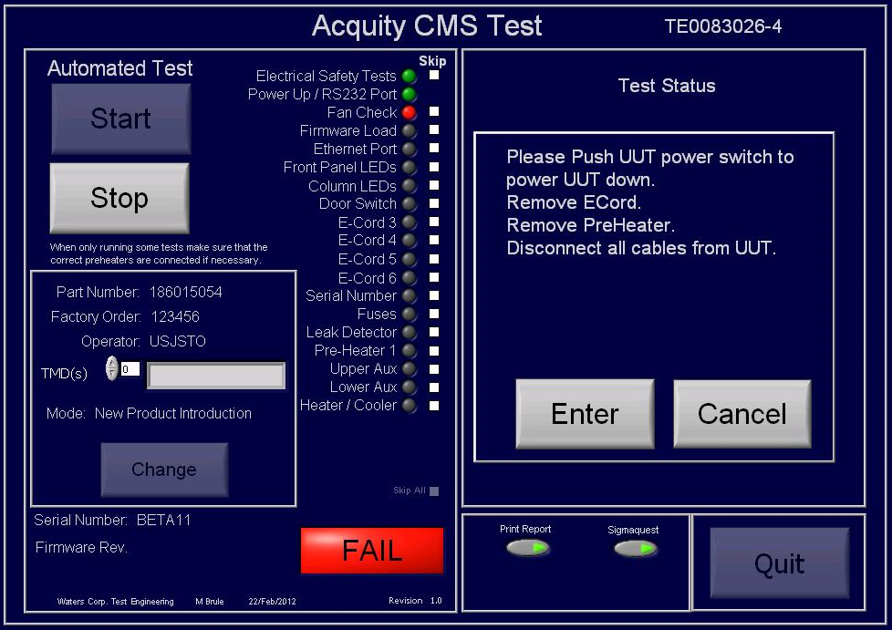

A copy of the Final Test Record for the Fan Fault Test is provided as Attachment 7.7.

The Ethernet Port Fault Insertion Test met the acceptance requirement of displaying a red “Fail” indicator on the Operator Interface display and a Fail result on the Final Test Report.

A screen capture of the Operator Interface display indicating a red “Fail” indicator for the Ethernet Port Fault Insertion Test is provided below:
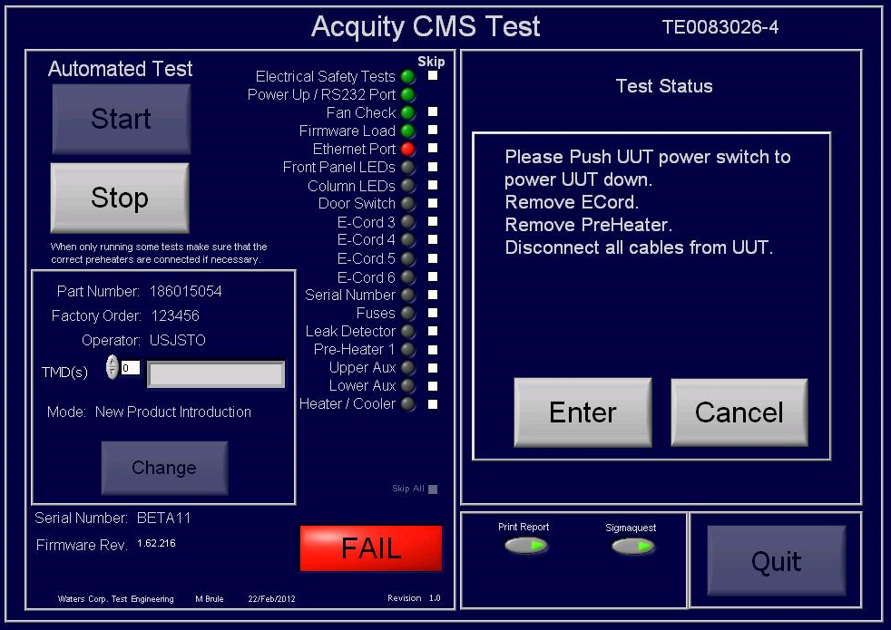

A copy of the Final Test Record for the Ethernet Port Fault Test is provided as Attachment 7.8.

The Front Panel LEDs – Power LED green - Fault Insertion Test met the acceptance requirement of displaying a red “Fail” indicator on the Operator Interface display and a Fail result on the Final Test Report.

A screen capture of the Operator Interface display indicating a red “Fail” indicator for the Front Panel LEDs, upon the insertion of the Power LED illuminated green Fault, is provided below:
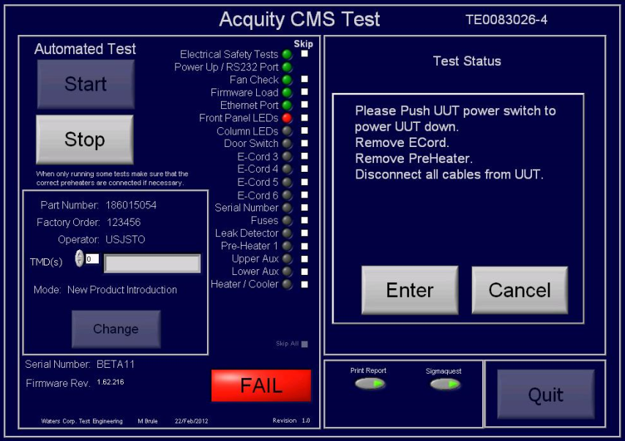

A copy of the Final Test Record for the Front Panel LEDs – Power LED illuminated green - Fault Test is provided as Attachment 7.9.

The Front Panel LEDs – Run LED blinking green and red – Fault Insertion Test met the acceptance requirement of displaying a red “Fail” indicator on the Operator Interface display and a Fail result on the Final Test Report.

A screen capture of the Operator Interface display indicating a red “Fail” indicator for the Front Panel LEDs, upon the insertion of the Run LED blinking green and red Fault, is provided below:
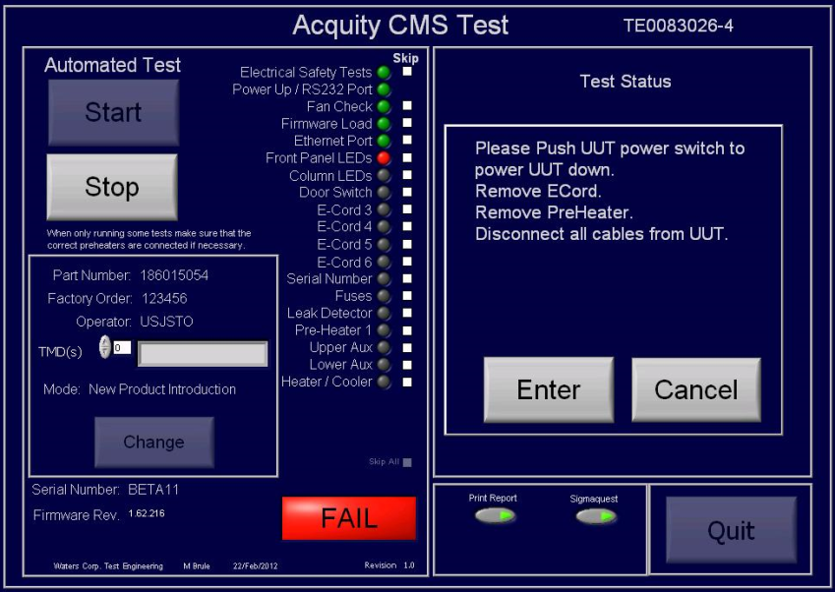

A copy of the Final Test Record for the Front Panel LEDs – Run LED blinking green and red - Fault Test is provided as Attachment 7.10.

The Column LEDs Fault Insertion Test met the acceptance requirement of displaying a red “Fail” indicator on the Operator Interface display and a Fail result on the Final Test Report.

A screen capture of the Operator Interface display indicating a red “Fail” indicator for the Column LEDs Fault Insertion Test is provided below:
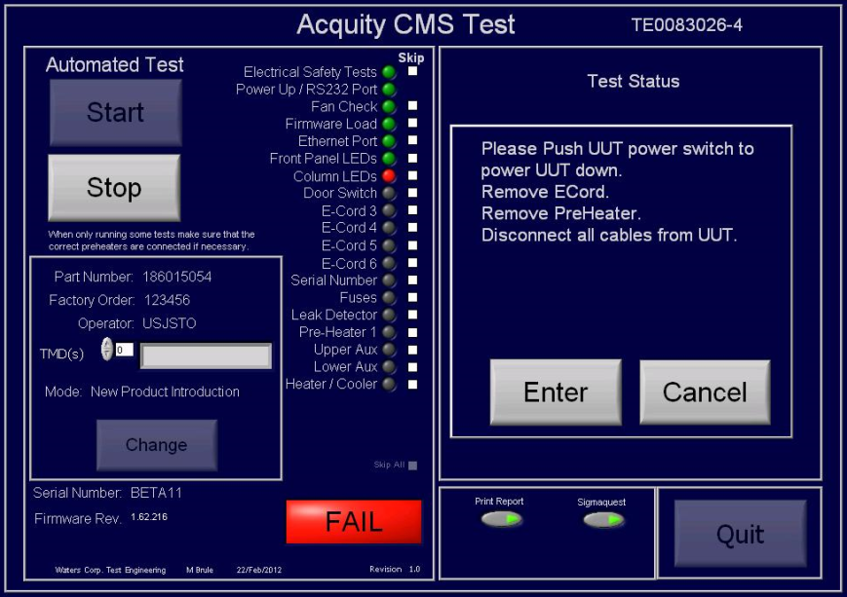

A copy of the Final Test Record for the Column LEDs Fault Test is provided as Attachment 7.11.

The Door Switch – Column Compartment Closed - Fault Insertion Test met the acceptance requirement of displaying a red “Fail” indicator on the Operator Interface display and a Fail result on the Final Test Report.

A screen capture of the Operator Interface display indicating a red “Fail” indicator for the Door Switch, upon the insertion of the Door Switch – Column Compartment Closed Fault, is provided below:
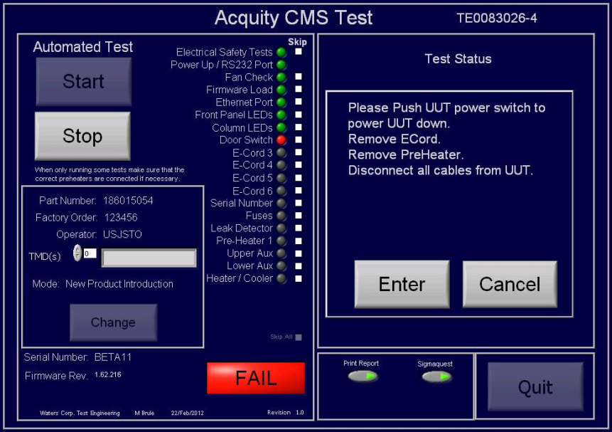

A copy of the Final Test Record for the Door Switch – Column Compartment Closed Fault Test is provided as Attachment 7.12.

The Door Switch – Column Compartment Removed - Fault Insertion Test met the acceptance requirement of displaying a red “Fail” indicator on the Operator Interface display and a Fail result on the Final Test Report.

A screen capture of the Operator Interface display indicating a red “Fail” indicator for the Door Switch, upon the insertion of the Door Switch – Column Compartment Removed Fault, is provided below:
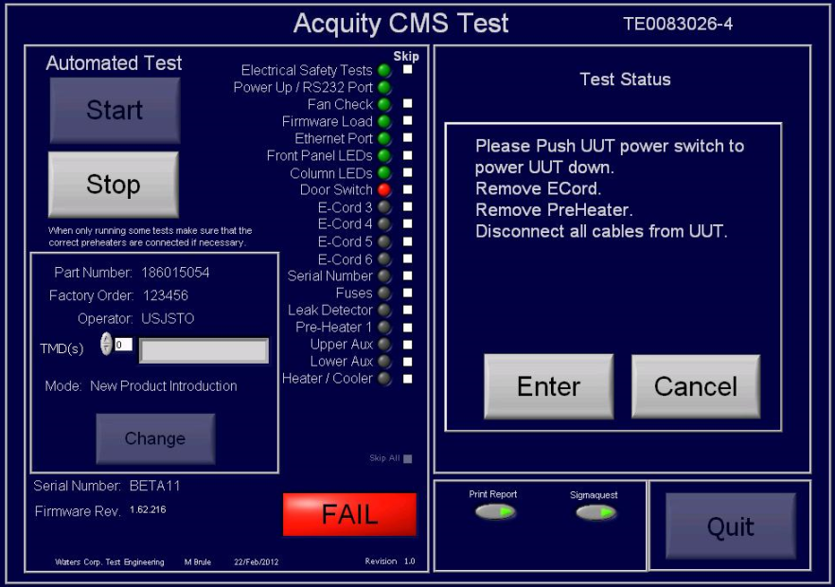

A copy of the Final Test Record for the Door Switch – Column Compartment Removed Fault Test is provided as Attachment 7.13.

The E-Cord 3 Fault Insertion Test met the acceptance requirement of displaying a red “Fail” indicator on the Operator Interface display and a Fail result on the Final Test Report.

A screen capture of the Operator Interface display indicating a red “Fail” indicator for the
E-Cord 3 Fault Insertion Test is provided below:
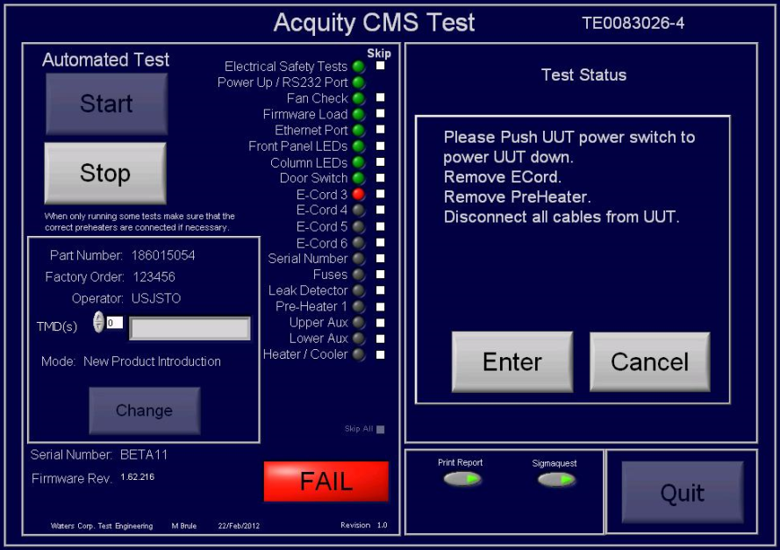

A copy of the Final Test Record for the E-Cord 3 Fault Test is provided as Attachment 7.14.

The E-Cord 4 Fault Insertion Test met the acceptance requirement of displaying a red “Fail” indicator on the Operator Interface display and a Fail result on the Final Test Report.

A screen capture of the Operator Interface display indicating a red “Fail” indicator for the
E-Cord 4 Fault Insertion Test is provided below:
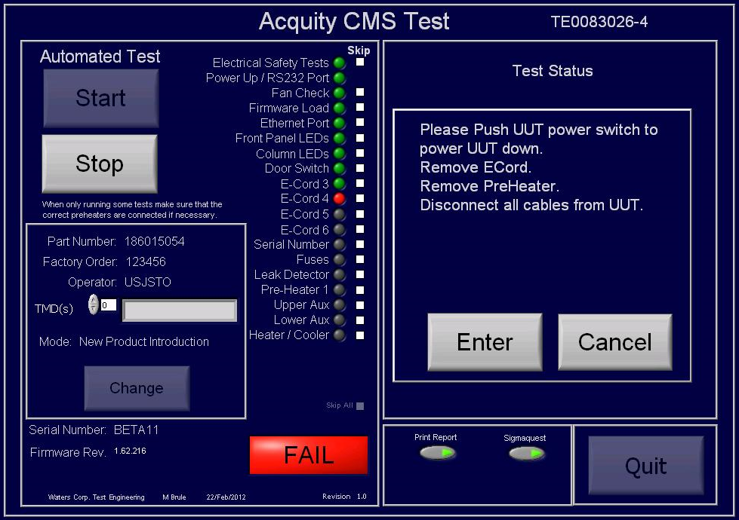

A copy of the Final Test Record for the E-Cord 4 Fault Test is provided as Attachment 7.15.

The E-Cord 5 Fault Insertion Test met the acceptance requirement of displaying a red “Fail” indicator on the Operator Interface display and a Fail result on the Final Test Report.

A screen capture of the Operator Interface display indicating a red “Fail” indicator for the
E-Cord 5 Fault Insertion Test is provided below:
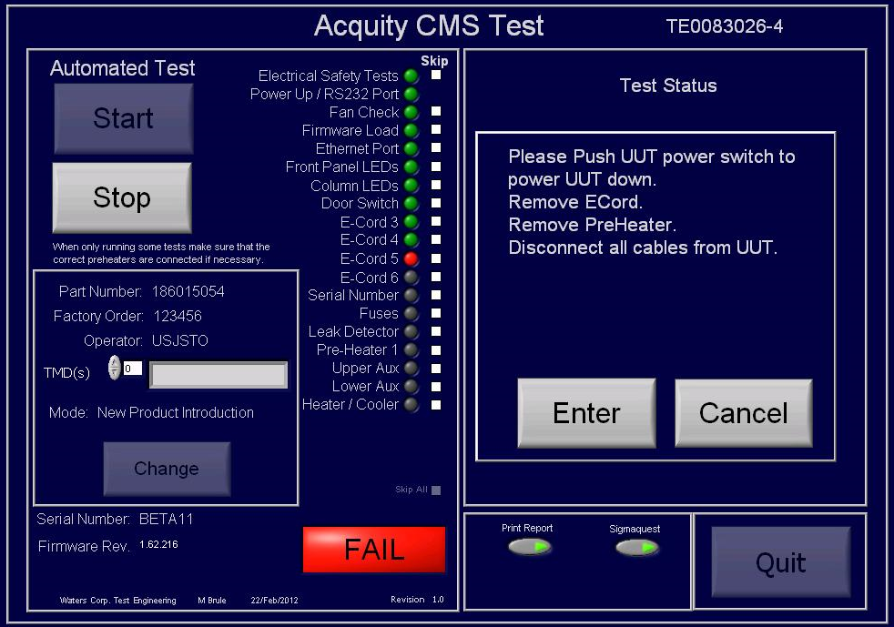

A copy of the Final Test Record for the E-Cord 5 Fault Test is provided as Attachment 7.16.

The E-Cord 6 Fault Insertion Test met the acceptance requirement of displaying a red “Fail” indicator on the Operator Interface display and a Fail result on the Final Test Report.

A screen capture of the Operator Interface display indicating a red “Fail” indicator for the
E-Cord 6 Fault Insertion Test is provided below:
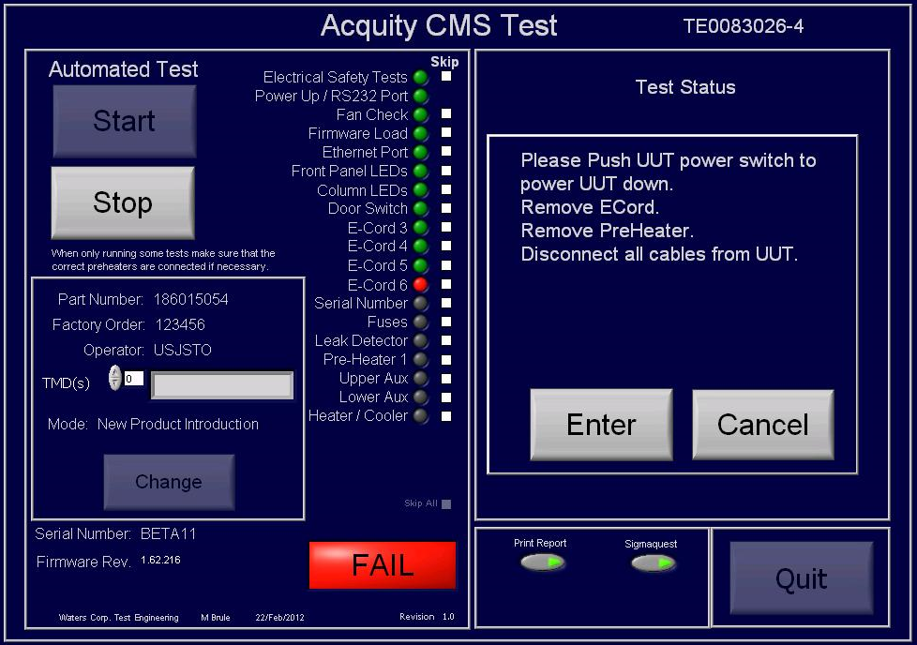

A copy of the Final Test Record for the E-Cord 6 Fault Test is provided as Attachment 7.17.

The Fuses Fault Insertion Test met the acceptance requirement of displaying a red “Fail” indicator on the Operator Interface display and a Fail result on the Final Test Report.

A screen capture of the Operator Interface display indicating a red “Fail” indicator for the Fuses Fault Insertion Test is provided below:
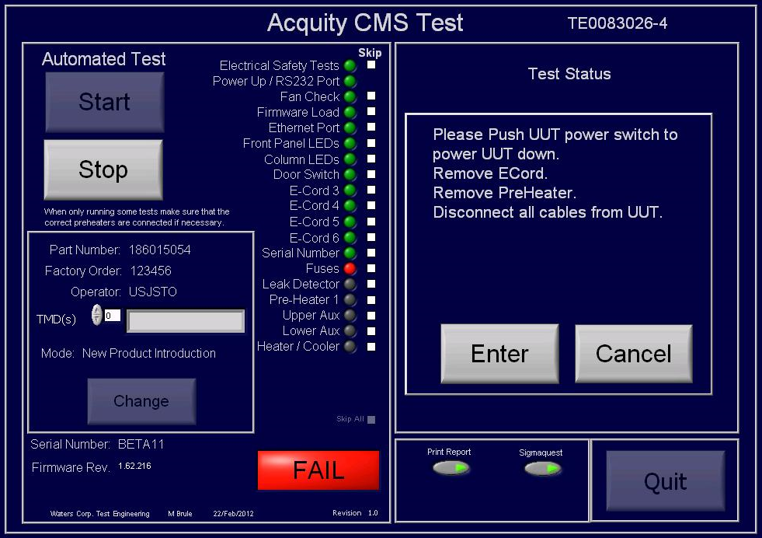

A copy of the Final Test Record for the Fuses Fault Test is provided as Attachment 7.18.

The Leak Detector Fault Insertion Test met the acceptance requirement of displaying a red “Fail” indicator on the Operator Interface display and a Fail result on the Final Test Report.

A screen capture of the Operator Interface display indicating a red “Fail” indicator for the Leak Detector Fault Insertion Test is provided below:
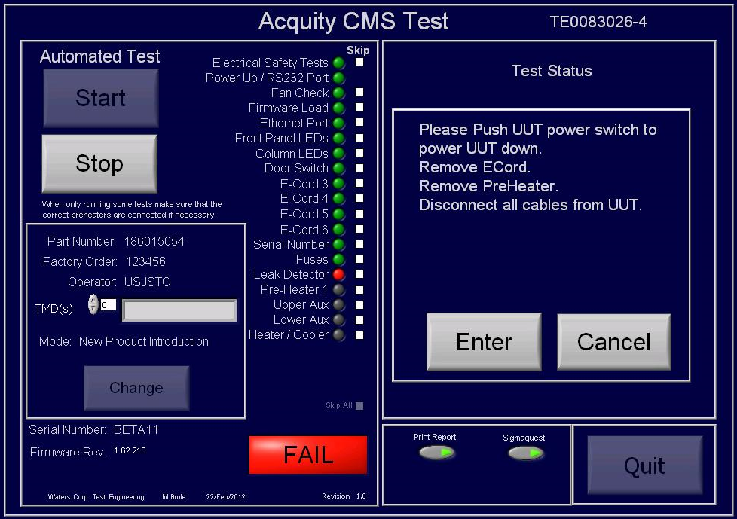

A copy of the Final Test Record for the Leak Detector Interface Fault Test is provided as Attachment 7.19.

The Pre-Heater 1 Fault Insertion Test met the acceptance requirement of displaying a red “Fail” indicator on the Operator Interface display and a Fail result on the Final Test Report.

A screen capture of the Operator Interface display indicating a red “Fail” indicator for the Pre-Heater 1 Fault Insertion Test is provided below:
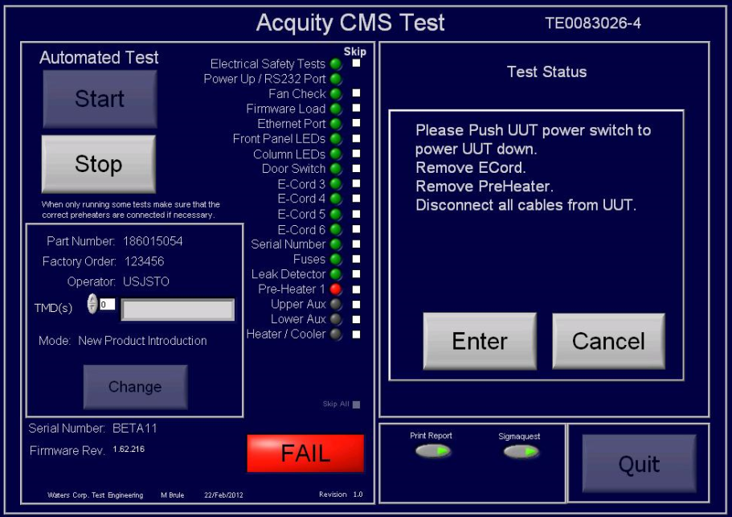

A copy of the Final Test Record for the Pre-Heater Interface TC-CM-APH1 Fault Test is provided as Attachment 7.20.

The Upper Aux Fault Insertion Test met the acceptance requirement of displaying a red “Fail” indicator on the Operator Interface display and a Fail result on the Final Test Report.

A screen capture of the Operator Interface display indicating a red “Fail” indicator for the Upper Aux Fault Insertion Test is provided below:
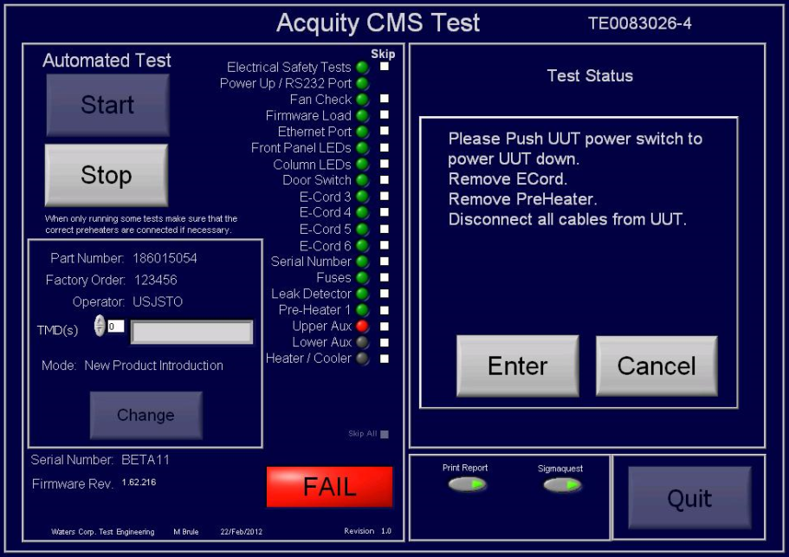

A copy of the Final Test Record for the TOP Auxiliary Interface Fault Test is provided as Attachment 7.21.

The Lower Aux Fault Insertion Test met the acceptance requirement of displaying a red “Fail” indicator on the Operator Interface display and a Fail result on the Final Test Report.

A screen capture of the Operator Interface display indicating a red “Fail” indicator for the Lower Aux Fault Insertion Test is provided below:
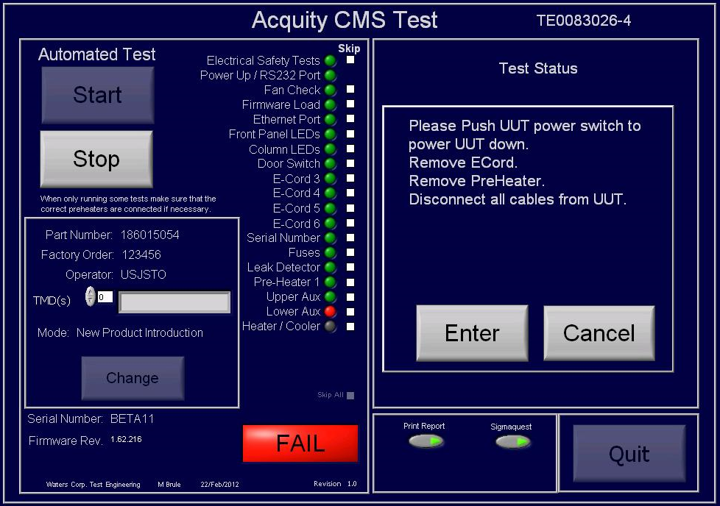

A copy of the Final Test Record for the BOTTOM Auxiliary Interface Fault Test is provided as Attachment 7.22.

The Heater/Cooler - Heater Fault Insertion Test met the acceptance requirement of displaying a red “Fail” indicator on the Operator Interface display and a Fail result on the Final Test Report.

A screen capture of the temperature versus time display for the Heater/Cooler – Heater stability/sync Fault Insertion Test is provided below:
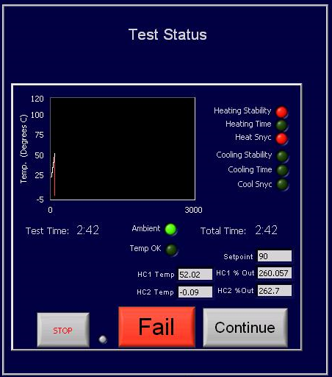

A screen capture of the Operator Interface display indicating a red “Fail” indicator for the Heater/Cooler - Heater Fault Insertion Test is provided below:
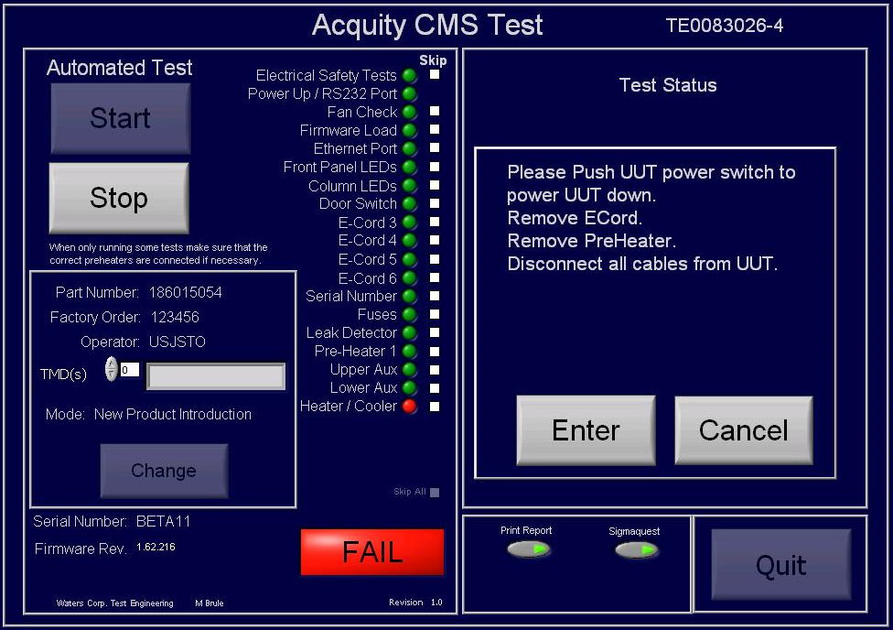

A copy of the Final Test Record for the Heater/Cooler - Heater Fault Test is provided as Attachment 7.23.

The Heater/Cooler - Cooler Fault Insertion Test met the acceptance requirement of displaying a red “Fail” indicator on the Operator Interface display and a Fail result on the Final Test Report.

A screen capture of the temperature versus time display for the Heater/Cooler – Cooler stability/sync Fault Insertion Test is provided below:
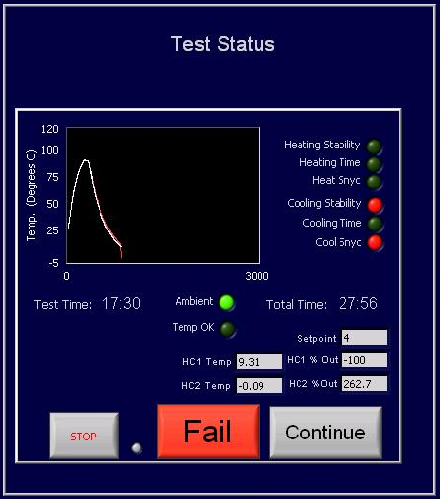

A screen capture of the Operator Interface display indicating a red “Fail” indicator for the Heater/Cooler - Cooler Fault Insertion Test is provided below:
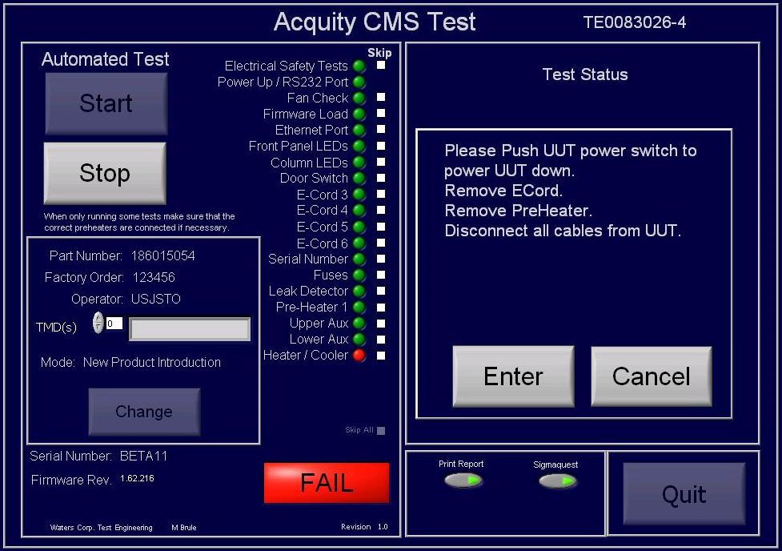

A copy of the Final Test Record for the Heater/Cooler - Cooler Fault Test is provided as Attachment 7.24.

A summary of the attached objective evidence that applies to each Test Script is provided in the Table below:
Script or Section | Pass/Fail | Objective Evidence | Deviations
EDV-01 | Pass | Attachments 7.2 and 7.3 | None
EDV-02 | Pass | Attachments 7.4 through 7.24 | None

Attachments

Training Record for 735002932, Veyron CM-S Final Test – Test and Specification Procedure

EDV-01 – Specification and Functional Verification Test Script Data Sheet

Final Test Record for Test Script EDV-01

EDV-02 – Fault Insertion Test, Test Script Data Sheet

Final Test Record for Test Script EDV-02 – Electrical Safety Fault Insertion Test

Final Test Record for Test Script EDV-02 – Power Up/Serial Port Fault Insertion Test

Final Test Record for Test Script EDV-02 – Fan Fault Insertion Test

Final Test Record for Test Script EDV-02 – Ethernet Port Fault Insertion Test

Final Test Record for Test Script EDV-02 – Front Panel LEDs – Power LED Fault Insertion Test

Final Test Record for Test Script EDV-02 – Front Panel LEDs – Run LED Fault Insertion Test

Final Test Record for Test Script EDV-02 – Column LEDs Fault Insertion Test

Final Test Record for Test Script EDV-02 – Door Switch – Column Compartment Closed Fault Insertion Test

Final Test Record for Test Script EDV-02 – Door Switch – Column Compartment Removed Fault Insertion Test

Final Test Record for Test Script EDV-02 – E-Cord 3 Fault Insertion Test

Final Test Record for Test Script EDV-02 – E-Cord 4 Fault Insertion Test

Final Test Record for Test Script EDV-02 – E-Cord 5 Fault Insertion Test

Final Test Record for Test Script EDV-02 – E-Cord 6 Fault Insertion Test

Final Test Record for Test Script EDV-02 – Fuses Fault Insertion Test

Final Test Record for Test Script EDV-02 – Leak Detector Interface Fault Insertion Test

Final Test Record for Test Script EDV-02 – Pre-Heater Interface TC-CM-APH1 Fault Insertion Test

Final Test Record for Test Script EDV-02 – TOP Auxiliary Interface Fault Insertion Test

Final Test Record for Test Script EDV-02 – BOTTOM Auxiliary Interface Fault Insertion Test

Final Test Record for Test Script EDV-02 – Heater/Cooler - Heater Fault Insertion Test

Final Test Record for Test Script EDV-02 – Heater/Cooler - Cooler Fault Insertion Test

Deviation from Test Equipment Verification
There were no deviations generated during the execution of TE0083026-EDV, Column Manager Test System (CM-S Program) Equipment Design Verification.

References
The current approved versions of the following documents are referenced within this document:
Document Number | Iteration/Rev. | Document title
TE0083026-EDV | 00 | Column Manager Test System (CM-S Program) Equipment Design Verification
735002932 | 02 | Veyron CM-S Final Test - Test and Specification Procedure (TSP)

