INSTALLATION QUALIFICATION REPORT
For the Alliance Column Heater / Cooler Test Station (TE82774-3)

PREPARED BY

Name | Role | Signature | Date
Emma Pierce | Test Validation Engineer

REVIEWED BY

Name | Role | Signature | Date
Ed Jackson | Principal Test Engineer

APPROVED BY

Name | Role | Signature | Date
Andre Kopoyan | Senior Operations Quality Engineer

The “Prepared By” signature denotes that this document accurately describes the qualification activities.

The “Reviewed By” signature[s] denotes agreement with the description of the qualification activities.

The “Approved By” signature denotes that this document has been reviewed and approved for overall quality and completeness.

REVISION HISTORY

Version | Author | Summary of change
00 | Emma Pierce | First document for approval

Purpose

The Alliance Column Heater / Cooler Test Station (TE82774-3) is located in the Venture Contract Manufacturer Site in Singapore. The station is used to test column heaters and column heater / coolers of the following part numbers: 186001863, 186001791, 186015011, 186179100, 186186301, 186017008, 186017009, 186017014, 186017015, N2971011. This station does not test 2695 or 2795 Alliance Column Heaters of the following part numbers: WAT270852, 186000266, 186000267, 186000306, and 186000320. The tests include checking communications and wiring, fan and door operation, heating, cooling (if applicable), and valve functionality (if applicable). For a detailed list of which UUTs undergo which tests, refer to Table 1: Instrument Test Summary in the Alliance Column Heater / Cooler Functional Test TSP 735000698, Ver. 13.

Once the operator connects the UUT to the test station, they must use the “Select UUT” button to choose the part number being tested from the dialog box that appears. When prompted, the operator must verify that the UUT has passed a Hi-Pot Ground Continuity test, close the heater door, and verify the functionality of the external and internal (if applicable) fan(s) as directed. The rest of the test is automated. Upon completion, the operator must reset the Rotary Switch at the back of the UUT to Position 0 and collect the automatically generated Test Record from the printer.

This Installation Qualification is being performed as required by TE82774-15SEP2017-VAF, which can be found in the TE0082774QX directory of SAP.

Scope of Report

This Installation Qualification Report details the qualification activities undertaken for the Alliance Column Heater / Cooler Test Station (TE82774-3) based on the requirements of the Installation Qualification Procedure 730004135, Ver. 00.

This Installation Qualification Report defines the documents used to qualify the Alliance Column Heater / Cooler Test Station (TE82774-3).

Summary of Results - Statement of Fitness for Intended Use

The Alliance Column Heater / Cooler Test Station was tested in accordance with the Installation Qualification Procedure 730004135, Ver. 00. All Test Scripts were performed and all objective evidence requirements have been met.

Waters now has the necessary documentation in place to ensure that the Alliance Column Heater / Cooler Test Station complies with Waters’ requirements, the latest relevant quality system regulations, and cGMP practices.

Following the approval of this Qualification Report, the Alliance Column Heater / Cooler Test Station (TE82774-3) can be considered fully qualified and fit for intended use with the following part numbers: 186001791, 186001863, 186015011, 186179100, 186186301, 186017008, 186017009, 186017014, 186017015, and N2971011.

Glossary

The following definitions are used in this document:
Term | Explanation
CAL/PM | Calibration/Preventive Maintenance
CH | Column Heater
CHC | Column Heater Cooler
cGMP | Current Good Manufacturing Practice
FSD | Functional Specification Document
Hz | Hertz
ID | Identification
IQ | Installation Qualification
IQR | Installation Qualification Report
N/A | Not Applicable
P/N | Part Number
SAP | Enterprise Resource Planning Software
S/N | Serial Number
TSP | Test Specification and Procedure
UUT | Unit Under Test
VAC | Volts Alternating Current
VAF | Validation Assessment Form

Training

The operator of the Alliance Column Heater / Cooler Test Station (TE82774-3) was trained according to the Alliance Column Heater / Cooler Functional Test TSP 735000698, Ver. 13. The executor of this qualification was trained according to the Installation Qualification Procedure 730004135, Ver. 00. Both training records are provided as Attachments 7.1 and 7.2, respectively.

Qualification Results

Test Script IQ-01: Associated Documentation Verification was performed according to Installation Qualification Procedure 730004135, Ver. 00. The completed Test Script Data Sheet is provided as Attachment 7.3.

The Alliance Column Heater / Cooler Functional Test TSP 735000698, Ver. 13 was confirmed to be in SAP with a status of Release General, as evidenced below:

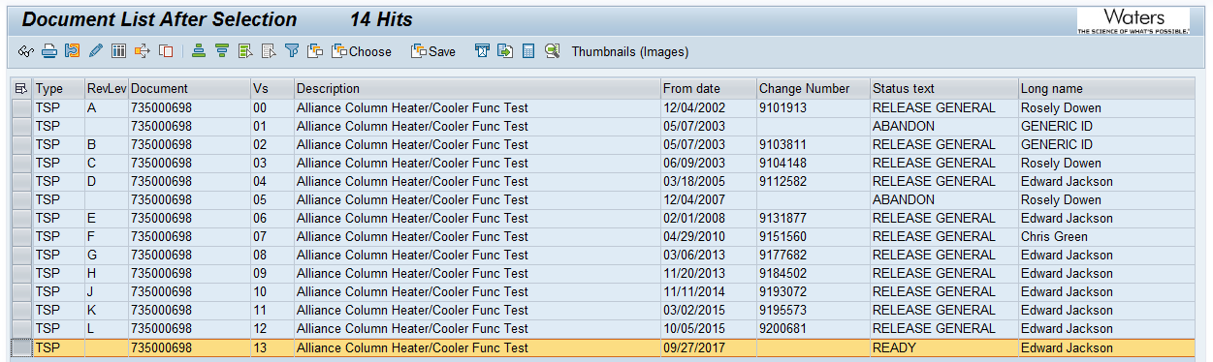

The Alliance Column Heater / Cooler Calibration Procedure 735000727, Ver. 00 / Rev. A was confirmed to be in SAP with a status of Release General, as evidenced below:

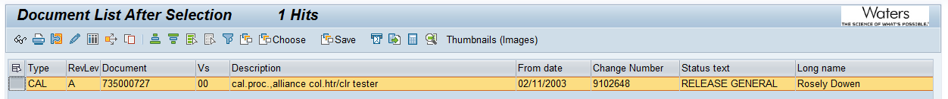

Test Script IQ-02: Site Verification was performed according to Installation Qualification Procedure 730004135, Ver. 00. The completed Test Script Data Sheet is provided as Attachment 7.4.

The ambient temperature and humidity were measured using alarm hygrometer (S/N #AA13015316) and were determined to be within specification as defined by the Acquity Arc Bio System FSD 721013355, Ver. 01. The calibration record is provided as Attachment 7.5.

The electrical supply was measured using a Fluke 115 Multimeter (S/N #23372874), and was determined to be within specification as defined by the Acquity Arc Bio System FSD 721013355, Ver. 01. The calibration record is provided as Attachment 7.6.

The Test Station was confirmed to have more than the two (2) dedicated electrical outlets required.

The space and test bench of the Alliance Column Heater / Cooler Test Station (TE82774-3) were confirmed to have adequate space for testing and service. The bench was confirmed to be large and strong enough to support all test equipment. A picture of the Test Station work area is provided as Attachment 7.7.

Test Script IQ-03: Instrumentation Calibration Verification was performed according to Installation Qualification Procedure 730004135, Ver. 00. The completed script is provided as Attachment 7.8.

The Alliance Column Heater / Cooler Test Station (TE82774-3) was confirmed to be in the Calibration Master List with a twelve (12) month maintenance cycle. A screen capture from the database is provided as Attachment 7.9.

The Test Station was confirmed to have had preventative maintenance within this time frame. The most recent PM Record is provided as Attachment 7.10.

Test Script IQ-04: Software and Instrument Firmware Version was performed according to Installation Qualification Procedure 730004135, Ver. 00. The completed Test Script Data Sheet is provided as Attachment 7.11.

The Test Equipment Software (Test Stand User Interface) version listed in the Alliance Column Heater / Cooler Functional Test TSP 735000698, Ver. 13 is Test Software 1.0 and was verified to match the version listed in the test equipment program display. A screen capture of the program display is provided as Attachment 7.12.

The Test Equipment Software (Test Stand Model) version listed in the Alliance Column Heater / Cooler Functional Test TSP 735000698, Ver. 13 is Test Software 1.0 and was verified to match the version listed in the test equipment program display. Refer to the screen capture of the program display provided as Attachment 7.12.

The Test Equipment Software (Sequence) version listed in the Alliance Column Heater / Cooler Functional Test TSP 735000698, Ver. 13 is Test Software 1.0 and was verified to match the version listed in the test equipment program display. Refer to the screen capture of the program display provided as Attachment 7.12.

This test station does not download instrument firmware.

Test Script IQ-05: General Safety and Alarms was performed according to Installation Qualification Procedure 730004135, Ver. 00. The completed Test Script Data Sheet is provided as Attachment 7.13.

It was confirmed that there were no mechanical safety pinch points or sharp edges.

Test Script IQ-06: Functional Verification was performed according to Installation Qualification Procedure 730004135, Ver. 00. The completed Test Script Data Sheet is provided as Attachment 7.15.

The Alliance CH (P/N: 186186301) and the Alliance CHC (P/N: 186179100) were chosen as the UUTs for this Installation Qualification because they undergo all tests applicable to a unit with a printed circuit board P/N: 210000400. The Alliance CHC (P/N: 186179100) has equivalent functionality to the Acquity Arc Bio CHC (P/N: 186017015) that was specified as the UUT in the Validation Assessment Form TE82774-15SEP2017-VAF.

It was verified that only units with a printed circuit board P/N: 210000400 of the following part numbers could be tested on this test station: 186001791, 186001863, 186015011, 186179100, 186186301, 186017008, 186017009, 186017014, 186017015, and N2971011. Two UUTs with P/N 186186301 and 186179100 were used for functional verification. A screen capture of the tests available to the operator is provided in Attachment 7.12.

Two (2) UUTs were tested using the Alliance Column Heater / Cooler Test Station (TE82774-3) with all tests passing. The test record is provided as Attachment 7.16.

This table provides a summary of each test script as performed according to 730004135, Ver. 00 along with the attachment location of all objective evidence. The table also indicates any deviation taken from the scripts during qualification.
Script or Section | Pass/Fail | Objective Evidence | Deviations
IQ-01 | Pass | Attachment 7.3 | None
IQ-02 | Pass | Attachments 7.4, 7.5, 7.6, and 7.7 | None
IQ-03 | Pass | Attachments 7.8, 7.9, and 7.10 | None
IQ-04 | Pass | Attachments 7.11 and 7.12 | None
IQ-05 | Pass | Attachments 7.13 and Attachment 7.14 | None
IQ-06 | Pass | Attachment 7.15, and 7.16 | None

Attachments

Completed Operator Training Record 735000698, Ver. 13

Completed Executor Training Record 730004135, Ver. 00

Completed Test Script IQ-01: Associated Document Verification

Completed Test Script IQ-02: Site Verification

Objective Evidence IQ-02: Hygro-thermometer (S/N# AA13015316) Calibration Record

Objective Evidence IQ-02: Fluke 115 Multimeter (S/N #23372874) Calibration Record

Objective Evidence IQ-02: Picture of Test Station Work Area

Completed Test Script IQ-03: Instrument Calibration Verification

Objective Evidence IQ-03: Screen Capture of Alliance Column Heater / Cooler Test Station (TE82774-3) in Calibration Master List

Objective Evidence IQ-03: Alliance Column Heater / Cooler Test Station (TE82774-3) PM Record

Completed Test Script IQ-04: Test Software and Instrument Firmware Version

Objective Evidence IQ-04: Screen Capture of the Test Software Program Display

Completed Test Script IQ-05: General Safety and Alarms

Objective Evidence IQ-05: Hi Pot Calibration Record

Completed Test Script IQ-06: Functional Verification of UUTs P/N: 186186301 (S/N: L17SMH436G) and P/N: 186179100 (S/N: L17SMC256G)

Objective Evidence IQ-06: Test Records for UUTs P/N: 186186301 (S/N: L17SMH436G) and P/N: 186179100 (S/N: L17SMC256G)

Deviation from Test Equipment Qualification

There were no deviations generated during the execution of the Installation Qualification Procedure 730004135, Ver. 00.

References

The current approved versions of the following documents are referenced within this report:
Document Number | Document Title
730004135, Ver. 00 | Installation Qualification Procedure
735000698, Ver. 13 | Alliance Column Heater / Cooler Functional Test TSP
735000727, Ver. 00 / Rev. A | Alliance Column Heater / Cooler Tester Calibration Procedure
721013355, Ver. 01 | Acquity Arc Bio System FSD
WAT046538, Ver. 09 | Generic Electrical Safety Test Procedure
TE82774-15SEP2017-VAF | Validation Assessment Form for Alliance Column Heater / Cooler Test Station

