For the PDA Final Test System

PREPARED BY
Name | Role | Signature | Date
Edwin Koh | Senior Operations Manager
The “Prepared By” signature denotes that this document accurately describes the qualification activities.
REVIEWED BY
Name | Role | Signature | Date
Eric Turner | Principal Test Engineer
The “Reviewed By” signature[s] denotes agreement with the description of the qualification activities.
APPROVED BY
Name | Role | Signature | Date
Tan Kah Chin | Senior Quality Assurance Manager
The “Approved By” signature denotes that this document has been reviewed and approved for overall quality and completeness.

REVISION HISTORY
Version: | 03 | Originator: | Edwin Koh | Change ID: | 9232558
Summary of Change: Acquity Premier part numbers add, PDA software version XX

PURPOSE
The purpose of this Installation Qualification Report is to detail the activities associated with the execution of 730004135, Installation Qualification Protocol, for the TE82882-08, PDA FINAL Test System.

SYSTEM BACKGROUND
The TE82882, PDA Final Test Station, is used to perform functionality testing of Waters Corporation’s Photo Diode Arrays (PDA’s) as defined in TSP 735001613, to ensure compliance to the defined Manufacturing Test Specifications.
The system is comprised of a PC running a custom software program and uses serial and ethernet ports to communicate to up to four (4) UUT’s in order to test Noise, Drift and Optics. Upon completion a Final Test Record is automatically generated, and a hard copy is printed. In addition, the Final Test Record is sent to the SigmaProd server.

SCOPE
This Installation Qualification Report details the Qualification activities undertaken for the TE82882-08, PDA FINAL Test System, based on the requirements of the executed protocol, 730004135, Installation Qualification Protocol, as detailed in PDA FINAL Test System.

SUMMARY OF RESULTS – STATEMENT OF FITNESS FOR INTENDED USE
The TE82882-08, was tested in accordance with the applicable sections of 730004135, Installation Qualification Protocol, Version 03 per PDA FINAL Test System Validation Assesement Form. All required Test Scripts were performed, and all objective evidence requirements have been met.
Waters now has the necessary documentation in place to ensure that the TE82882-08, remains compliant with Waters’ requirements, the latest relevant quality system regulations, and cGMP practices.
Following the approval of this Qualification Report, the TE82882-08, remains fully qualified and fit for intended use.

ABBREVIATIONS
The following definitions are used in this document:
Term | Explanation
APC | Advanced Polymer Chromatography
ARC | Acquity Reduced Cost
PDA | Photo Diode Array
cGMP | Current Good Manufacturing Practice
CTQ | Critical to Quality
IQR | Installation Qualification Report
N/A | Not Applicable
NPI | New Product Introduction
P/N | Part Number
SAP | Enterprise Resource Planning Software
SDS | Solvent Delivery System
TSP | Test Specification and Procedure
UUT | Unit Under Test
VP | Validation Plan

TRAINING
The executor of this qualification was trained to the Installation Qualification Protocol, 730004135, Version 03, and the training record is provided as Attachment 6.1 below
The Operator who performed the testing of the UUT using the TE82882-08, was trained to 735001613, ACQUITY PDA Final Instrument Test and Specification Procedure Ver 25 Rev AB and a Training Record is provided as Attachment 6.1.

Attachment 6.1
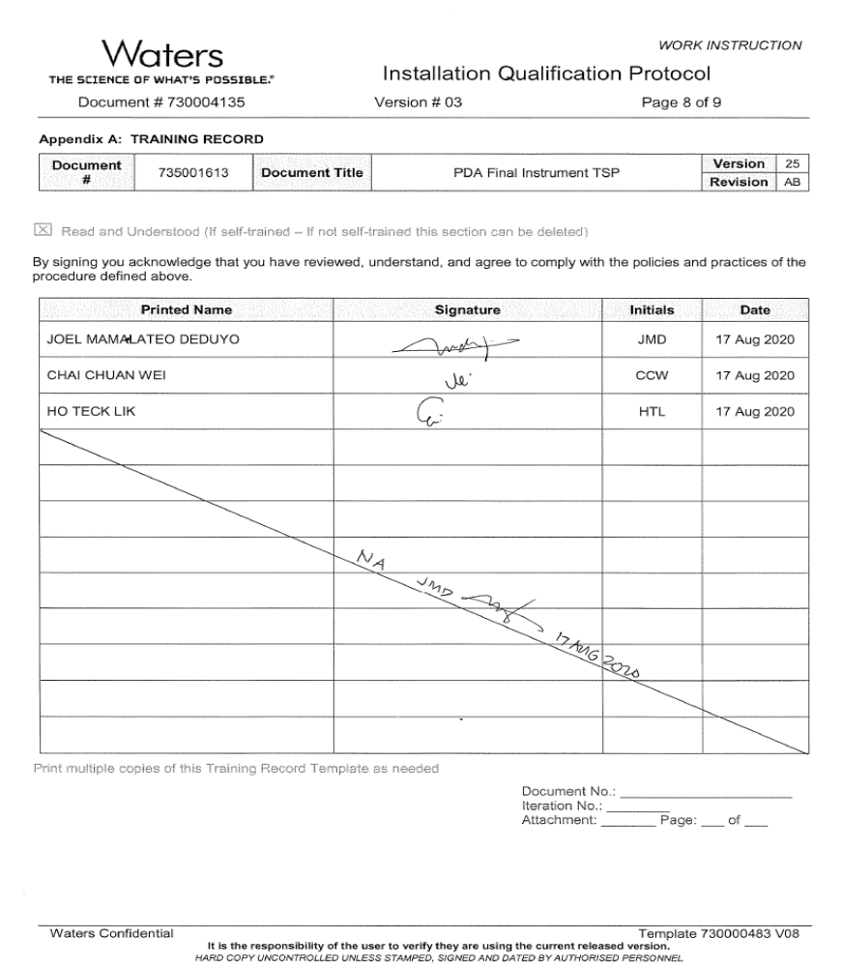

QUALIFICATION RESULTS

TEST SCRIPT IQ-01, ASSOCIATED DOCUMENTATION VERIFICATION

Test Script IQ-01, Associated Documentation Verification, was performed in accordance with Installation Qualification Protocol, 730004135, Version 03, and 735001613, ACQUITY PDA Final Instrument Test and Specification Procedure Ver 25 Rev AB PDA FINAL Test System

IQ-01, Associated Documentation Verification Test Script Data Sheet is provided as Attachment 7.1.

The 735001613, ACQUITY PDA Final Instrument Test and Specification Procedure Ver 25 Rev AB, was confirmed to be in SAP with a status of Ready. A screen capture is provided below:
Attachment 7.1
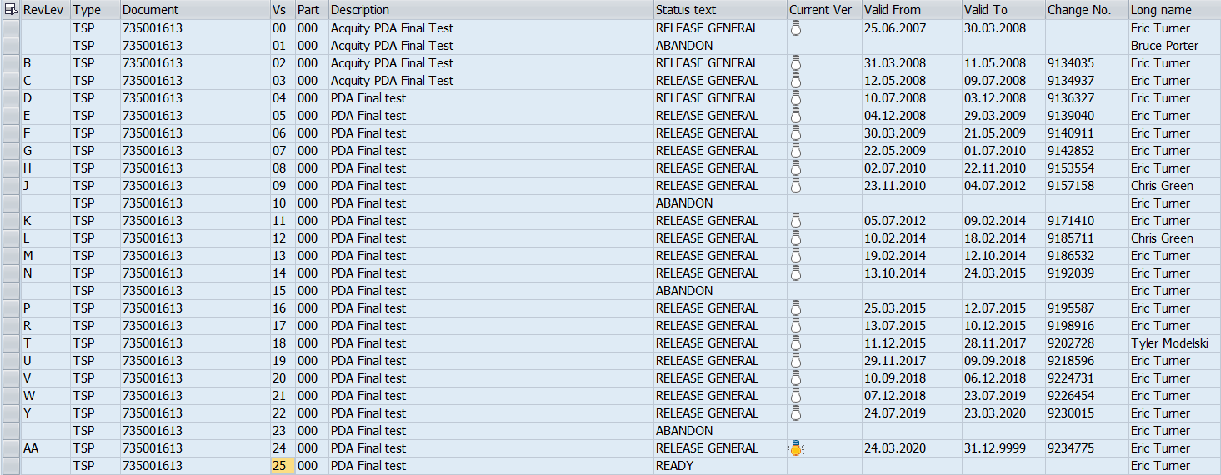

All other system related documents were previously verified as detailed in 735001613, ACQUITY PDA Final Instrument Test and Specification Procedure Ver 24 Rev AA and were not affected by the change summarized in TE82882-07AUG2020-VAF

TEST SCRIPT IQ-02, SITE VERIFICATION

N.A

TEST SCRIPT IQ-03, INSTRUMENTATION CALIBRATION VERIFICATION

N.A

TEST SCRIPT IQ-04, TEST SOFTWARE AND INSTRUMENT FIRMWARE VERSION

Test Script IQ-04, Software and Instrument Firmware Version, was performed in accordance with Installation Qualification Protocol, 730004135, Version 03.

IQ-04, Software and Instrument Firmware Version Test Script Data Sheet is provided as Attachment 7.2.

The system met the requirement of having the Acquity PDA Test Software Version as specified on the cover sheet of 735001613, ACQUITY PDA Final Instrument Test and Specification Procedure Ver 25 Rev AB. A screen capture of the TE82882-08 PDA FINAL Test System showing the Software Version 4.2 is provided in attachment 7.2

One (1) UUT, part number 186018007, ACQUITY Premier eLambda PDA, H20PPD001A was tested using the TE82882-08, PDA FINAL Test System, in accordance with 735001613, ACQUITY PDA Final Instrument Test and Specification Procedure Ver 25 Rev AB, and met the requirement of all required CTQ Specification measurements resulting in a Pass and the Firmware Version being 1.70.6367 as provided in attachment 7.3

Attachment 7.2

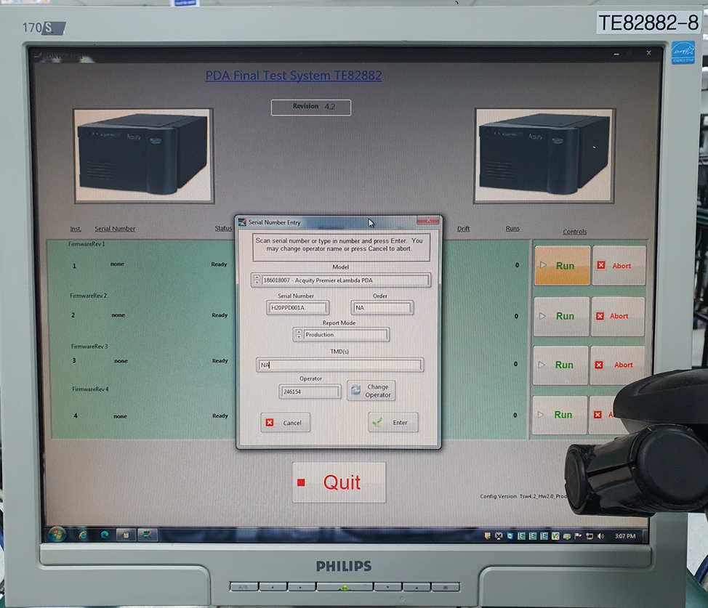

The PDA program version 4.2 is verified, as detailed in TE82882-08.

Attachment 7.3
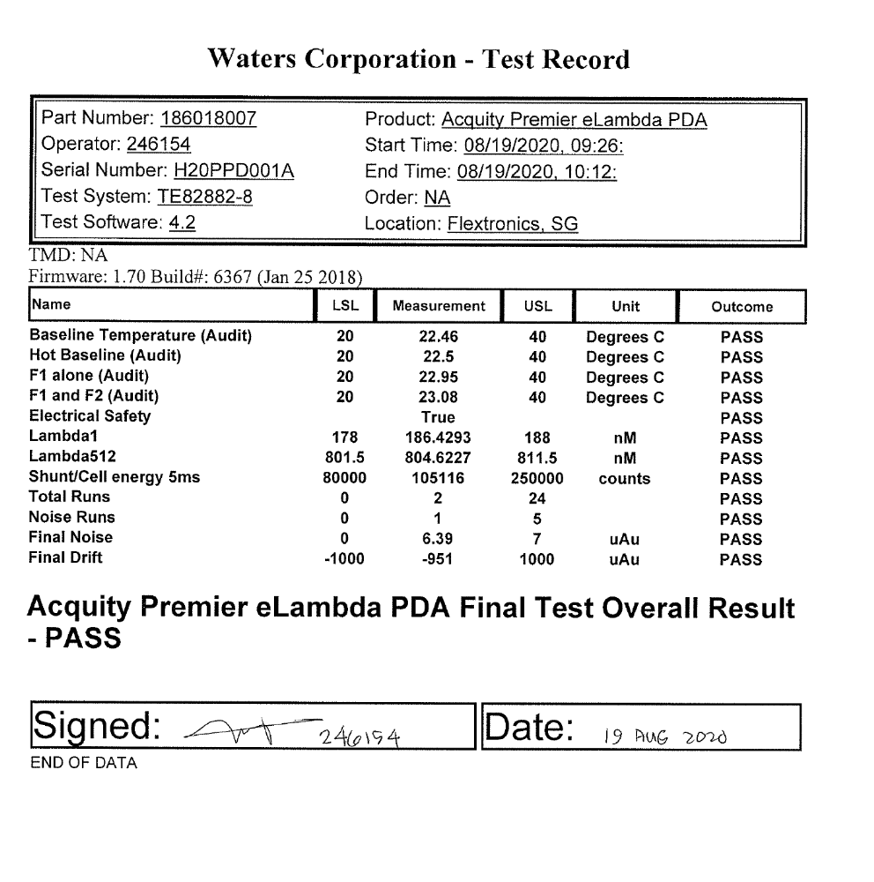

The PDA test firmware version 1.70.6367 is verified

TEST SCRIPT IQ-05, GENERAL SAFETY AND ALARMS

N.A

TEST SCRIPT IQ-06, FUNCTIONAL VERIFICATION

Test Script IQ-06, Functional Verification, was performed in accordance with Installation Qualification Protocol, 730004135, Version 03 and TE82882-07AUG2020-VAF.

The 186018007, ACQUITY Premier eLambda PDA, H20PPD001A was selected for the Functional Verification UUT as the change summarized in TE82882-07AUG2020-VAF, was the addition to the PDA program and the 800000535, which is the Refurb equivalent.

The Final Test Record showing the passing results and the Firmware Version is provided as Attachment 7.4.

Attachment 7.4
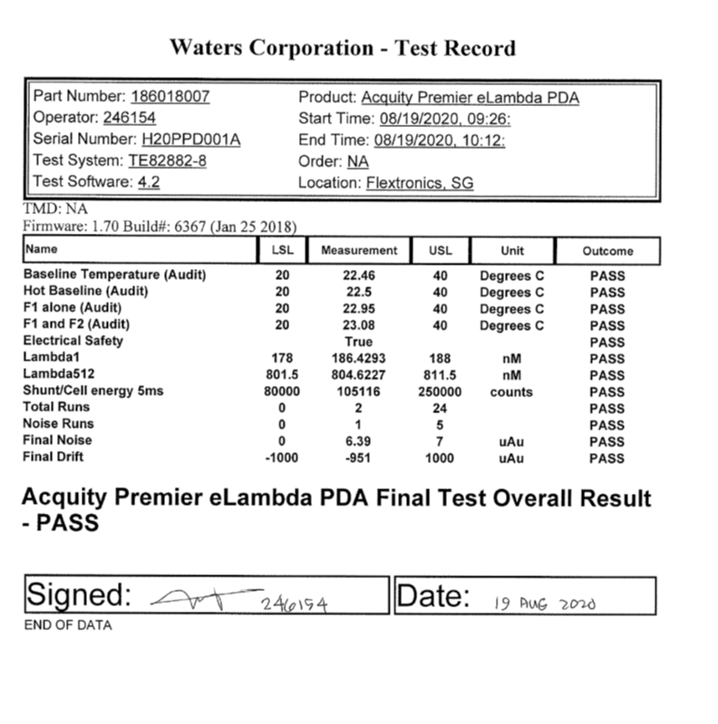

The functional verification testing of the PDA program was previously verified, as detailed in TE82882-08 -IQR and was not affected by the change summarized in TE82882-07AUG2020-VAF

TEST SCRIPT OBJECTIVE EVIDENCE

A summary of the attached objective evidence that applies to each Test Script is provided in the Table below:
Script or Section | Pass/Fail | Objective Evidence | Deviations
IQ-01 | Pass | Attachment 7.1 | None
IQ-04 | Pass | Attachment 7.2 and 7.3 | None
IQ-06 | Pass | Attachment 7.4 | None

ATTACHMENTS

6.1 Training Records of the Executor and Operator.

IQ-01 – Associated Documentation Verification Test Script Data Sheet

IQ-04 – Test Software and Instrument Firmware Version Test Script Data Sheet

IQ-06 – Functional Verification Test Script Data Sheet

Final Test Record for Test Script IQ-06, Functional Verification Test

DEVIATION FROM THE QUALIFICATION PROTOCOL
There were no deviations generated during the execution the 730004135, Installation Qualification Procedure, Version 03, for TE82882-08, PDA FINAL Test System.

REFERENCES
The current approved versions of the following documents are referenced within this document:
Document Number | Document title
730004135, Version 03 | Installation Qualification Protocol
735001613, Version 25 | ACQUITY PDA Final Instrument Test and Specification Procedure
TE82882-07AUG2020-VAF | Acquity PDA Premier Validation Assessment Form

