INSTALLATION QUALIFICATION REPORT
For the PDA Final Test System (TE82882-13)

PREPARED BY
Name | Role | Signature | Date
Luo HuaZhen | Senior Test Engineer
The “Prepared By” signature denotes that this document accurately describes the qualification activities.
REVIEWED BY
Name | Role | Signature | Date
Eric Turner | Principal Test Engineer
The “Reviewed By” signature[s] denotes agreement with the description of the qualification activities.
APPROVED BY
Name | Role | Signature | Date
Tan Kah Chin | Senior Quality Assurance Manager
The “Approved By” signature denotes that this document has been reviewed and approved for overall quality and completeness.

REVISION HISTORY
Version: | 00 | Originator: | Emma Pierce | Change ID: | N/A
Summary of Change: First document for approval
Version: | 01 | Originator: | James J.Stors | Change ID: | N/A
Summary of Change: New software version to print serial number in report folder
Version: | 02 | Originator: | Luo Huazhen | Change ID: | N/A
Summary of Change: new Sotfware version to add optics bench part numbers
Version: | 03 | Originator: | Luo HuaZhen | Change ID: | 9236204
Summary of Change: NEW ACQUITY PREMIER PART NUMBER ADDED

PURPOSE
The purpose of this Installation Qualification Report is to detail the activities associated with the execution of 730004135, Installation Qualification Protocol, for the TE82882-13, Final Test Station as defined in TE82882-07AUG2020-VAF and TSP 735001613, ACQUITY PDA Final Instrument Test and Specification Procedure, Version 25
SYSTEM BACKGROUND
The TE82882-13, PDA Final Test Station, is located at Flex Pte Ltd in Singapore and is used to perform functionality testing of Waters Corporation’s Photo Diode Arrays (PDA’s) as defined in TSP 735001613, to ensure compliance to the defined Manufacturing Test Specifications.

The system is comprised of a PC running a custom software program and uses serial and ethernet ports to communicate to up to four (4) UUT’s in order to test Noise, Drift and Optics. Upon completion a Final Test Record is automatically generated, and a hard copy is printed. In addition, the Final Test Record is sent to the SigmaProd server.

SCOPE
This Installation Qualification Report details the Qualification activities undertaken for the TE82882-13, Final Test Station, based on the requirements of the executed protocol, 730004135, Installation Qualification Protocol, as detailed in Final Test Station and as defined in TE82882-07AUG2020-VAF.

SUMMARY OF RESULTS – STATEMENT OF FITNESS FOR INTENDED USE
The TE82882-13, was tested in accordance with the applicable sections of 730004135, Installation Qualification Protocol, Version 03 per Final Test Station as defined in TE82882-07AUG2020-VA. All required Test Scripts were performed, and all objective evidence requirements have been met.
Waters now has the necessary documentation in place to ensure that the TE82882-13, remains compliant with Waters’ requirements, the latest relevant quality system regulations, and cGMP practices.
Following the approval of this Qualification Report, the TE82882-13, remains fully qualified and fit for intended use.

ABBREVIATIONS
The following definitions are used in this document:
Term | Explanation
PDA | Photodiode Detector Array
cGMP | Current Good Manufacturing Practice
CTQ | Critical to Quality
IQR | Installation Qualification Report
N/A | Not Applicable
NPI | New Product Introduction
P/N | Part Number
SAP | Enterprise Resource Planning Software
TSP | Test Specification and Procedure
UUT | Unit Under Test
VAF | Validation Assessment Form

TRAINING
The executor who perform the TE82882-13 Final Test Station installation qualification was trained according to the Installation Qualification Protocol, 730004135, Version 03, and the training record is provided as Attachment 7.1.

The operator who performed the testing of the UUT using the TE82882-13, was trained to 735001613, ACQUITY PDA Final Instrument Test and Specification Procedure Ver 25 and a Training Record is provided as Attachment 7.2.

QUALIFICATION RESULTS

- Test Script IQ-01, Associated Documentation Verification, was performed in accordance with Installation Qualification Protocol, 730004135, Version 03 and 735001613, ACQUITY PDA Final Instrument Test and Specification Procedure Ver 25, Final Test Station

IQ-01, Associated Documentation Verification Test Script Data Sheet is provided as Attachment 7.3

The 735001613, ACQUITY PDA Final Instrument Test and Specification Procedure Ver 25, was confirmed to be in SAP with a status of Ready. A screen capture is provided below:
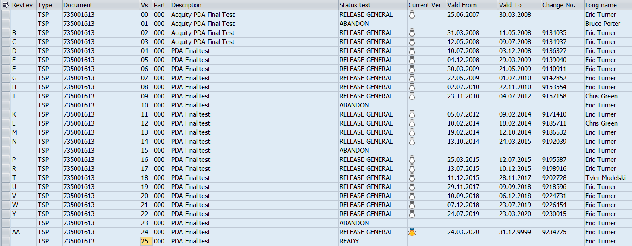

All other system related documents were previously verified as assessed and were not affected by the changes summarized in TE82882-07AUG2020-VAF
- Test Script IQ-02, Site Verification

Test Script IQ-02, Site Verification, was not performed as it was previously executed, and was not affected by the change summarized in TE82882-13 TE82882-07AUG2020-VAF
- Test Script IQ-03, Instrumentation Calibration Verification

Test Script IQ-03, Instrumentation Calibration Verification, was not performed as it was previously executed, and was not affected by the change summarized in TE82882-13 TE82882-07AUG2020-VAF
- Test Script IQ-04, Software and Instrument Firmware version

Test Script IQ-04, Software and Instrument Firmware version, was not performed as it was previously executed, and was not affected by the change summarized in TE82882-13 TE82882-07AUG2020-VAF
- Test Script IQ-05, General Safety and Alarms

Test Script IQ-05, General Safety and Alarms, was not performed as it was previously executed, and was not affected by the change summarized in TE82882-13 TE82882-07AUG2020-VAF

6.6 Test Script IQ-06, Functional Verification,

Test Script IQ-06, Functional Verification, was performed in accordance with Installation Qualification Protocol,

730004135, Version 03 and TE82882-07AUG2020-VAF.

IQ-06, Functional Verification Data Sheet is provided as attachment 7.4

6.6.2 One (1) UUT, part number 186018007, ACQUITY Premier eLambda PDA, H20PPD016A was selected for the Functional Verification UUT as the change summarized in TE82882-07AUG2020-VAF, and met the requirement of obtaining a Final Test Record with the UUT serial number correctly listed and all results passed.

6.6.2.1 The Final Test Record showing the passing results is provided as Attachment 7.5

6.6.3 A summary of the attached objective evidence that applies to each Test Script is provided in the Table below:
Script or Section | Pass/Fail | Objective Evidence | Deviations
IQ-01 | Pass | Attachment 7.3 | None
IQ-06 | Pass | Attachment 7.4 and 7.5 | None

ATTACHMENTS

Completed Executor Training Records 730004135, Ver 03

Completed Operator Training Records 735001613, Ver 25

IQ-01 – Associated Documentation Verification Test Script Data Sheet

IQ-06 – Functional Verification Test Script Data Sheet

Instrument Final Test Record for Test Script IQ-06, Part number 186018007, serial number: H20PPD016A

DEVIATION FROM THE QUALIFICATION PROTOCOL
There were no deviations generated during the execution the 730004135, Installation Qualification Procedure, Version 03, for TE82882-13, Final Test Station per change outlined in TE82882-07AUG2020-VAF

REFERENCES
The current approved versions of the following documents are referenced within this document:
Document Number | Document title
730004135, Version 03 | Installation Qualification Protocol
735001613, Version 25 | ACQUITY PDA Final Instrument Test and Specification Procedure
TE82882-07AUG2020-VAF | TE82882-13 Acquity Final Test System Validation Assessment Form
ECO9236204 | Engineering Change Request to release the Acquity Premier eLambda PDA

