INSTALLATION QUALIFICATION REPORT
For the PDA Detector Download Station (TE83057-4)

PREPARED BY
Name | Role | Signature | Date
Edwin Koh | Senior Operations Manager
The “Prepared By” signature denotes that this document accurately describes the qualification activities.
REVIEWED BY
Name | Role | Signature | Date
Eric Turner | Principal Test Engineer
The “Reviewed By” signature[s] denotes agreement with the description of the qualification activities.
APPROVED BY
Name | Role | Signature | Date
Tan Kah Chin | Senior Quality Assurance Manager
The “Approved By” signature denotes that this document has been reviewed and approved for overall quality and completeness.

REVISION HISTORY

Version: | 00 | Originator: | Edwin Koh | Change ID: | 9236204
Summary of Change: Test Firmware Download for new PDA Premier

PURPOSE
The purpose of this Installation Qualification Report is to detail the activities associated with the execution of 730004135, Installation Qualification Protocol, for the TE83057-4, PDA Detector Download Station.

SYSTEM BACKGROUND
The TE83057-4, PDA Detector Download Station, is located at Flex Pte Ltd, Singapore. The station is used to download instrument firmware to the following part numbers; 186015026, 186002998, 186015032, 186015033, 186015030, 700004035, 700004024, 700005027,186299800, N2971013, N2971035, 186020003, 186017003, 279002655, 186017013 and 186018007.
The system is equipped with a PC running customer test program and the appropriate cables to connect the UUT. After the UUT is connected, the Operator selects the version on the test software program display and begin download. After the UUT has completed the firmware download according to the corresponding procedure, it is moved to the PDA Final Test System (TE82882) to undergo Final Test.

SCOPE
This Installation Qualification Report details the Qualification activities undertaken for the TE83057-4, PDA Detector Download Station, based on the requirements of the executed protocol, 730004135, Installation Qualification Protocol, Version 03 as detailed in TE83057-07AUG2020-VAF.

SUMMARY OF RESULTS – STATEMENT OF FITNESS FOR INTENDED USE
The TE83057-4, PDA Detector Download Station was tested in accordance with the applicable sections of 730004135, Installation Qualification Protocol, Version 03 per TE83057-07AUG2020-VAF. All required Test Scripts were performed, and all objective evidence requirements have been met.
Waters now has the necessary documentation in place to ensure that the TE83057-4, PDA Detector Download Station remains compliant with Waters’ requirements, the latest relevant quality system regulations, and cGMP practices.
Following the approval of this Qualification Report, the TE83057-4, PDA Detector Download Station remains fully qualified and fit for intended use.

ABBREVIATIONS
The following definitions are used in this document:
Term | Explanation
PDA | Photodiode Detector Array
cGMP | Current Good Manufacturing Practice
CTQ | Critical to Quality
IQR | Installation Qualification Report
N/A | Not Applicable
NPI | New Product Introduction
P/N | Part Number
SAP | Enterprise Resource Planning Software
TSP | Test Specification and Procedure
UUT | Unit Under Test
VAF | Validation Assessment Form

TRAINING
The executor of this qualification was trained to the Installation Qualification Protocol, 730004135, Version 03, and the training record is provided as Attachment 7.1

The Operator who performed the testing of the UUT using the TE83057-4, PDA Detector Download Station was trained to 735001613, ACQUITY PDA Final Instrument Test and Specification Procedure, Version 25 and a Training Record is provided as Attachment 7.2

QUALIFICATION RESULTS

6.1 Test Script IQ-01, Associated Documentation Verification

Test Script IQ-01, Associated Documentation Verification, was performed in accordance with Installation Qualification Protocol, 730004135, Version 03, and per TE83057-07AUG2020-VAF.

IQ-01, Associated Documentation Verification Test Script Data Sheet is provided as Attachment 7.3.

The 735001613, PDA Final Test and Specification Procedure, Version 25, was confirmed to be in SAP with a status of Ready. A screen capture is provided below:
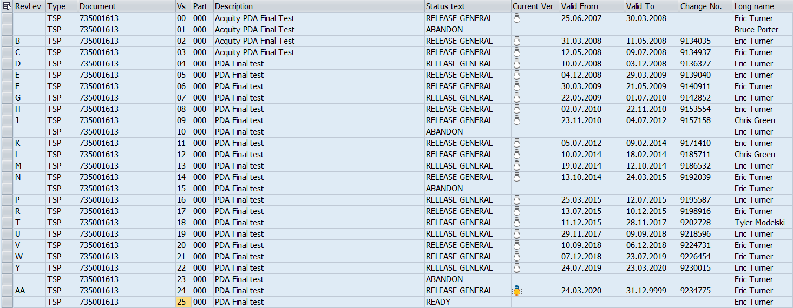

All other system related documents were previously verified as assessed and were not affected by the changes summarized in TE83057-07AUG2020-VAF

TEST SCRIPT IQ-02, SITE VERIFICATION

Test Script IQ-02, Site Verification, was not performed as it was previously executed, and was not affected by the change summarized in TE83057-4 TE83057-07AUG2020-VAF

TEST SCRIPT IQ-03, INSTRUMENTATION CALIBRATION VERIFICATION

Test Script IQ-03, Instrumentation Calibration verification, was not performed as it was previously executed, and was not affected by the change summarized in TE83057-4 TE83057-07AUG2020-VAF

TEST SCRIPT IQ-04, SOFTWARE AND INSTRUMENT FIRMWARE VERSION

Test Script IQ-04, Software and Instrument Firmware version, was not performed as it was previously executed, and was not affected by the change summarized in TE83057-4 TE83057-07AUG2020-VAF

TEST SCRIPT IQ-05, GENERAL SAFETY AND ALARMS

Test Script IQ-05, General Safety and Alarms, was not performed as it was previously executed, and was not affected by the change summarized in TE83057-4 TE83057-07AUG2020-VAF

TEST SCRIPT IQ-06, FUNCTIONAL VERIFICATION

Test Script IQ-06, Functional Verification, was performed in accordance with Installation Qualification Protocol, 730004135, Version 03, as outlined in TE83057-07AUG2020-VAF.

IQ-06, Software and Instrument Firmware Version Test Script Data Sheet is provided as Attachment 7.4

One (1) UUT, 186018007, ACQUITY Premier eLambda PDA, H20PPD001A, was selected for the Functional Verification UUT as the change summarized in TE83057-07AUG2020-VAF and met the requirement of functionality test and report properly on test record.

6.6.2.1 The instrument Test Record is provided as attachment 7.5

6.6.3 A summary of the attached objective evidence that applies to each Test Script is provided in the Table below:
Script or Section | Pass/Fail | Objective Evidence | Deviations
IQ-01 | Pass | Attachment 7.3 | None
IQ-06 | Pass | Attachment 7.4 and 7.5 | None

ATTACHMENTS
  - Completed Executor Training Records 730004135, Ver 03
  - Completed Operator Training Records 735001613, Ver 25
  - IQ-01 – Associated Documentation Verification Test Script Data Sheet

7.4 IQ-06 – Functional Verification Test Script Data Sheet
  - Instrument Final Test Record for Test Script IQ-06, Part number 186018007, serial number: H20PPD001A

DEVIATION FROM THE QUALIFICATION PROTOCOL
There were no deviations generated during the execution the 730004135, Installation Qualification Procedure, Version 03, for TE83057-4, PDA Detector Download Station.

REFERENCES
The current approved versions of the following documents are referenced within this document:
Document Number | Document title
730004135, Version 03 | Installation Qualification Protocol
735001613, Version 25 | PDA Final Instrument Test and Specification Procedure
TE83057-07AUG2020-VAF | TE83057-4 PDA Detector Download Station Validation Assessment Form
ECO9236204 | Engineering Change Request to release the Acquity Premier eLambda PDA

