installation qualification REPORT
For the ACQUITY SDS Automated Test System (TE82943-12)

PREPARED BY
Name | Role | Signature | Date
Luo Huazhen | Senior Test Engineer
The “Prepared By” signature denotes that this document accurately describes the qualification activities.
REVIEWED BY
Name | Role | Signature | Date
Ernest Chua | Process Validation Engineer
The “Reviewed By” signatures denotes agreement with the description of the qualification activities.
APPROVED BY
Name | Role | Signature | Date
Tan Kah Chin | Senior Quality Assurance Manager
The “Approved By” signature denotes that this document has been reviewed and approved for overall quality and completeness.

REVISION HISTORY
Version: | 04 | Originator: | Luo Huazhen | Change ID: | N/A
Summary of Change: Addition of new BioBSM part number 186015061 and update of system software to version 2.4.

PURPOSE
The purpose of this Installation Qualification Report is to detail the activities associated with the execution of 730004135, Installation Qualification Protocol, for the TE82943-12, ACQUITY SDS Automated Test System.

SYSTEM BACKGROUND
The TE82943-12, ACQUITY SDS Automated Test System, facilitates the final functional test of ARC QSM, BSM, ISM, M Class, QSM, and UPC2 solvent managers. Each family of products is tested on a unique test program according to the corresponding Test and Specification Procedure, as shown in the Table below:

TE82943-ACQUITY SDS FINAL TEST SYSTEM - PROGRAMS
PRODUCT/PROGRAM | TEST AND SPECIFICATION PROCEDURE
ARC QSM | 735003612
BSM | 735002010
ISM | 735002977
M-Class | 735003807
QSM | 735002155
UPC2 | 735002690

Thus, the associated part number is 186015061. The system performs testing to ensure the product meets the critical to quality specifications in accordance with TSP Test Specification and Procedure 735002010, Rev P, Version 13 for the TE82943-12, ACQUITY SDS Automated Test System.

In the final test, the UUT is connected to the system and the electrical, mechanical and fluidic performance of the unit are tested. Upon completion of all testing, a Final Test Record is to be kept and maintained locally or on SigmaSure Database.

The ACQUITY SDS Automated Test System TE82943-12 is located at Flex, Singapore.

SCOPE
This Installation Qualification Report details the Qualification activities undertaken for the TE82943-12, ACQUITY SDS Automated Test System, based on the requirements of the executed protocol, 730004135 Ver. 03, Installation Qualification Protocol, as detailed in TE82943-VP, Iteration 01.

SUMMARY OF RESULTS – STATEMENT OF FITNESS FOR INTENDED USE
The TE82943-12, ACQUITY SDS Automated Test System was tested in accordance with the Installation Qualification Protocol, 730004135 Ver. 03. All Test Scripts were performed, and all objective evidence requirements have been met.
Waters now has the necessary documentation in place to ensure that the TE82943-12, ACQUITY SDS Automated Test System complies with Waters’ requirements, the latest relevant quality system regulations, and cGMP practices.
Following the approval of this Qualification Report, the TE82943-12, ACQUITY SDS Automated Test System can be considered fully qualified and fit for intended use.

ABBREVIATIONS
The following definitions are used in this document:
Term | Explanation
ARC | Acquity Reduced Cost
BioBSM | An inert Binary Solvent Manager Pump
BSM | Binary Solvent Manager
cGMP | Current Good Manufacturing Practice
CTQ | Critical to Quality
IQR | Installation Qualification Report
ISM | Isocratic Solvent Manager
N/A | Not Applicable
NPI | New Product Introduction
P/N | Part Number
QSM | Quaternary Solvent Manager
SAP | Enterprise Resource Planning Software
SDS | Solvent Delivery System
TSP | Test Specification and Procedure
UPC2 | Ultra-Performance Convergence Chromatography
UUT | Unit Under Test
VP | Validation Plan

TRAINING
The executor of this qualification was trained to the Installation Qualification Protocol, 730004135 Ver. 03. The training records are provided as Attachments 7.1. The operator of the TE82943-12, ACQUITY SDS Automated Test System was trained according to the Test Specification and Procedures 735002010, Rev P, Version 13. The training records are provided as Attachment 7.2.

QUALIFICATION RESULTS

Test Script IQ-01: Associated Documentation Verification was performed according to Installation Qualification Protocol 730004135, Ver. 03. The completed Test Script Data Sheet is provided as Attachment 7.3.

The Test Specification and Procedure 735002010, Revision P, Version 13 was confirmed to be in SAP with a status of Release General. A screen capture is provided below:
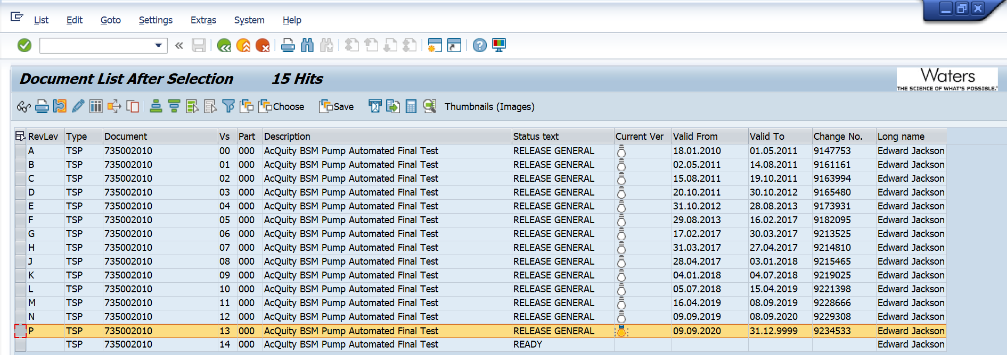

The 735001828 Rev E, Version 04, the Calibration/Maintenance for TE82943 was confirmed to be in SAP with a status of Release General. A screen capture from SAP is provided as follows:
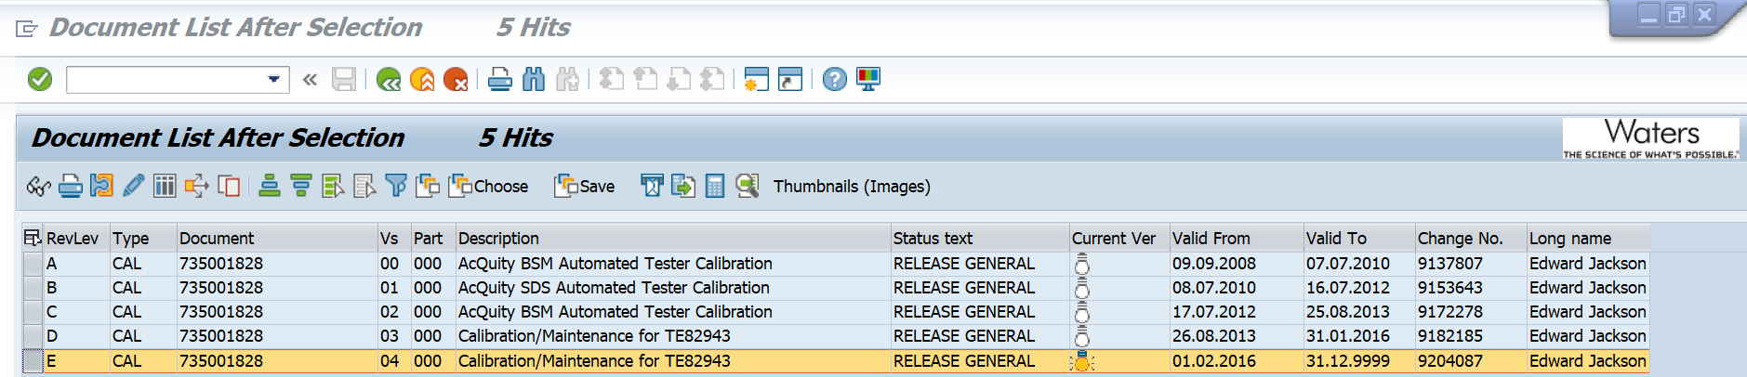

Test Script IQ-04: Software and Instrument Firmware Version was performed according to Installation Qualification Protocol 730004135, Ver. 03. The completed Test Script Data Sheet is provided as Attachment 7.4.

The Test Equipment Software version listed in 735002010, Rev P, Version 13 is Test Software 2.4. The test record of passing result is provided as Attachment 7.6.

The instrument firmware listed for P/N 186015061 is Version 1.72.415. A screen capture from the SAP is as follows:
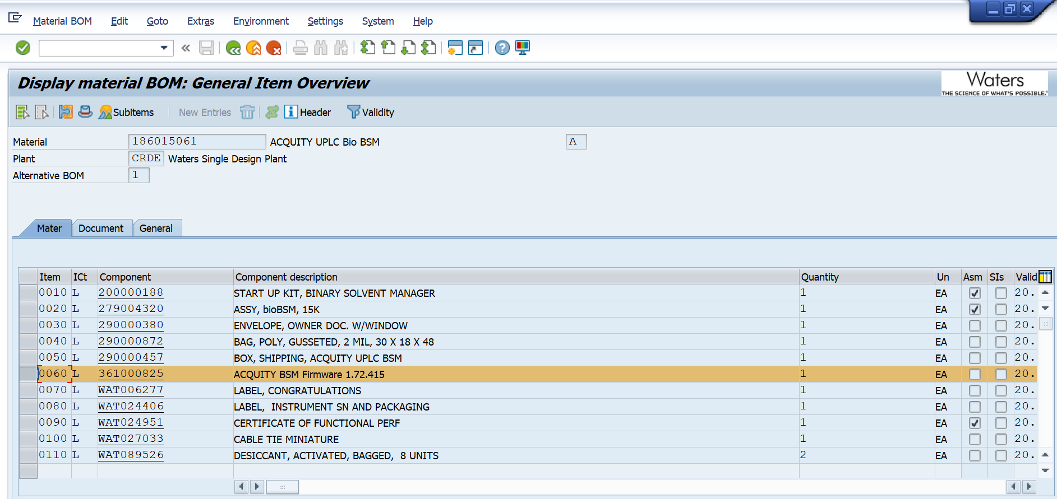

.

Test Script IQ-06: Functional Verification was performed according to Installation Qualification Protocol 730004135, Ver. 03. The completed Test Script Data Sheet is provided as Attachment 7.5.

One (1) UUT (P/N: 186015061) was tested using the TE82943-12, ACQUITY SDS Automated Test System with all tests passing, meeting the acceptance criteria of all required CTQ Specification measurements/conditions. The screenshot of passing result is provided as Attachment 7.6.

This table provides a summary of each test script as performed according to 730004135, Ver. 03 along with the attachment location of all objective evidence. The table also indicates any deviation taken from the scripts during qualification.
Script or Section | Pass/Fail | Objective Evidence | Deviations
IQ-01 | Pass | Attachment 7.3 | None
IQ-04 | Pass | Attachments 7.4, 7.5 and 7.6 | None
IQ-06 | Pass | Attachments 7.5 and 7.6 | None

ATTACHMENTS

Completed Executor Training Record 730004135, Ver. 03

Completed Operator Training Record 735002010, Rev P, Version 13

Completed Test Script IQ-01: Associated Document Verification

Completed Test Script IQ-04: Test Software and Instrument Firmware Version

Completed Test Script IQ-06: Functional Verification

Objective Evidence IQ-04 and IQ-06: Test record of passing UUT (P/N: 186015061)

DEVIATION FROM THE QUALIFICATION PROTOCOL
There were no deviations generated during the execution of the 730004135, Installation Qualification Procedure, Version 03, for TE82943-12, Acquity SDS Automated Test System.

REFERENCES
The following documents are referenced within this Report:
Document Number | Document title
730004135, Ver. 03 | Installation Qualification Protocol
735002010, Rev P, Version 13 | Test Specification and Procedure, Acquity BSM Pump Automated Final Test
735001828 Rev E, Version 04 | Calibration/Maintenance for TE82943
TE82943-VP | Validation Plan for the ACQUITY SDS Final Test Program – BSM Program

