IQ-04 Test Software and Instrument Firmware Version
Screenshot of Test Software showing Version 0.0
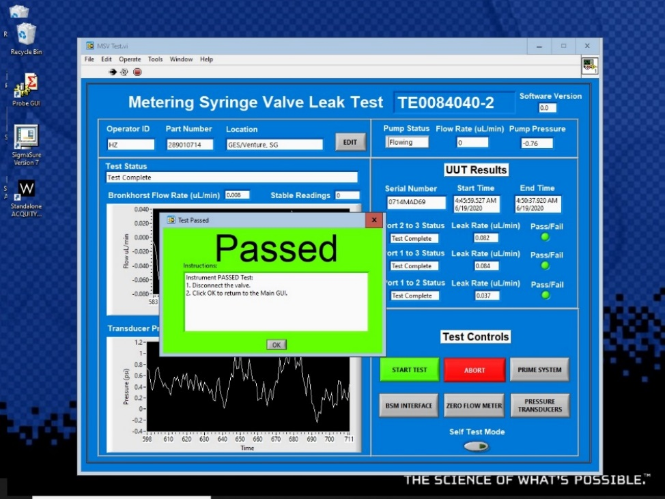

Screenshot of BSM interface showing Micro BSM Firmware Version 1.50.221.
