Test Script # | IQ-01 |  | IQ Test Name: | Associated Documentation Verification
Equipment # | TE82526 |  | Equipment Name: | Pump Tray Tester
Installation Site: | Flextronics Contract Manufacturing Site in Singapore
Purpose:
To verify that supporting documentation is available prior to the completion of qualification.
Test Execution:
- List all applicable documents (Preventive Maintenance, Calibration, Operating Procedures, Test Specification Procedures, Manufacturing Procedures, etc.) under the Document type header, then complete the table below. Rows may be added/removed as needed.
- All applicable documents must have a status of Ready, Pre-Rel-Prod, or Release General in SAP. If applicable documents are unavailable in SAP state why in the comments section.
Objective Evidence:
- Completed IQ-01 Test Script Data Sheet
- SAP screenshots of below available document(s)
Document Type |  | Title, Doc. #, Version/Revision # |  |  | Status in SAP | Initial & Date
TSP |  | TEST SPECIFICATION AND PROCEDURE, ALLIANCE PUMPTRAY, Rev 09 |  |  | RELEASE GENERAL
Comments:

Overall Test Conclusion
  Document No.: ______________________
  Iteration No.: ________
  Attachment: _______ Page: ___ of ___
Pass Fail

Test Script # | IQ -02 |  | IQ Test Name: |  |  | Site Verification
Equipment # | TE82526 |  | Equipment Name: |  |  | Pump Tray Tester
Installation Site: | Flextronics Contract Manufacturing Site in Singapore
Purpose:
To verify the location in which the test equipment is to be installed is suitable for use.
Test Execution:
- List additional applicable parameters in the Parameters column. Rows may be added as needed.
- Using the applicable equipment documentation, define the specification(s) in the Acceptance Criteria column.
- Verify and/or measure the applicable parameters and complete the Table below. Do not delete any of the listed defined parameters. Enter N/A for any parameter or cell that is not used or applicable. The reason for why the parameter is not used or applicable shall be explained within the corresponding Installation Qualification Report.
Objective Evidence:
- Completed IQ-02 Test Script Data Sheet
- Photo(s) of the work area, as applicable
- The source of each Acceptance Criterion shall be referenced in the IQR if stored in SAP. If not in SAP objective evidence specifying the Acceptance Criterion shall be provided in or as an attachment to the IQR.
- Copies of calibration certificates for measurement tools, if applicable
Parameters |  | Acceptance Criteria |  | As Found |  |  | Pass/Fail | Initial & Date
Ambient Temperature |  | 18 ºC to 28 ºC
Relative Humidity |  | 10 % to 80 %,  Non-Condensing
Electrical Supply |  | 100 VAC to 240 VAC,  50 Hz/60 Hz ±5%
Electrical Outlets |  | Minimum of 4  dedicated outlets
Network Available |  | Minimum of 1  dedicated network
Workspace |  | The system has sufficient room  for the test station, UUT and service
Test Station Bench |  | The Test Station Bench is large and  strong enough to support the station
Comments:
• Ambient temperature/humidity measured using a Temperature/Humidity Meter, Control Number
• Electrical supply measured using a Multimeter, Control Number

Note: If the electrical supply range or tolerance is not specified for voltage and/or frequency, a tolerance of ±5% may be used in accordance with ANSI C84.1 – Voltage Tolerance Standard.

Overall Test Conclusion
  Document No.: ______________________
  Iteration No.: ________
  Attachment: _______ Page: ___ of ___
Pass Fail

Test Script # | IQ-03 |  | IQ Test Name: | Instrumentation Calibration Verification
Equipment # | TE82526 |  | Equipment Name: | Pump Tray Tester
Installation Site: | Flextronics Contract Manufacturing Site in Singapore
Purpose:
To verify that all critical instruments are in the calibration database and that a calibration and/or a preventive maintenance has been performed, as appropriate.
Test Execution:
- List all critical instruments/components and/or sub-systems that require calibration and/or preventive maintenance in the Description column. Rows may be added as needed.
- Verify that all listed critical instruments/components have had a preventive maintenance and/or calibration performed in accordance with the PM and/or Calibration procedure(s) or by an outside source, and are listed within the associated calibration database, then complete the table below.
Objective Evidence:
- Completed IQ-03 Test Script Data Sheet
- Copies of calibration and/or maintenance certificates
- Screen captures from the associated Calibration database
Description |  | Asset # |  | Cal/PM Dates | Initial & Date
Electronics Weigh Balance |  | 12303631 |  | Last Cal/PM: 07 Feb 2020  Cal/PM Due: 07 Aug 2020
Comments:
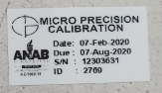

Overall Test Conclusion
  Document No.: ______________________
  Iteration No.: ________
  Attachment: _______ Page: ___ of ___
Pass Fail

Test Script # | IQ-04 |  | IQ Test Name: | Test Software and Instrument Firmware Version
Equipment # | TE82526 |  | Equipment Name: | Pump Tray Tester
Installation Site: | Flextronics Contract Manufacturing Site in Singapore
Purpose:
To verify that the installed software/firmware is correct per the applicable design and/or operational document(s).
Test Execution:
- List all relevant Equipment software and/or instrument firmware in the Description column. Specify the associated part number for the instrument firmware, if applicable. Rows may be added/removed as needed.
- List the associated required equipment software and/or critical instrument/internet connection sharing firmware version(s), as defined in the applicable design/operational document(s), in the Acceptance Criteria column.
- Verify that the software version displayed on the Operator Interface of the program and/or the firmware loaded on the instruments/PC match the acceptance criteria identically, if applicable, then complete the table below.
Objective Evidence:
- Completed IQ-04 Test Script Data Sheet
- Identify and/or provide a screen capture/print out/copy of the applicable design/operational document that defines the required software/firmware version(s) within or as an attachment to the associated Installation Qualification Report.
- Screen capture and/or test record displaying/indicating the software and/or firmware version(s), as applicable
Description |  | Acceptance Criteria |  | As Found | Pass/Fail | Initial & Date
TE82526 |  | Version: 1.0 |  | Version:
Comments:
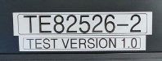

Overall Test Conclusion
  Document No.: ______________________
  Iteration No.: ________
  Attachment: _______ Page: ___ of ___
Pass Fail

Test Script # | IQ-05 | IQ Test Name: |  | General Safety and Alarms
Equipment # | TE82526 | Equipment Name: |  | Pump Tray Tester
Installation Site: | Flextronics Contract Manufacturing Site in Singapore
Purpose:
To verify that the equipment can operate in a safe manner, within its designated location.
Test Execution:
- List any additional safety related conditions or alarms in the Safety Inspection column, such as: guarding, interlocks, thermal or mechanical safety, chemical, secured gas tanks, restart or power loss, emergency stop, environmental exhaust, electrical safety, noise, safety labels, etc. Rows may be added as needed. EH&S shall be consulted as necessary.
- List the associated safety requirement(s)/specification(s) in the Acceptance Criteria column.
- Perform an inspection/test of the equipment to assess its safety related conditions, then complete the table below.
Objective Evidence:
- Completed IQ-05 Test Script Data Sheet
- Photo(s) of the secured glass bottles, tanks, etc., if applicable
- The source of any applicable Acceptance Criterion shall be summarized in the IQR if stored in SAP. If the source is not stored in SAP, at a minimum the page specifying the applicable Acceptance Criterion shall be provided as an attachment.
Safety Inspection |  |  | Acceptance Criteria |  |  |  |  | Pass/Fail | Initial & Date
Mechanical Safety/  Pinch Points/Sharp Edges |  |  | None Found (or mitigated appropriately)
Glass Bottles |  |  | Secure
Waste Tanks |  |  | Secure and located below the system
Emergency Stop |  |  | System ceases operation upon  depressing the Emergency Stop button
Guarding |  |  | Shielding in place to prevent  hazard during operation
Comments:

Overall Test Conclusion
  Document No.: ______________________
  Iteration No.: ________
  Attachment: _______ Page: ___ of ___
Pass Fail
Test Script # | IQ-06 | IQ Test Name: |  | Functional Verification
Equipment # | TE82526 | Equipment Name: |  | Pump Tray Tester
Installation Site: | Flextronics Contract Manufacturing Site in Singapore
Purpose:
To verify that the system operates as expected.
Test Execution:
- Select the UUT(s) or tests to be performed as defined within the Installation Qualification Section of 730001835.
- List the Part Number and Serial Number, if applicable, in the UUT Part Number/Serial Number column.
- Define the appropriate Acceptance Criteria within the Acceptance Criteria column.
- Perform a test of the UUT(s), verify the Acceptance Criteria, then complete the table below. If an associated Test Record is being used as objective evidence the Header/Footer information should be verified for accuracy.
Objective Evidence:
- Completed IQ-06 Test Script Data Sheet
- Copy of the Test Record(s) for the UUT(s), as applicable
- The UUT(s) selected for this Test Script and the reasoning for why it/they were selected shall be summarized within the associated Installation Qualification Report.
- If this Acceptance Criteria is other than “All required CTQ Specification measurements result in a Pass” then it shall be summarized within the associated VAF, Process Validation Plan, and/or Installation Qualification Report.
- For systems that download firmware to product the BOM showing the firmware requirement shall be provided within the IQR.
UUT Part Number/Serial Number |  |  | Acceptance Criteria |  |  |  | Pass/Fail |  |  | Initial & Date
Part Number:  Serial Number: |  |  | All required CTQ Specification measurements result in a Pass
Comments:

Overall Test Conclusion
  Document No.: ______________________
  Iteration No.: ________
  Attachment: _______ Page: ___ of ___
Pass Fail
Appendix A: TRAINING RECORD
Document # | WAT210700 | Document Title | tEST sPECIFICATION AND pROCEDURE, Alliance Pumptray | Version | 00
 |  |  |  | Revision | 09

Training Performed By: (If not used this section can be deleted)
Printed Name | Signature | Date
Read and Understood (If self-trained – If not self-trained this section can be deleted)
By signing you acknowledge that you have reviewed, understand, and agree to comply with the policies and practices of the procedure defined above.
Printed Name | Signature | Initials | Date
Print multiple copies of this Training Record Template as needed

Document No.: ______________________
Iteration No.: ________
Attachment: _______ Page: ___ of ___

DOCUMENT HISTORY
(Note: Complete Document History may be obtained via the Document Management System.)

Version: | 03 | Originator: | James Stors | Change ID: | N/A
Summary of Change: Changed the 730001835 document name to be current. Modified the Workspace and the Test Station Bench checks of IQ-02 Test Script Data Sheet to Pass/Fail. Added the ANSI C84.1 electrical supply tolerance specification to the Comments Section of the IQ-02 Test Script Data Sheet. Updated the Related Documents Section to be current. Updated to the current Template format.

Version: | 02 | Originator: | James Stors | Change ID: | N/A
Summary of Change: Edited for overall grammar and terminology. Updated the Abbreviation section. Changed Performer to Executor. Updated the Records section to reference 730001835. Added Health & Safety Section. Section 8 updated to guide the Originator to type in descriptive/acceptance criteria in the Test Script Data Sheets and Training Form. Test Script Data Sheets updated to utilize gray cells for guidance and to provide a specified location for the Attachment Stamp/Marking. Removed blank rows from the Test Script Data Sheets. Removed the Electrical Safety Hi Pot/Ground Continuity test from IQ-05 Test Script Data Sheet. Added additional safety considerations to the Test Execution of IQ-05 Test Script Data Sheet. Added the Document Control Section marking to the Test Script Data Sheets and the Training Record appendix.

Version: | 01 | Originator: | N/A | Change ID: | N/A
Summary of Change: Abandoned

Version: | 00 | Originator: | James Stors | Change ID: | N/A
Summary of Change: Initial Release of the Installation Qualification Protocol.

IQ-02 TEST SCRIP DATA SHEET:

AMBIENT TEMPERATURE: 21 ºC to 22 ºC
Verified using
THERMOHYGROGRAPH
Serial Number : 5650
EQID : 0418EQID : 0418
Calibration Due Date: 07-Jan-2021

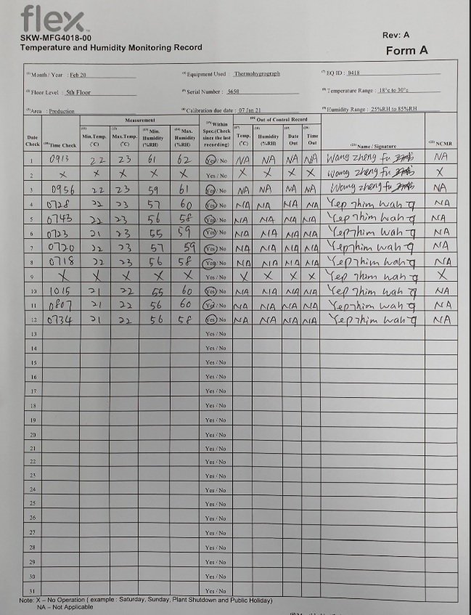

RELATIVE HUMIDITY: 56 % to 58 %
Verified using
THERMOHYGROGRAPH
Serial Number : 5650
EQID : 0418EQID : 0418
Calibration Due Date: 07-Jan-2021

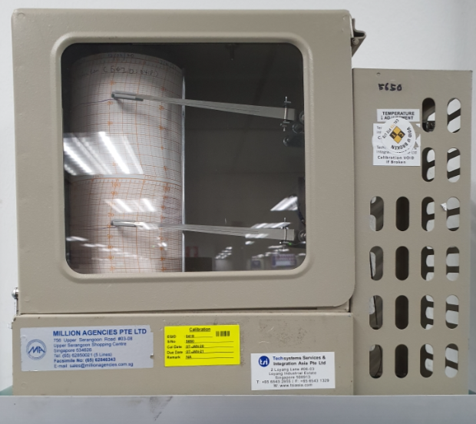

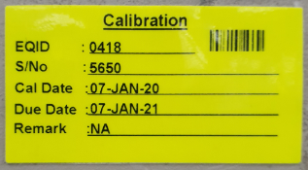

ELECTRICAL SUPPLY : Minimum 4 dedicated outlets
Verified using :
FLUKE 110 TRUE RMS MULTIMETER
Serial Number: 85730619
EQID: 0245
Calibration Due Date: 16-Dec-2020

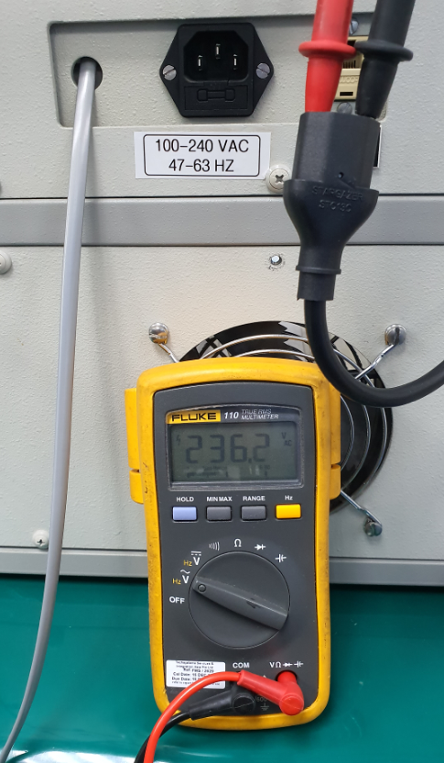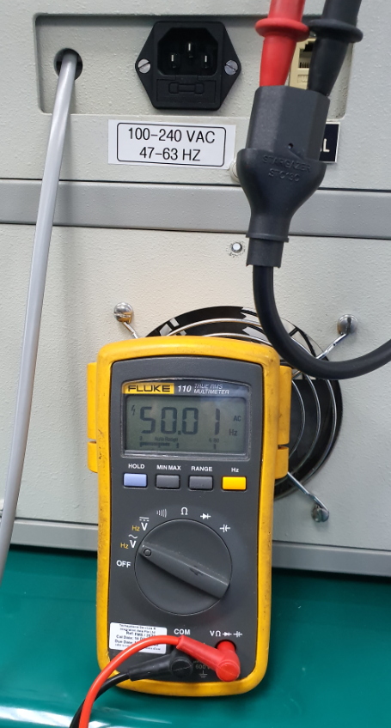

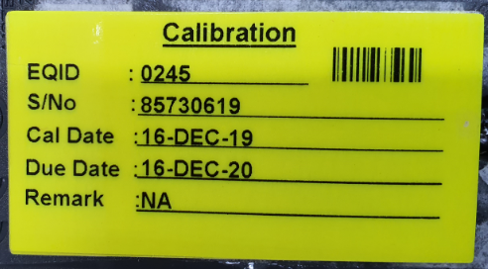

ELECTRICAL OUTLET
Computer Work
Station (AC Line CPU)
TE82526-2 Pump
Tray Tester (AC Line)
LCD Monitor (AC Line_

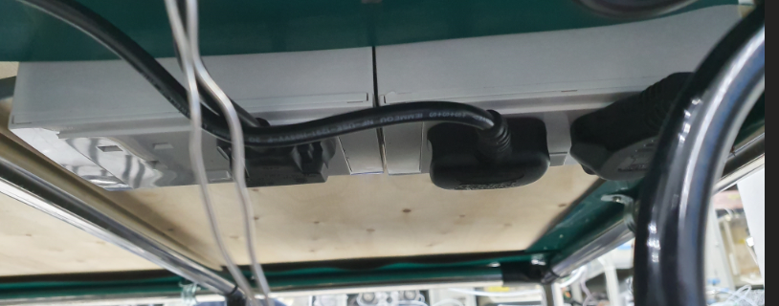

AND HR 200 Electronics Balance (AC Line)
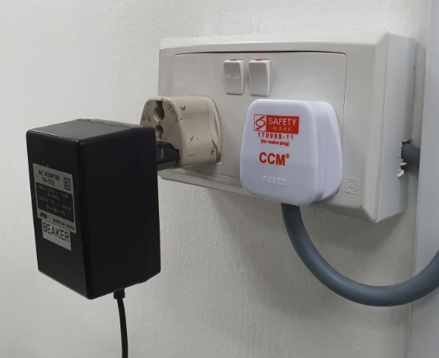

NETWORK AVAILABLE : Minimum of 1 dedicated network
Blue Sticker : WS-8 is a dedicated network

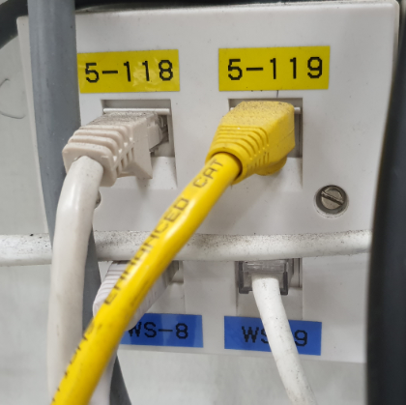

WS-8 is a dedicated network

WORK SPACE: The system has sufficient room for the test station, UUT and service
TE82526-2 Pump
Tray Tester
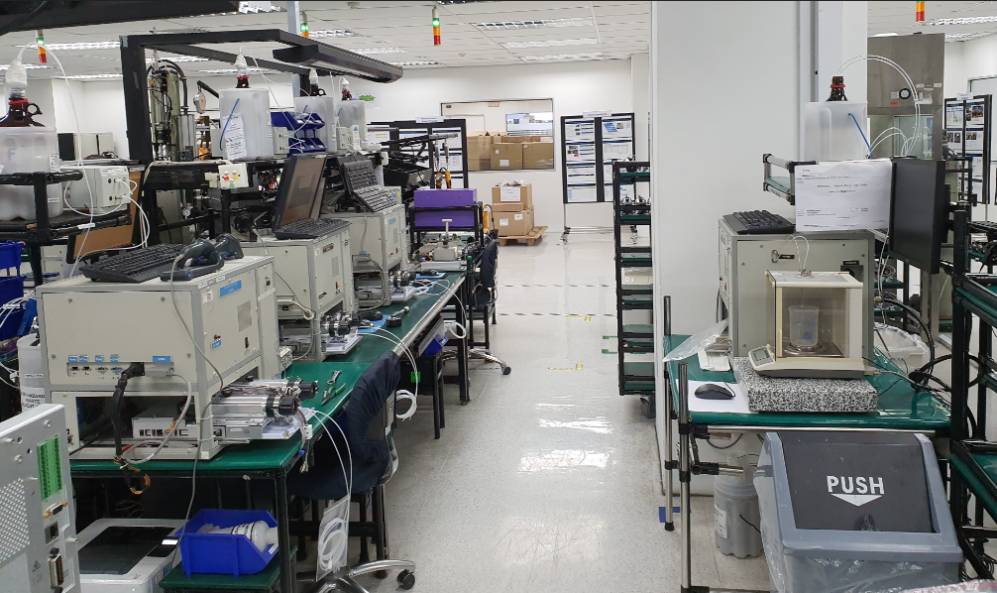

TEST STATION BENCH : The test station bench is lasge and strong enough to support the station 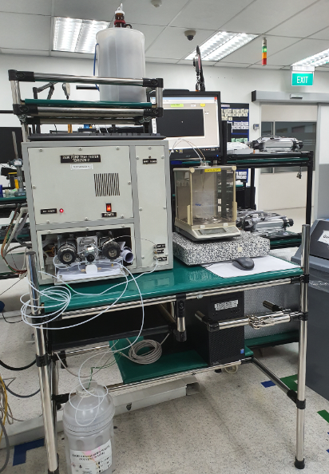
Test Station Bench

IQ-05 Test Script Data Sheet:

Station does not have Pinch Points/ sharp edges
Glass Bottle is secured by plastic container
Glass Bottles secured inside the container

Secure Glass Bottle
Wastes Bottle / Glass secured inside the container

IQ-06 Test Script Data Sheet:
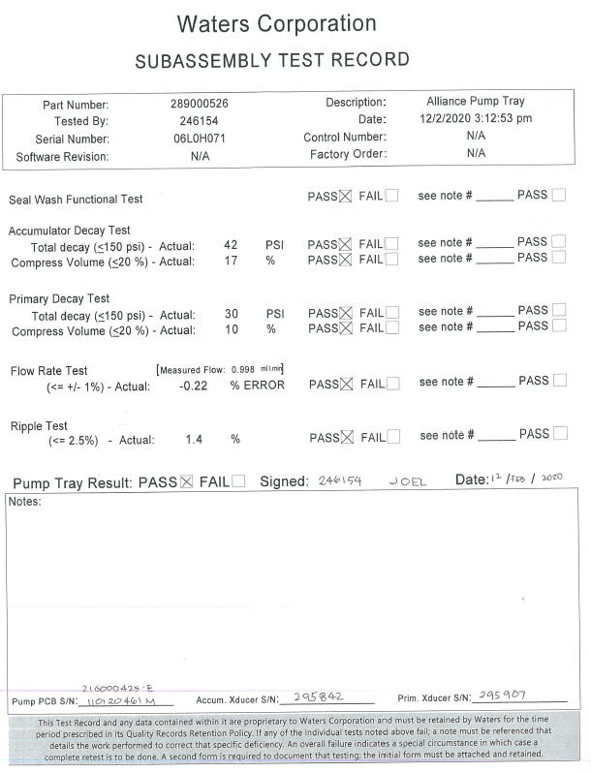
Appendix A: TRAINING RECORD
