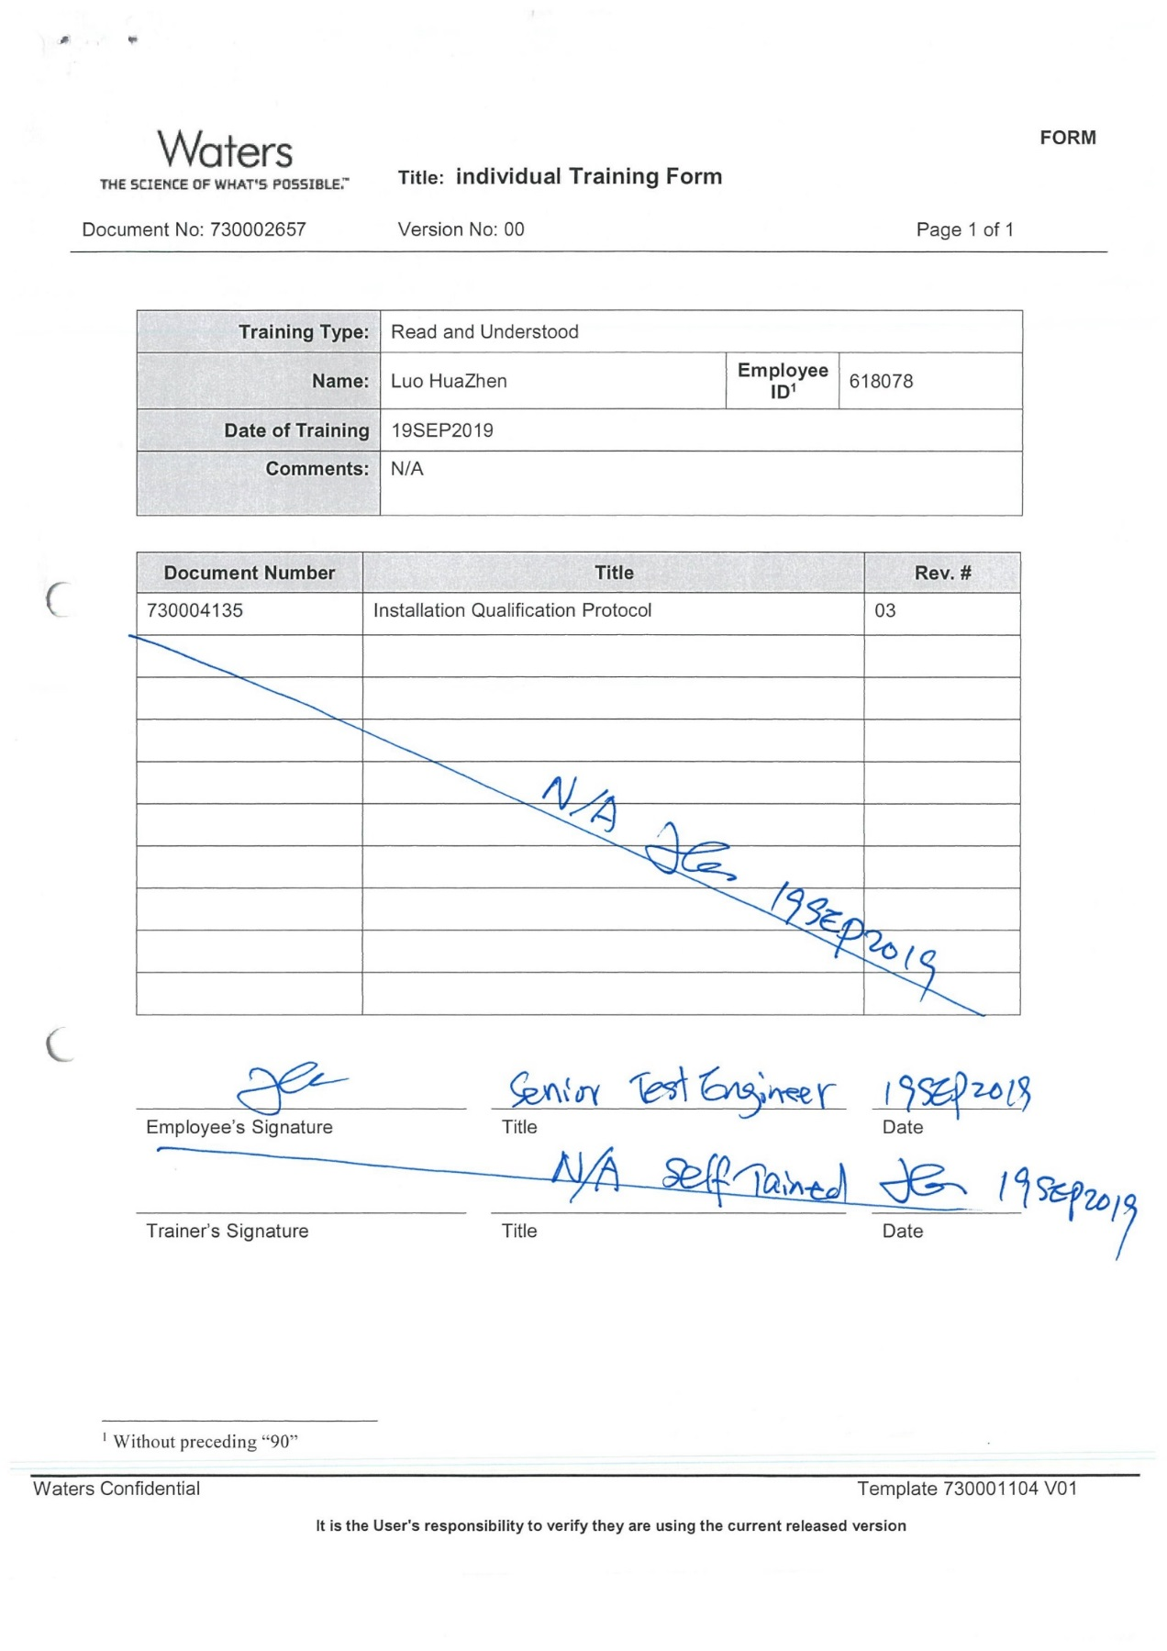

IQ-02 TEST SCRIP DATA SHEET:

AMBIENT TEMPERATURE: 21 ºC to 22 ºC
Verified using
THERMOHYGROGRAPH
Serial Number : 5650
EQID : 0418EQID : 0418
Calibration Due Date: 07-Jan-2021
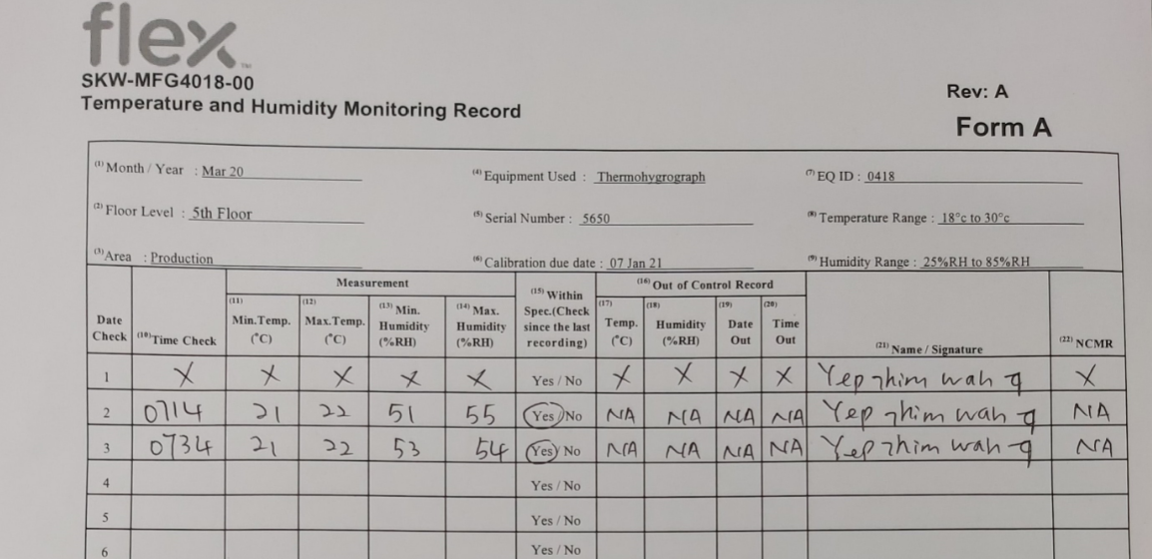

RELATIVE HUMIDITY: 51 % to 55 %
Verified using
THERMOHYGROGRAPH
Serial Number : 5650
EQID : 0418
Calibration Due Date: 07-Jan-2021

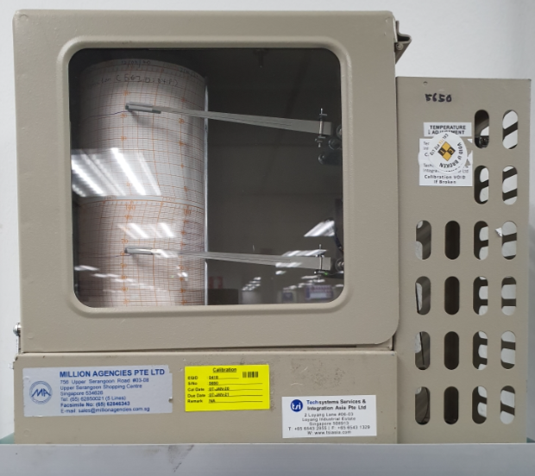

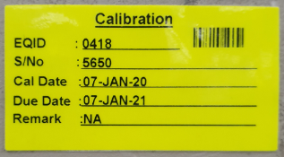

ELECTRICAL SUPPLY :
Verified using :
FLUKE 110 TRUE RMS MULTIMETER
Serial Number: 85730619
EQID: 0245
Calibration Due Date: 16-Dec-2020
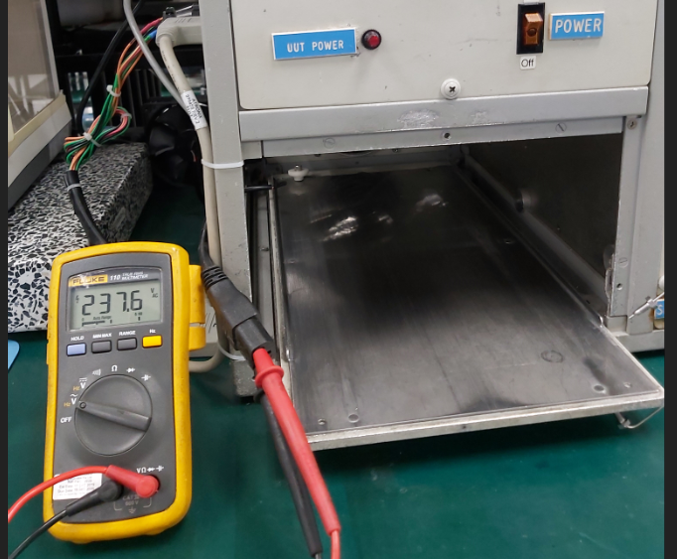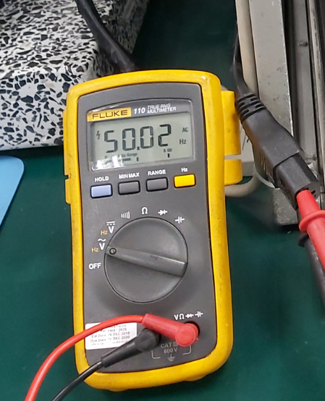

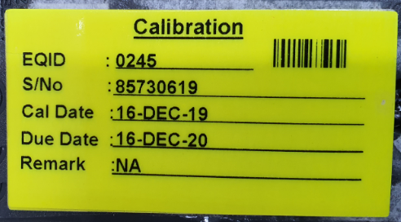

Minimum 4 dedicated outlets

ELECTRICAL OUTLET
Computer Work
Station (AC Line CPU)
LCD Monitor (AC Line_

TE82526 Pump
Tray Tester (AC Line)

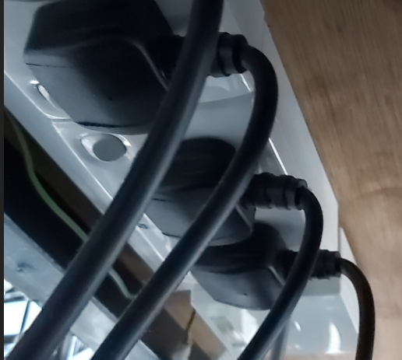

AND HR 200 Electronics Balance (AC Line)

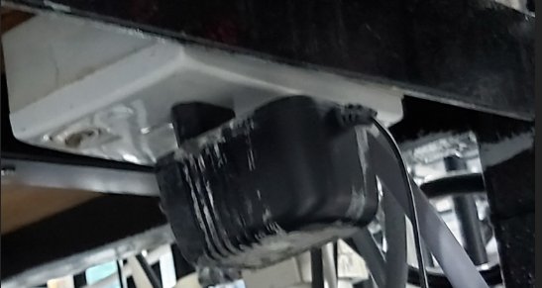

NETWORK AVAILABLE: Minimum of 1 dedicated network
Blue Sticker : Dedicated network for Pump Tray Area

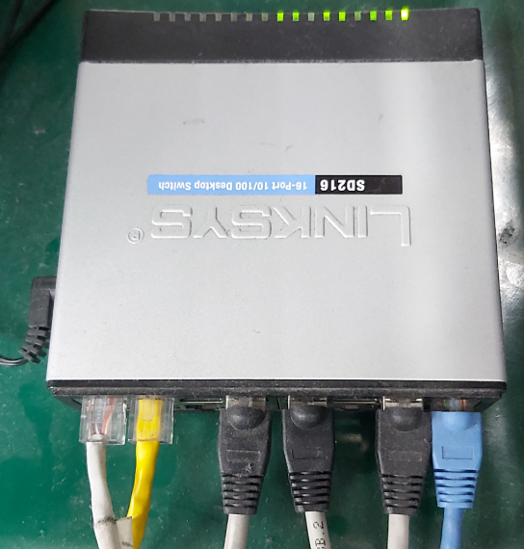

WS-9 is a dedicated network

WORK SPACE: The system has sufficient room for the test station, UUT and service
TE82526 Pump
Tray Tester
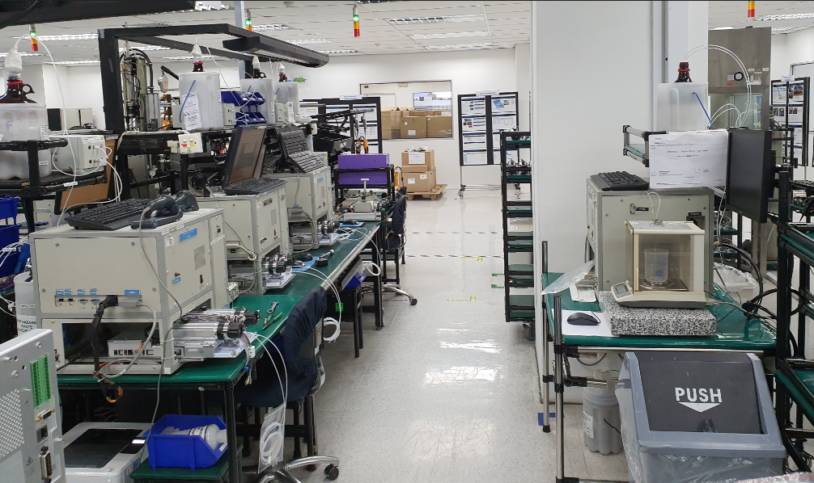

TEST STATION BENCH : The test station bench is large and strong enough to support the station
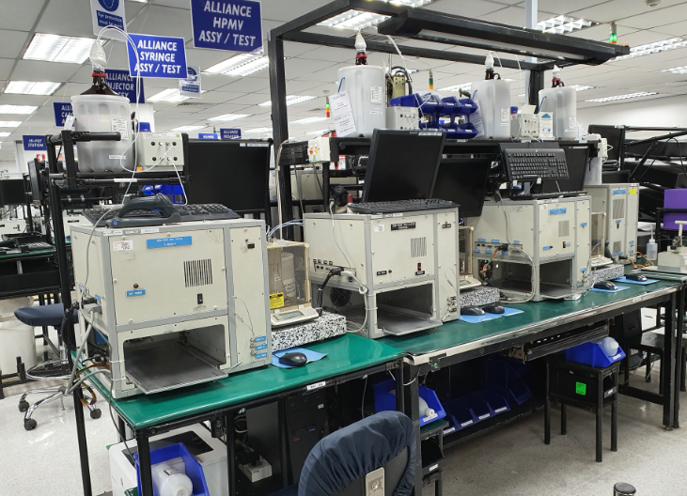
Test Station Bench

IQ-04: Test Software and Instrument Firmware Version

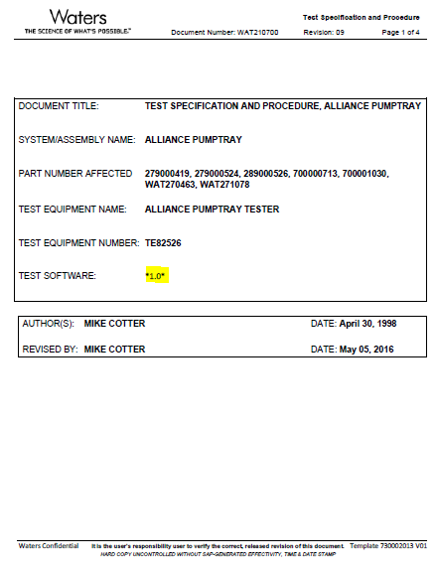

IQ-04: Test Software and Instrument Firmware Version

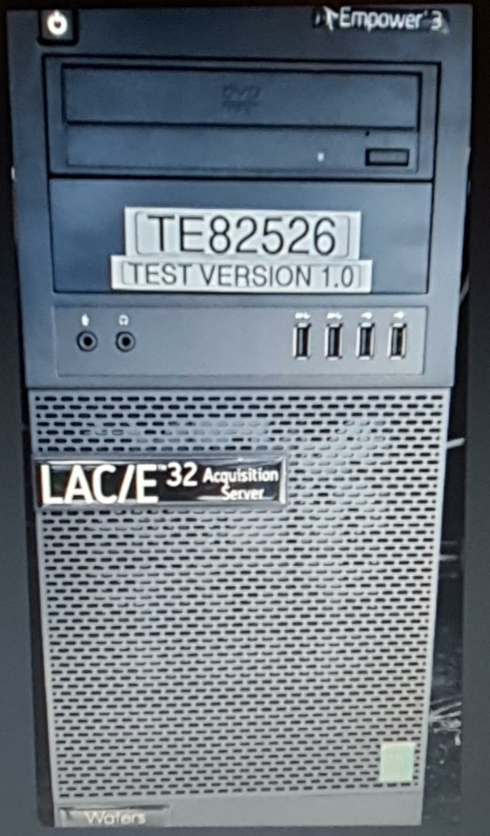

IQ-05 Test Script Data Sheet:

Station does not have Pinch Points/ sharp edges
Glass Bottle is secured by plastic container
Glass Bottles secured inside the container
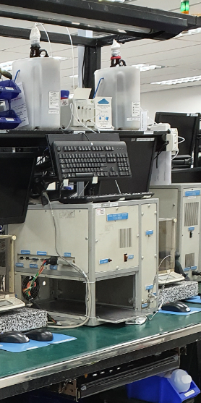
Waste Bottles secured inside the container
Wastes Bottle / Glass secured inside the container

