IQ-01 Associated Documentation Verification
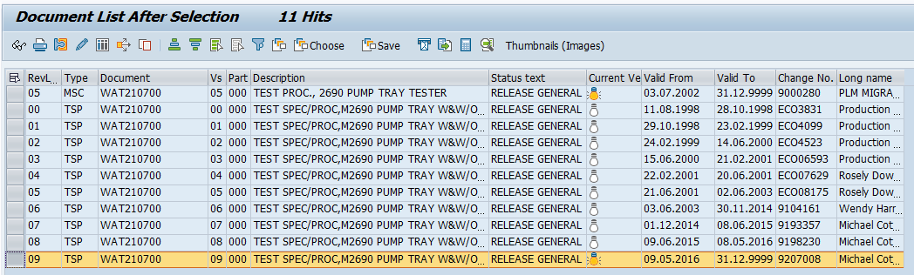

IQ-02 TEST SCRIP DATA SHEET:

AMBIENT TEMPERATURE: 21 ºC to 22 ºC
Verified using
THERMOHYGROGRAPH
Serial Number : 5650
EQID : 0418EQID : 0418
Calibration Due Date: 07-Jan-2021

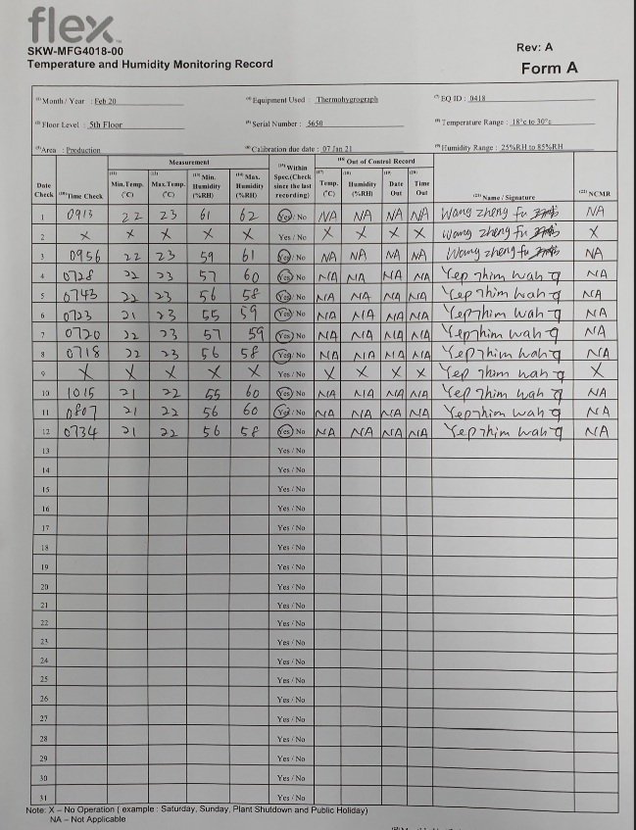

RELATIVE HUMIDITY: 56 % to 58 %
Verified using
THERMOHYGROGRAPH
Serial Number : 5650
EQID : 0418EQID : 0418
Calibration Due Date: 07-Jan-2021

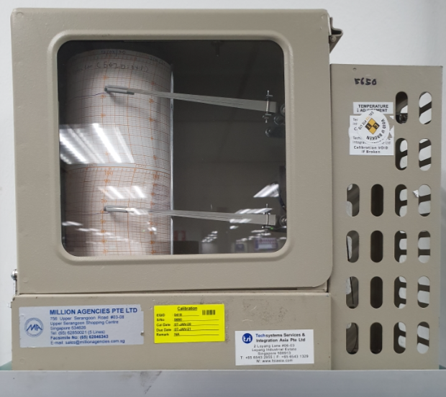

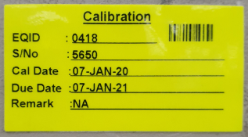

ELECTRICAL SUPPLY : Minimum 4 dedicated outlets
Verified using :
FLUKE 110 TRUE RMS MULTIMETER
Serial Number: 85730619
EQID: 0245
Calibration Due Date: 16-Dec-2020
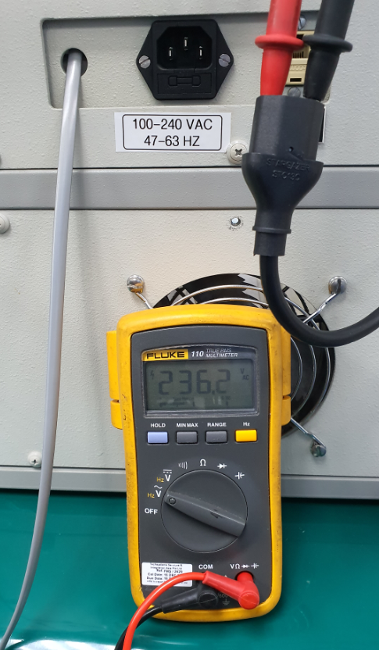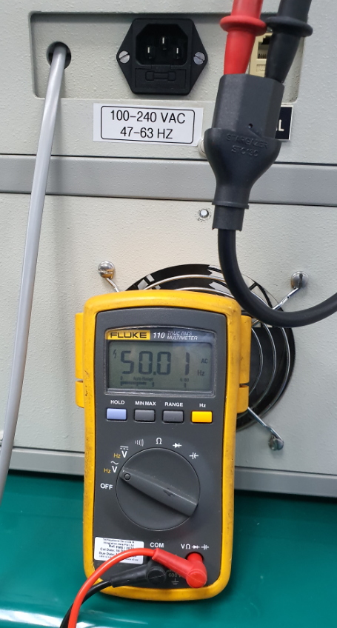

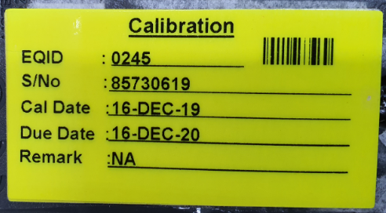

ELECTRICAL OUTLET
TE82526-2 Pump
Tray Tester (AC Line)
Computer Work
Station (AC Line CPU)
LCD Monitor (AC Line_

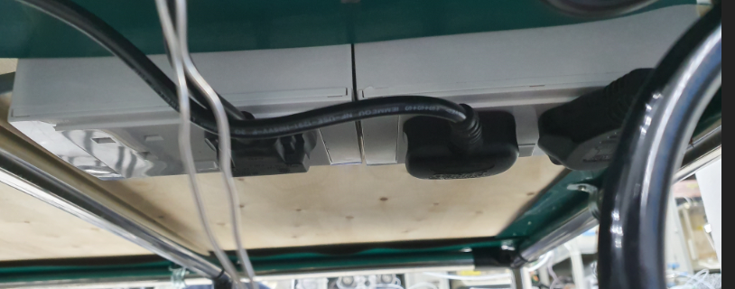
AND HR 200 Electronics Balance (AC Line)

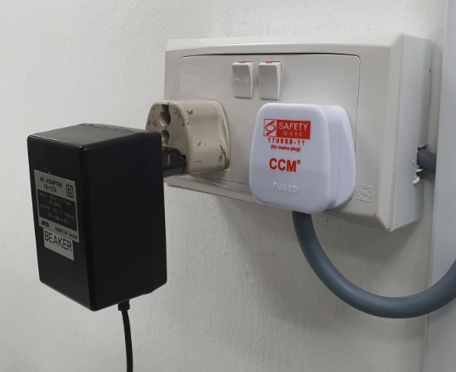

NETWORK AVAILABLE : Minimum of 1 dedicated network
Blue Sticker : WS-8 is a dedicated network

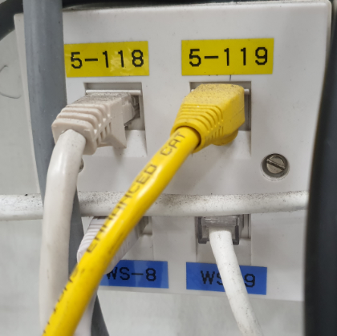

WS-8 is a dedicated network

WORK SPACE: The system has sufficient room for the test station, UUT and service
TE82526-2 Pump
Tray Tester
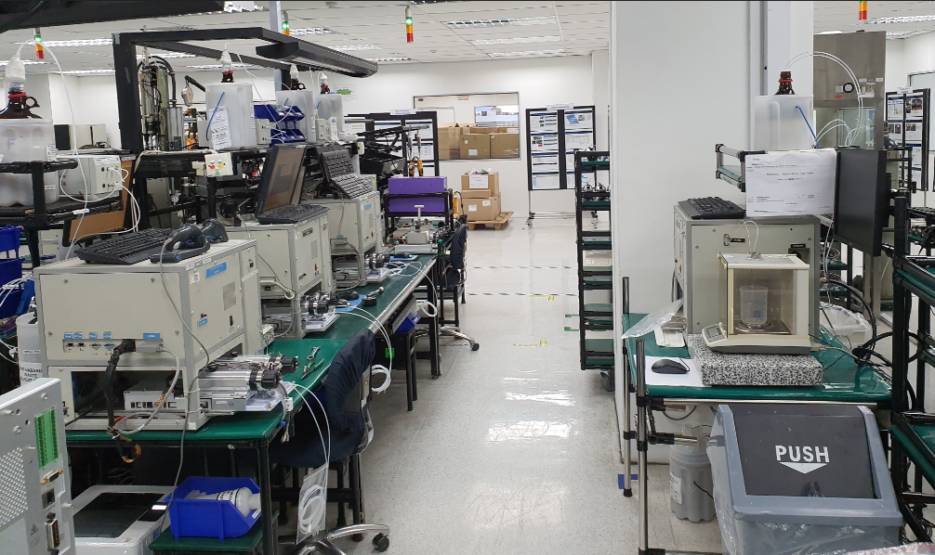

TEST STATION BENCH : The test station bench is large and strong enough to support the station 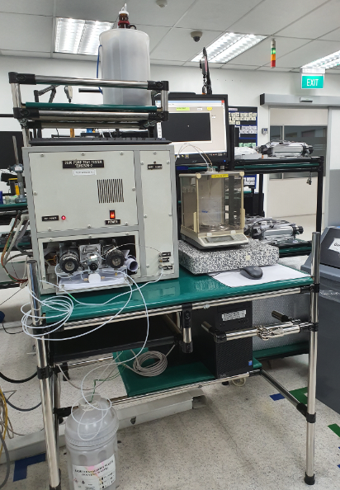
Test Station Bench

IQ-04 Software and Instrument Firmware Version

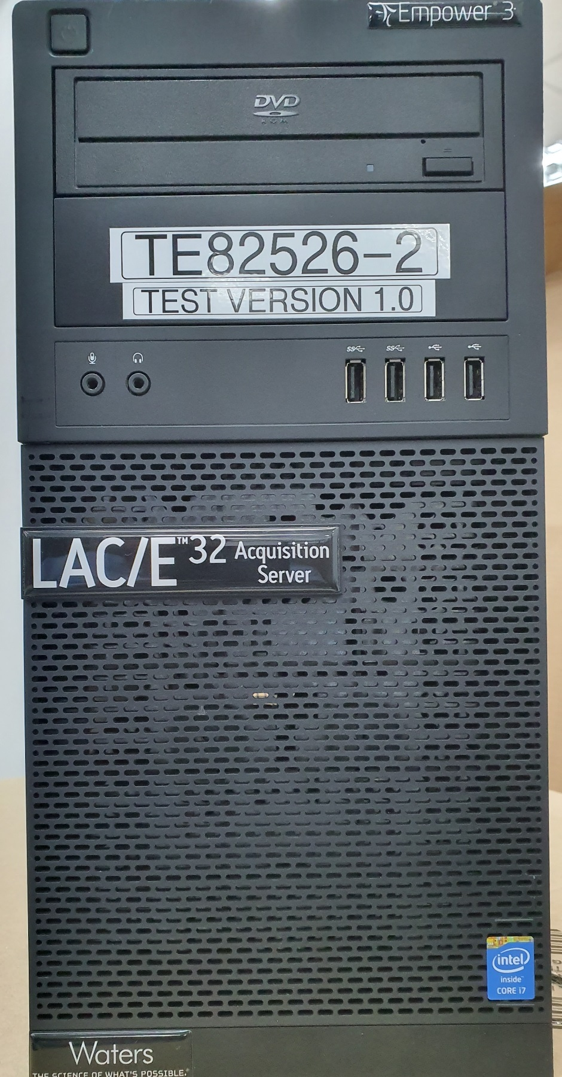

IQ-05 Test Script Data Sheet:

Station does not have Pinch Points/ sharp edges
Glass Bottle is secured by plastic container
Glass Bottles secured inside the container
Secure Glass Bottle

Wastes Bottle / Glass secured inside the container

IQ-06 Test Script Data Sheet:
