INSTALLATION QUALIFICATION REPORT
For the 2489 ACQUITY TUV Pre-test Download Station (TE82964-1)

PREPARED BY

Name | Role | Signature | Date
James J. Stors | Senior Test Validation Engineer

REVIEWED BY

Name | Role | Signature | Date
Mark Jussaume | Senior Test Engineer

APPROVED BY

Name | Role | Signature | Date
Andre Kopoyan | Senior Operations Quality Engineer

The “Prepared By” signature denotes that this document accurately describes the qualification activities.

The “Reviewed By” signature[s] denotes agreement with the description of the qualification activities.

The “Approved By” signature denotes that this document has been reviewed and approved for overall quality and completeness.

REVISION HISTORY

Version | Author | Summary of change
00 | Emma Pierce | First document for approval.
01 | James J. Stors | Firmware change based on the Denim Driver Pack Project.

Purpose
The 2489 ACQUITY TUV Pre-Test Download Station (TE82964-1) is located at Contract Manufacturer Flextronics in Singapore. The system is designed to download instrument firmware and assign the instrument serial number for 2489 and ACQUITY TUV Detectors and has been classified as Fit for Use.

Scope of Report
This Installation Qualification is being performed as required by Project DENIM. This Installation Qualification Report details the requalification activities undertaken for the 2489 ACQUITY TUV Pre-test Download Station (TE82964-1) based on the requirements of the Installation Qualification Procedure, 730004135 Ver. 00, per TE82964-1-22JAN18-VAF.
The Denim Project results in a change of firmware loaded onto TUV Detector Models 186015028 and 186015031, which will be verified through the Execution of Test Script 04 – Test Software and Instrument Firmware Version, as follows:
- Model 186015028, ACQUITY UPLC TUV Detector will require Firmware 1.70.2710.
- Model 186015031, ACQUITY UPLC TUV Detector TC will require Firmware 1.70.2698.

Summary of Results - Statement of Fitness for Intended Use
The 2489 ACQUITY TUV Pre-test Download Station was tested in accordance with Installation Qualification Procedure, 730004135 Ver. 00, per TE82964-1-22JAN18-VAF. The required Test Script was performed and all objective evidence requirements have been met.
Waters now has the necessary documentation in place to ensure that the 2489 ACQUITY TUV Pre-test Download Station complies with Waters’ requirements, the latest relevant quality system regulations, and cGMP practices.
Following the approval of this Qualification Report, the 2489 ACQUITY TUV Pre-test Download Station (TE82964-1) remains fully qualified and fit for intended use.

Glossary
The following definitions are used in this document:
Term | Explanation
IQ | Installation Qualification
IQR | Installation Qualification Report
N/A | Not Applicable
ECR | Engineering Change Request
BOM | Bill of Material
TSP | Test Specification and Procedure
cGMP | Current Good Manufacturing Practice
VAF | Validation Assessment Form
UPLC | Ultra Performance Liquid Chromatography
UUT | Unit Under Test
TUV | Tunable UV/Vis Absorbance Detector
SAP | Enterprise Resource Planning (ERP) software

Training

The Executor of the 730004135, Installation Qualification Procedure, is the Author and is therefore trained. The Executor was trained to 735001617, 2489 – ACQUITY TUV Download/Pre-test Test Specification and Procedure (TSP) and a Training Record is provided as Attachment 7.1.

Qualification Results

Test Script IQ-04: Software and Instrument Firmware Version was performed according to Installation Qualification Procedure 730004135, Ver. 00, per TE82964-1-22JAN18-VAF. The completed Test Script Data Sheet is provided as Attachment 7.2.

Per ECR 9219848, the BOM of Model 186015028, ACQUITY UPLC TUV Detector, has been modified to specify Firmware Version 1.70.2710. A screen capture of the BOM from SAP showing the Firmware is provided below:
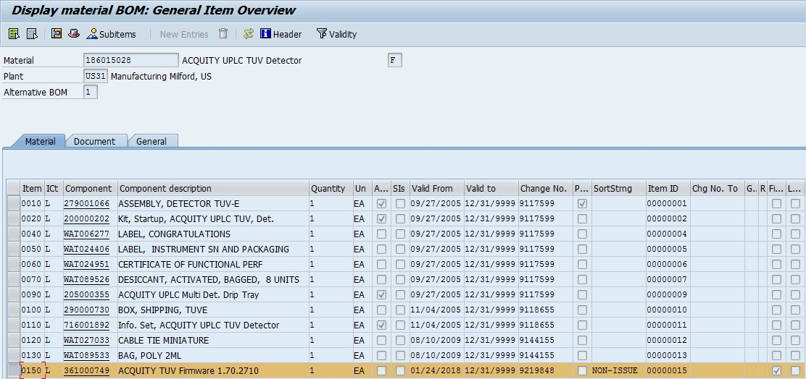

Per ECR 9219848, the BOM of Model 186015031, ACQUITY UPLC TUV Detector TC, has been modified to specify Firmware Version 1.70.2698. A screen capture of the BOM from SAP showing the Firmware is provided below:
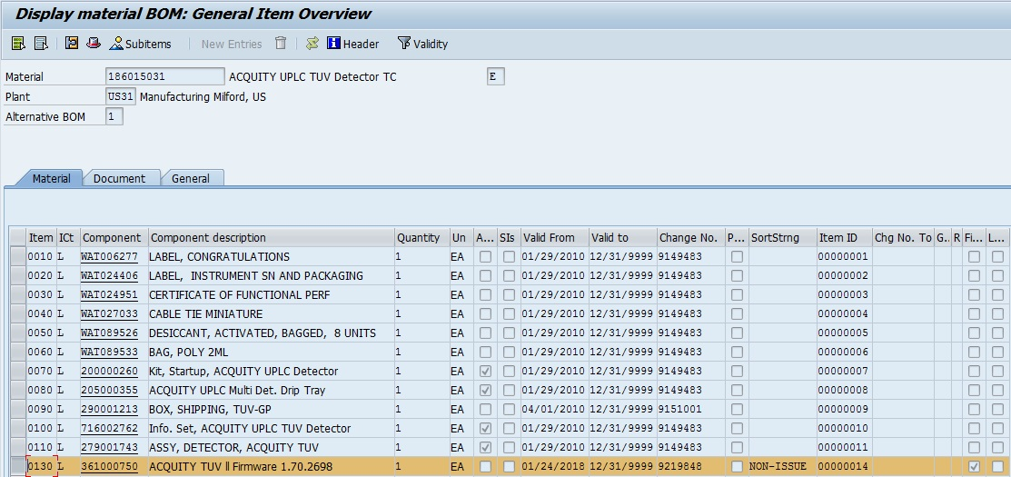

The test station was used to download Firmware for the Model 186015028, ACQUITY UPLC TUV Detector. The Firmware loaded by the system was verified using HyperTerminal and met the requirement of loading Version 1.70.2710, as shown in the screen capture below:
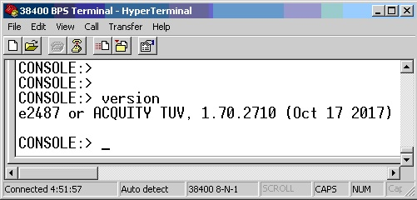

Model 186015028, ACQUITY UPLC TUV Detector, as specified by TE82964-1-22JAN18-VAF, was not available for testing during the execution of Test Script IQ-04: Software and Instrument Firmware Version, as summarized in Section 8.0, Deviation from Test Equipment Qualification.

The test station was used to download Firmware onto one (1) Model 186015031 UUT. The Firmware loaded by the system was verified using HyperTerminal and met the requirement of loading Version 1.70.2698, as shown in the screen capture below:

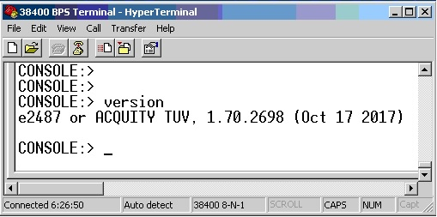

A summary of the attached objective evidence is provided in the Table below:
Script or Section | Pass/Fail | Objective Evidence | Deviations
IQ-04 | Pass | Attachments 7.2 | Section 8.1 – Deviation #1

Attachments

Training Record for 735001617, 2489 – ACQUITY TUV Download/Pre-test Test Specification and Procedure

IQ-04: Test Software and Instrument Firmware Version Test Script Data Sheet

Deviation from Test Equipment Qualification
There was one deviation found during the execution of the Installation Qualification Procedure 730004135 Ver. 00, per
TE82964-1-22JAN18-VAF, for TE82964-1, 2489 ACQUITY TUV Pre-Test Download Station.

Deviation #1
Description: TE82964-1-22JAN18-VAF requires the loading of the new Firmware Version 1.70.2710 onto one (1) Model 186015028, ACQUITY UPLC TUV Detector. The required UUT Model was not available for testing during the execution of Test Script IQ-04: Software and Instrument Firmware Version.
Corrective Action: A Model N2971036 A-30 UV Detector was used for the Firmware Version 1.70.2710 verification test. The Executor used the test station to download Firmware Version 1.70.2710 onto the Model N2971036 A-30 UPLC TUV Detector by selecting Model 186015028, ACQUITY UPLC TUV Detector.
Resolution: The Corrective Action defined above is acceptable as the N2971036 A-30 UV Detector is functionally similar to the Model 186015028, ACQUITY UPLC TUV Detector, enabling the system to load the new Firmware that is being verified by this test. The intent of the test is to verify that the new Firmware Version 1.70.2710 loaded onto the Detector when Model 186015028, ACQUITY UPLC TUV Detector is selected. Since the Firmware Version 1.70.2710 was verified to have been loaded onto the UUT, as detailed in Section 6.1.3. the Deviation does not affect the overall Passing result.

References
The current approved versions of the following documents are referenced within this report:
Document Number | Document title
730004135, Ver. 00 | Installation Qualification Procedure
735001617, Ver. 09 | 2489 – ACQUITY TUV Download/Pre-test Test Specification and Procedure
ECR 9219848 | Engineering Change Request for Project DENIM
TE82964-1-22JAN18-VAF | Validation Assessment Form for Project DENIM TUV Implementation

