Note: Added by Matt B. 16 January 2019
On two Windows 10 installs I have found the below instructions not to work. After much messing around and trying things, what seemed to work was to reinstall the Sigma Probe Service (Step 1 below). This reinstall behaved differently on both machines, one required a reboot one did not, one restarted the probe automatically, one did not, Java reinstall or not, etc. But both ultimately worked after a reinstall, reconfiguring the config.xml file, and restarting the service. Wanted to document it here so we can figure out the optimum way to get Probe to work with Win 10…..

Camstar SigmaProbe Installation Guide

5/10/14
NI LabVIEW: Integration Guidelines
In this installation guide main purpose is to help install the LabVIEW wrapper VI for Camstar ActiveX API calls along with a manual step that is required for Windows 7 64bit operating system. Also, there one other installer that is required for LabVIEW support including the LabVIEW wrapper driver for Camstar SigmaProbes.

Step 1. Install SigmaProbe Service
The following steps are for sigmaprobe installation process.
- Download the latest available SigmaProbe installer from finserv.
- Start the installation process by launching SigmaProbe7.1.exe
A window similar to the one shown in Figure 1 will appear.
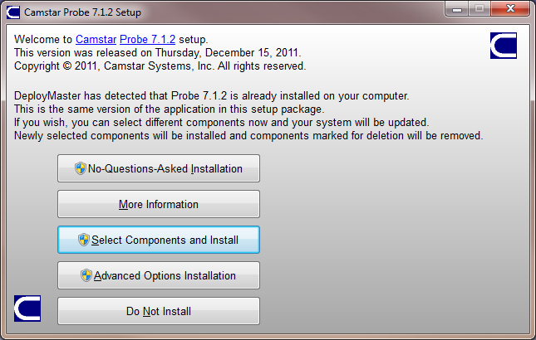
Figure 1 Example of the Camstar SigmaProbe installer
- Select No-Question-Asked Installation to continue to End User License Agreement.

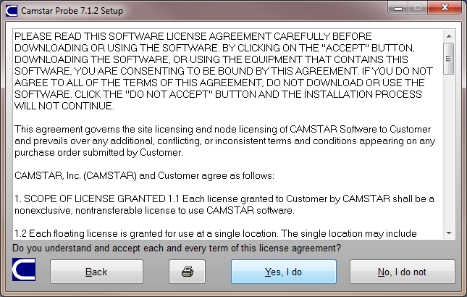
Figure 2 Example of End User Licesne Agreement
  - Select Yes, I do
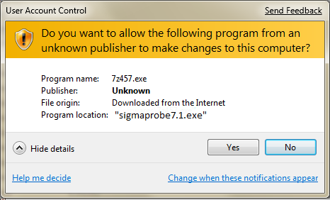
Figure 3 Example User Account Control screen
- Select Yes
- Once, software is installed registration information is entered into the You name and Your company as shown in the Figure 4.
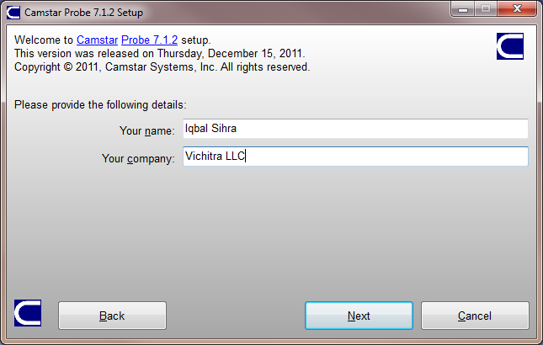
Figure 4 Example of Registration Information

Step 2. Install ActiveXAPI
The following steps are for ActiveX API installation process.
- Download the latest available ActiveX API installer from the Camstar wevsite.
SigmaProbe7.1.zip is available at http://sites.camstar.com/sigmaprobe/download.shtml
- Start the installation process by selecting Start > Run > Browse, navigate to the “ActiveXAPI.exe” file, and select Open to start the installation wizard.
A window similar to the one shown in Figure 5 will appear.
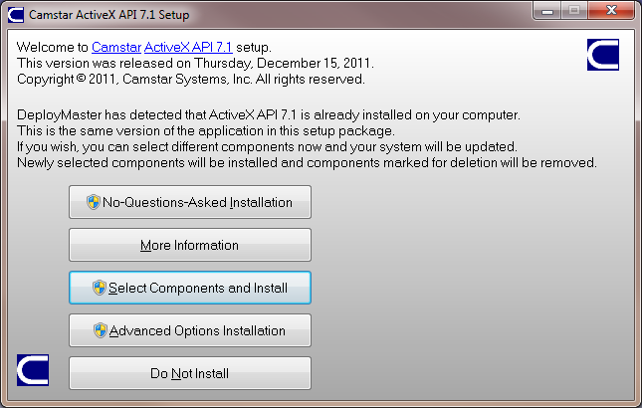
Figure 5 Example of the Camstar ActiveX API installer
- When you see the User Account Control screen you will need to select Yes to continue to install the software.
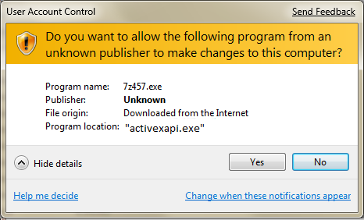
Figure 6 Example User Account Control screen
- Select No-Question-Asked Installation to continue to End User License Agreement.

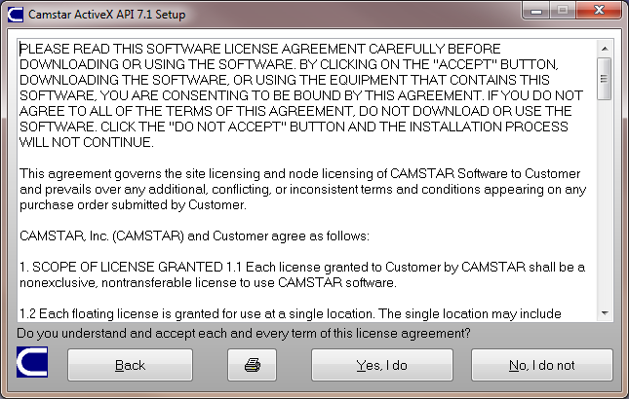
Figure 7 Example of End User Licesne Agreement
- Carefully read through the End User License Agreement.
  - If you agree with the terms of the software license agreement select “Yes, I do” to continue.
  - If you do not agree, you will not be able to install the software.
- Once, software is installed ActiveX API 7.1 has been successfully installed on you system screen will come up. To continue please click on the Thanks button.
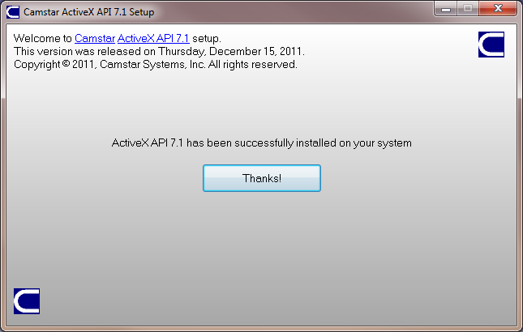
Figure 8 Example of ActiveX API 7.1 successfully installed

- When you see the User Account Control screen you will need to select Yes to continue to register the ActiveX DLL.
Figure 9 Example User Account Control screen
- On completion windows regsvr_32.exe will display the following pop-up message. To continue please click on the OK button.
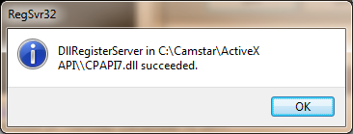
Figure 10 Example of automatically registration of 32 bit DLL in 32 bit OS

Step 3 Manually Registering CPAPI7.DLL

- For windows 7 64bit OS there are some additional step need to be performed are listed below:

Administrative credentials
To complete these procedures, you must be a member of the Administrators group.
To start a command prompt as an administrator
- Click Start, click All Programs, and then click Accessories.
- Right-click Command prompt, and then click Run as administrator.
- If the User Account Control dialog box appears, confirm that the action it displays is what you want, and then click Continue.
To start a command prompt as an administrator (alternative method)
- Click Start.
- In the Start Search box, type cmd, and then press CTRL+SHIFT+ENTER.
- If the User Account Control dialog box appears, confirm that the action it displays is what you want, and then click Continue.

- To register a 32 bit DLL in 64bit OS you will need to use the first switch to 32bit supporting system files in "C:\Windows\SysWOW64" and load the “regsvr32.exe” from there as shown in Figure 11.

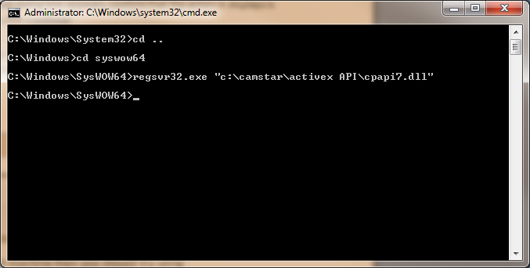
Figure 11 Example of registering a 32 bit DLL into 64bit OS
- On completion windows regsvr_32.exe will display the following pop-up message. To continue please click on the OK button.
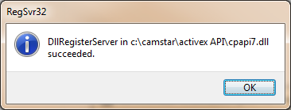
Figure 12 Example of automatically registration of 32 bit DLL in 32 bit OS

Step 4 Install Camstar ActiveX SigmaProbe for LabVIEW
- Install the Camstar LabVIEW2013 support VI using the following method:
  - Download the latest available software package from the Camstar web site and unzip it to a location on the host machine.
- Start the installation process by selecting Start > Run > Browse, navigate to the "setup.exe" file and select Open to start the installation wizard.
  - After a small delay, a screen similar to Figure 1 is displayed.
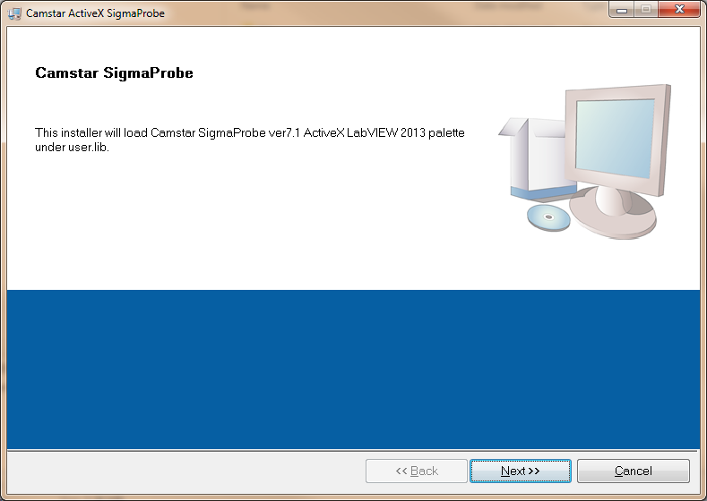
Figure 12 : Camstar ActiveX SigmaProbe Installation Wizard
- Continue to the next screen.
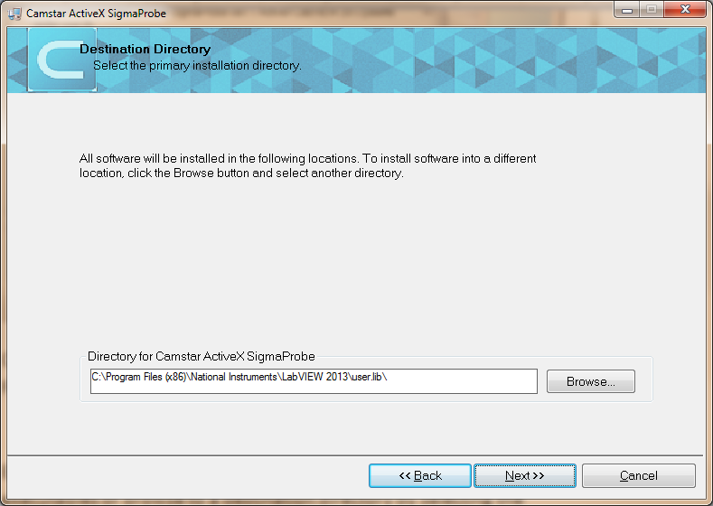
Figure 13 : Example of Selecting Destination Directory for Executables
- Enter the destination directory for the Camstar ActiveX SigmaProbe VI or browse to a destination directory by selecting the Browse button.
- Once the file path has been entered, select Next to continue to the Software License Agreement.
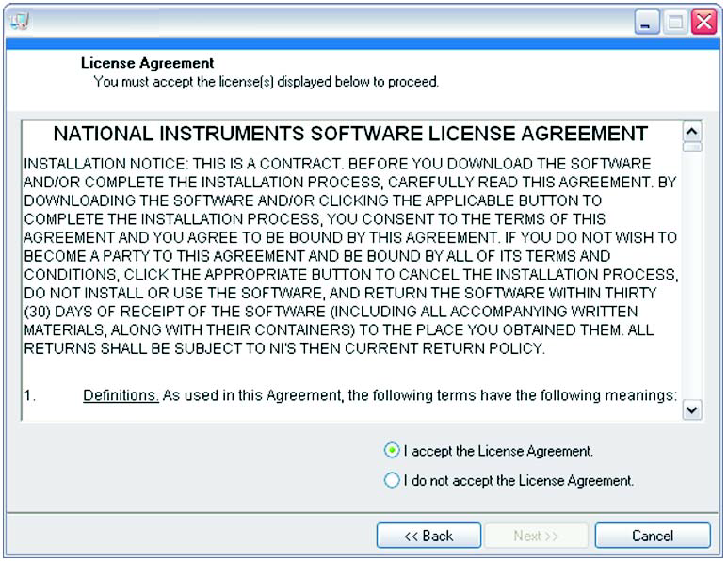
Figure 14: Example Software License Agreement
- Carefully read through the Software License Agreement.
- If you agree to the terms of the software license agreement, select "I accept the License Agreement" and select Next to continue.
- If you do not agree, you will not be able to install the software.
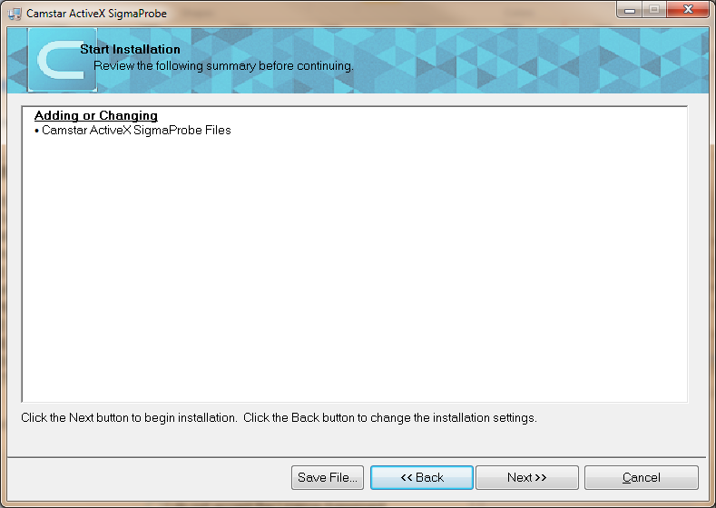
Figure 15: Example Summary of Files Being Installed
- Review the list of files to be installed and select Next to begin the installation.
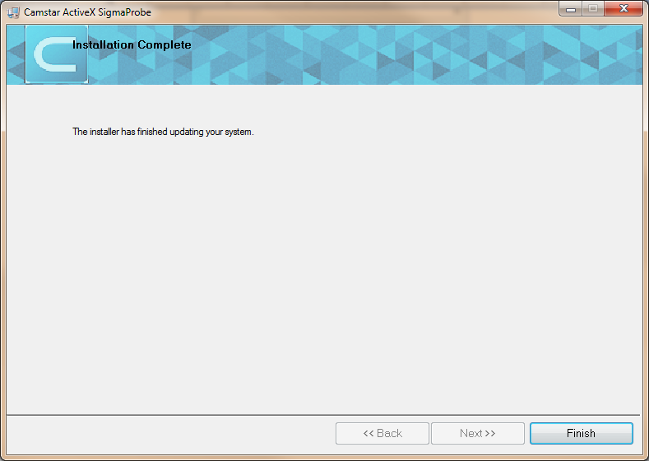
Figure 16 : Example of Completing Camstar ActiveX SigmaProbe Installation Wizard
- Select Finish to complete the Soft Front Panel installation.
- Copy MSXML.exe that is stored in finserv2\te\projects\sigmasure\Labview and Probe setup with W7 and 64Bit to target PC.
- Run it

